Dendroclimatology in the Eastern Mediterranean, Middle East, and North Africa
Dr. Ramzi Touchan, Associate Research Professor, Laboratory of Tree-Ring Research (rtouchan@ltrr.arizona.edu)
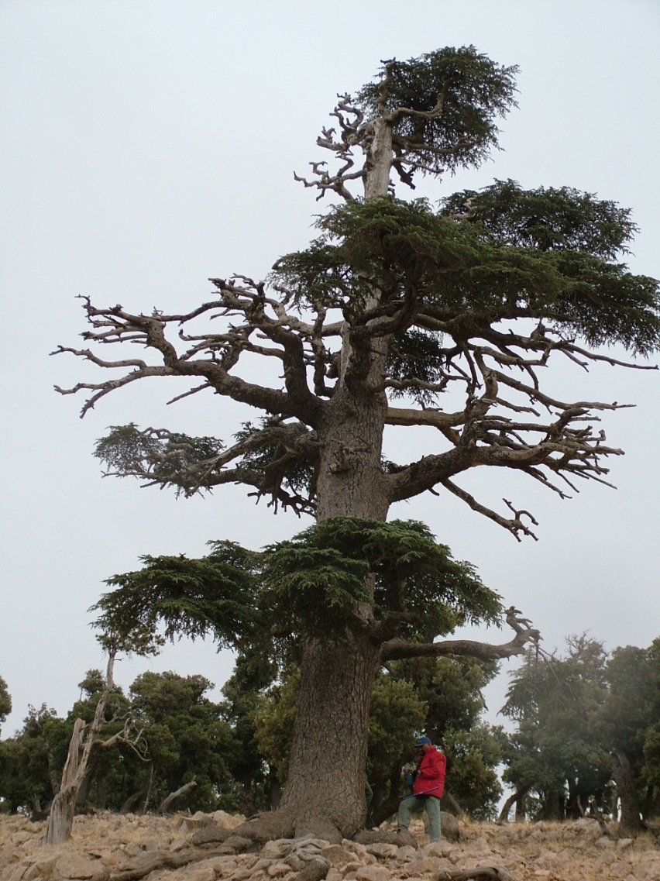
1999-2002 were the driest 4 years since AD 1179 in a PDSI reconstruction for North Africa from trees such as Cedrus atlantica, Pinus halepensis, Pinus pinaster, Abies marocan, Pinus nigra, Quercus afares, and Quercus canariensis.
Regional drought reconstructions from northwestern Africa. Top panel shows the 20-year low pass
filtered standardized reconstructed PDSI from the western and eastern grid points and their mean (7 grid
cell). Decadal-scale drought is widespread of the region when the regional time series are in phase, as they
are through much of the early part of the record until 1500, the 19th century, and most recent decades. The bottom panel map shows the PDSI grid points (in red) of which the western and eastern mean time series are composed. Tree ring sites are shown by filled circles whose size scales with the length of the chronology. The 500 km radius rings around each of the western and eastern grid points demonstrates that the eastern and western regional series are independent, with no predictors in common.
Dr. Ramzi Touchan's research integrates dendrochronology into natural and water resources management in the Middle East, Eastern Mediterranean (Greece, Turkey, Syria, Lebanon, Cyprus, and Jordan), and North Africa (Morocco, Algeria and, Tunisia). Dr. Touchan and M.K. Hughes conducted the first large-scale systematic dendroclimatic sampling in the eastern Mediterranean and the Middle East. Dr. Touchan also conducted the first large-scale systematic dendroclimatic sampling in North Africa. He and his colleagues (K. Anchukaitis and D. Meko) developed the first climate field reconstruction using Palmer drought Index (PDSI) for North Africa. This pioneering work, supported by the National Science Foundation, is critically important in an arid region where understanding and managing water resources essential for sustaining resources. This network will be used to study interannual to century-scale climate fluctuations in the region and their links to forcing factors and large-scale patterns of ocean and atmosphere variability.
Network of Tree-Ring Chronologies for the Mediterranean and North African Regions Developed by NSF (ESH) Funded Research (1996-Present).
