Late Pleistocene to Holocene Paleo-Environment
from Sub-Fossil Wood around the U.S. Great Lakes Region
Dr. Steven W. Leavitt, Professor, Laboratory of Tree-Ring Research
Dr. Irina P. Panyushkina, Adjunct Assistant Professor, Laboratory of Tree-Ring Research

Abundant evidence exists, albeit via lower-resolution pollen records, for climate variability during deglaciation and into the Holocene Period including a large number of climate excursions such as the Bølling and Allerød warm periods, the Intra-Allerød cold period, Younger Dryas cold event (YDE), and the Mid-Holocene Climate Optimum. Our understanding of these events in the Great Lakes region may be improved by the fortuitous availability of ancient wood resources for developing high-resolution environment and ecology records. A better understanding of this environmental history will have relevance to unraveling the peopling of the region over the last 12,000+ years and provide important lessons related to possible future global climate changes.

Since 2003, Drs. Leavitt and Panyushkina have been actively acquiring ancient wood samples 14,000 to 4000 years old from a number of sites in the region (Wisconsin, Illinois, Indiana, Michigan). This emergent wood collection has been assembled from samples obtained from previously known and newly discovered sites, pieces of which have been kindly provided by others or actively collected during recent field campaigns.

This effort has resulted in assessment of the first in situ Younger Dryas forest in N. America via multiple state-of-the-art techniques. Detection of forest conditions and environmental change was accomplished by examination of anomalies of tree-ring anatomy, tree-ring width variability, stable-isotope composition, radiocarbon wiggles, ground penetrating radar, and sedimentology of local deposits. This project has resulted in development of tree-ring width chronologies, radiocarbon series, and stable-isotope series applied to environmental reconstruction during the Younger Dryas Event and other time intervals.

RIGHT- Stump in submerged forest in Lake Huron near Sanilac Co., MI, in ca. 12.5 m of water, which radiocarbon dates to about 7300 to 8000 years ago. Wood from this site was obtained through the efforts of Inter-Seas Exploration, Ltd. and the Great Lakes Division- U.S. Naval Sea Cadet Corps. [photo credit: Clyburn]

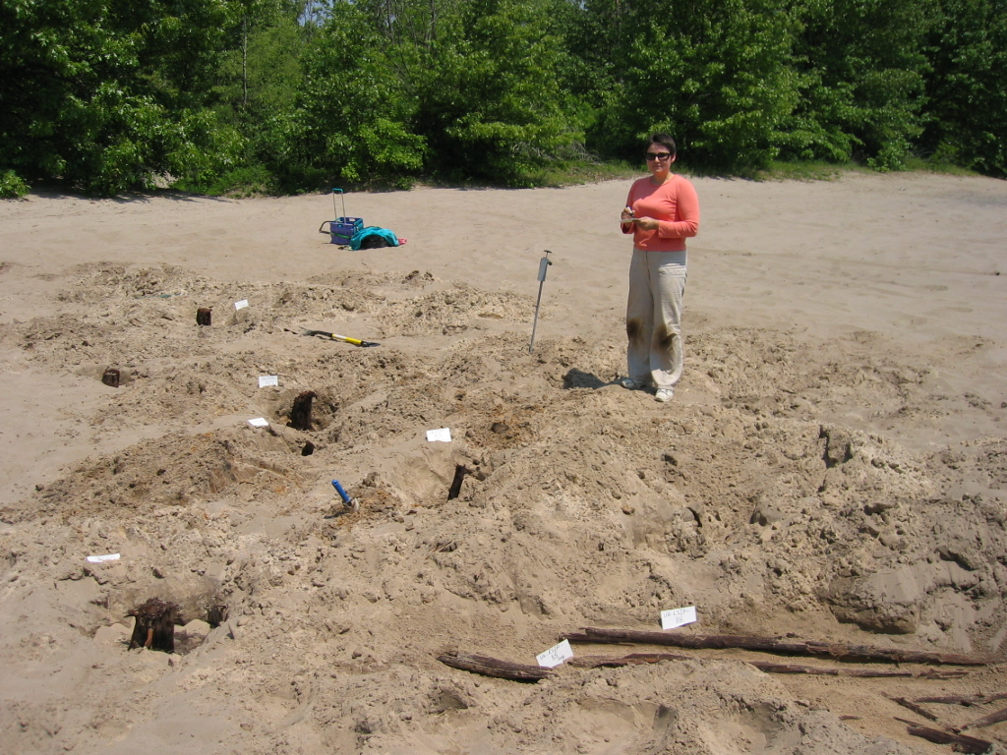

LEFT- Dr. Panyushkina at Liverpool East site in Indiana, a Younger Dryas-age spruce (Picea) forest. The white cards are placed adjacent to individual stumps. About 12,000 years ago, this forest existed for 116 years, with evidence of frost events, tilting, short growing seasons, and ultimate inundation by water and sediment, with an intermediate warm period and associated wave of establishment of new trees.

