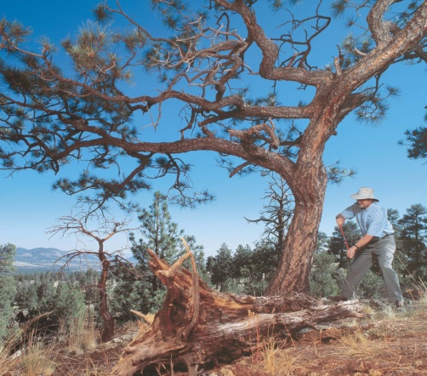
Ten Facts about the Laboratory of Tree-Ring Research

- We are the birth place of the field of “dendrochronology” (tree-ring sciences). Tree-ring research began at the University of Arizona in 1906.

- Our Laboratory is the pre-eminent and largest center of tree-ring research and teaching in the world.

- We are 10 faculty, 10 faculty affiliates and adjuncts, 5 research associates, 9 research staff, 18 graduate students, and 5 undergraduate assistants.
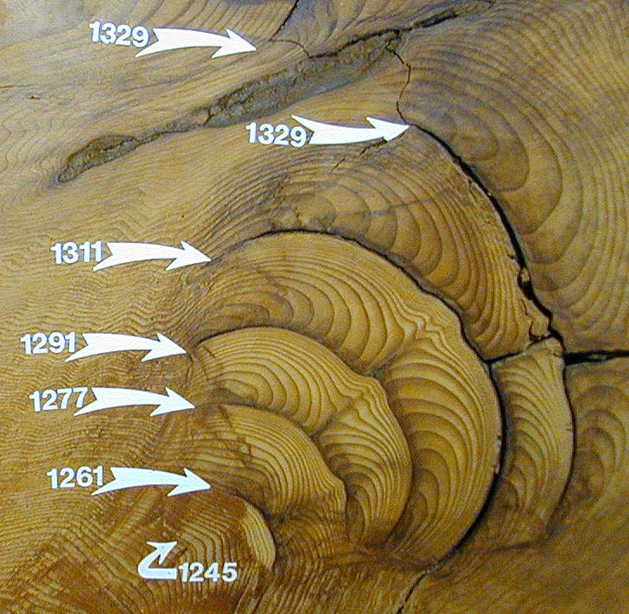
- We excel in multidisciplinary applications of dendrochronology in climatology, hydrology, archaeology, ecology, geology, and human-environment interactions.

- Our research contributes fundamental and applied insights on the long-term dynamics and history of temperature in the Northern hemisphere, drought in North America, the Mediterranean region and Middle East, and river flows of the Colorado River, Salt River, Rio Grande and other major watersheds.

- We maintain the world’s largest collection of ancient timbers, including specimens from the oldest and largest trees and beams from thousands of archeological sites.
Top: Sampling tree rings for drought and river flow history; Bottom: forest fire scars and dates in ancient giant sequoia tree rings.

- We have hosted visitors and trained students from more than 100 countries over the past 5 years. Our web pages receive more than 350,000 visits per month and we give tours and demonstrations to more than 3,000 K-12 students per year.

- Support for our research comes from the National Science Foundation, National Oceanic and Atmospheric Administration, National Aeronautics and Space Administration, U.S. Forest Service, National Park Service, U.S. Geological Survey, Salt River Project, and other sources.

- Honors among our faculty include: Lifetime Achievement Award from the Society for American Archaeology, AAAS Fellow, Regents’ Professor, a national award from the Secretary of Interior for Colorado River studies, and appointments to advisory boards by the Governor of Arizona and the President of the United States.

- Our research findings are frequently in the news, including recent coverage in the New York Times, National Geographic Magazine, and CBS 60 Minutes.

New Developments

LTRR will be moving into a new, integrated laboratory, office, and archive building on campus in approximately 2011. We recently hired a “Curator of Collections” to reorganize our wood archive and increase it’s accessibility to scholars from around the world.

