Jemez Mountains Field Trip Handout – From Tom Swetnam, February 27, 2012
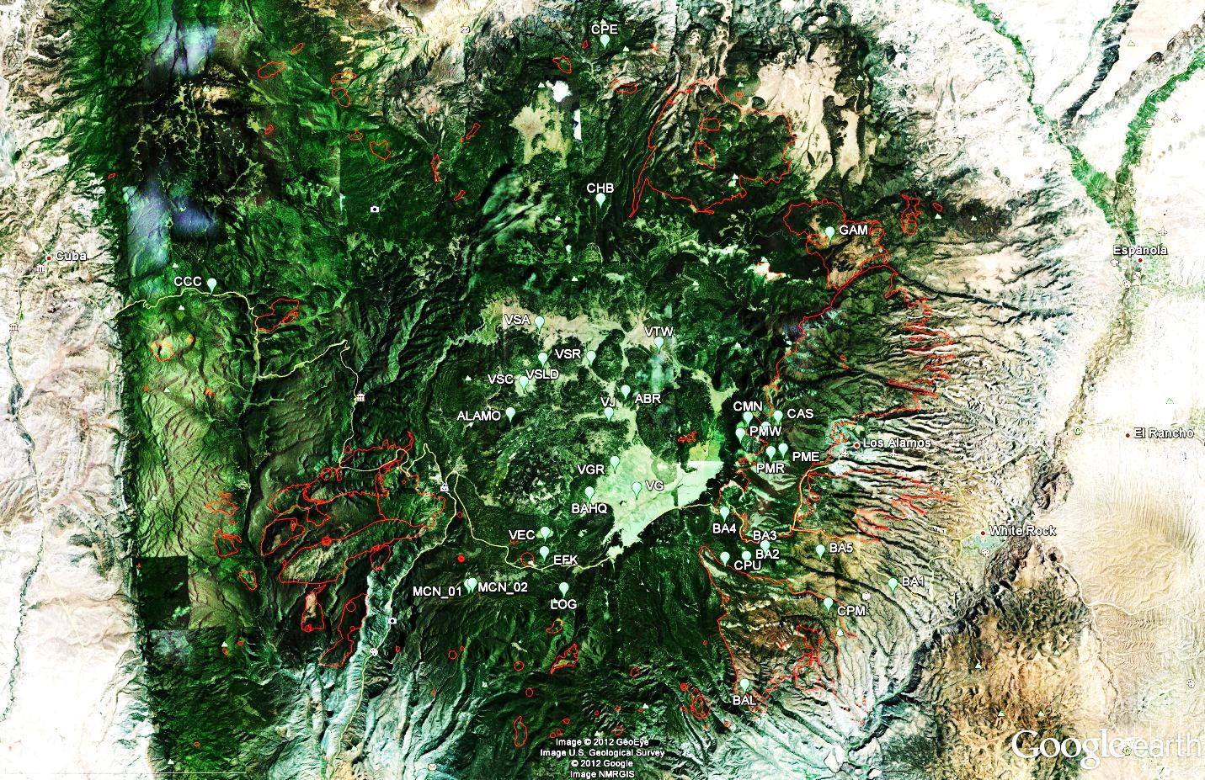
Tree-Ring fire scar study sites are shown above (with 3 letter codes), and perimeters of large wildfires since about 1970 are visible as red lines (the 2011 Las Conchas Fire is not shown).
This is a very rich physical, ecological and cultural landscape. I grew up in Jemez Springs (1964 to 1973), attending the elementary and high schools at Cañon, NM. Since then I have worked with students and colleagues in this landscape on various fire, insect outbreak, climate, and human history studies.
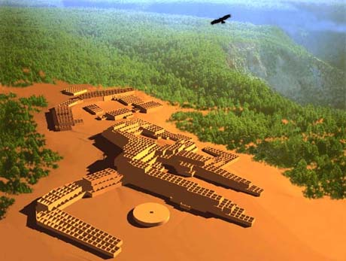
Our newest study is aimed at learning how people, fire and ponderosa pine forests co-existed in these mountains over many centuries. The opportunity is great, because there are archaeological, historical, cultural, tree ring, and sedimentary sources that we can learn from. The need to learn is also great because of the increasing risk of forest cultural resource loss. I include the public abstract for this National Science Foundation funded project at the end of this handout.
A key learning opportunity is the fact that the Jemez people lived within ponderosa pine forests here for many centuries prior to the Spanish settlement period (circa 1610-1700).
A number of large, multi-story villages with more than 1,000 rooms each were occupied when the Spanish first arrived. The population density on the southern flanks of the mountain is not known with certainty, but a conservative estimate would be about 28 people/km². The modern definition of the Wildland Urban Interface is 25 people/km².
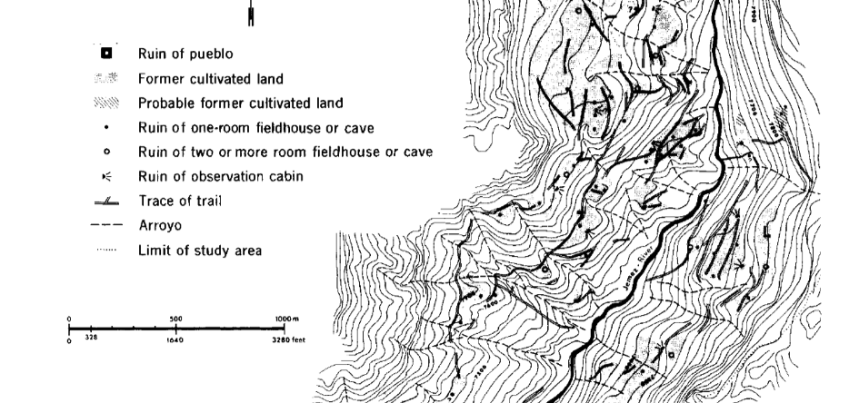
These ponderosa pine and mixed-conifer forests were extensively occupied and utilized for living space, agriculture, hunting, and other purposes. Dryland farming was practiced on mesa tops, in shallow drainages , and along canyon bottoms. The long-term human use of this landscape is hard to fully appreciate today. Diterich Fliedner’s mapping of a small area near Battleship Rock (above) exemplifies the remarkable number and distribution of agricultural, water control, travel and living features in this landscape (Annals of Assoc. Amer. Geog. 65(3), 1975).
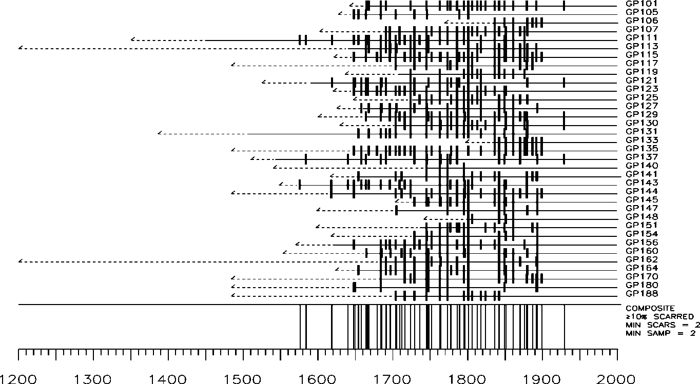
What effect did such long-term, intensive human occupation and use of this landscape have on forests and fire regimes? What effect did wild and managed fires have upon the Jemez people? How did past climate variability and its effects on fire and agricultural systems affect the people and the forests? What insights and lessons can we learn for understanding and managing these systems today and in the future?
Our fire history studies from fire scarred trees in the Jemez Mountains show typical Southwestern ponderosa pine patterns: frequent, widespread surface fires prior to circa 1900, and a sharp reduction of burning after that time. Don Falk’s dissertation research in the 640 acre Monument Canyon Research Natural Area (about 3 miles northeast of the Fliedner map above), suggests that widespread fires may have been less frequent during the intensive occupation period of these forests before circa 1630.

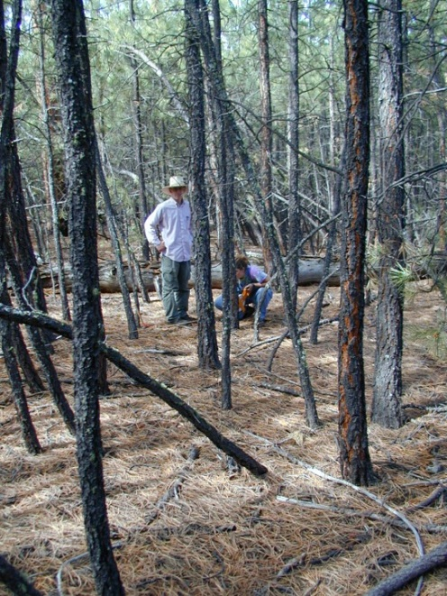
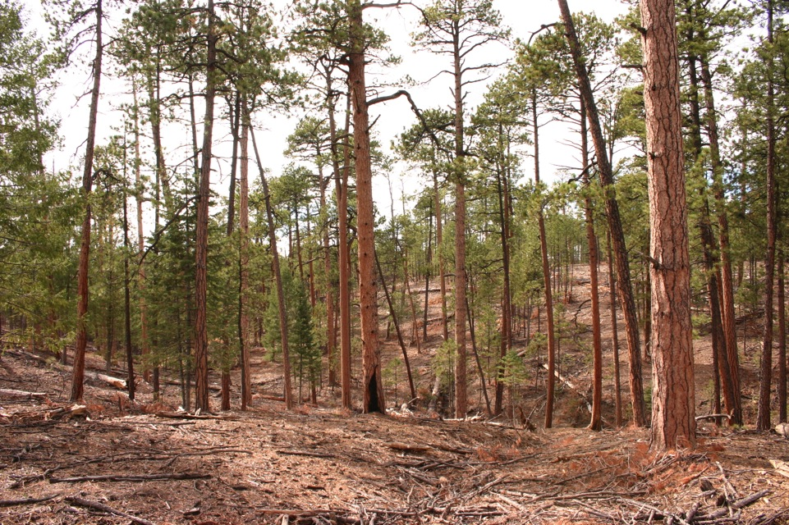
Forest changes after 1900 in Monument Canyon and elsewhere are evident from historical photos, early aerial photography (1935-36), tree age structure data, and other evidence. Don Falk measured some post-1900 tree thickets at Monument Canyon that exceeded 10,000 stems per acre! Recent restoration work at Monument Canyon RNA has been carried out by the Forest Service and in partnership with the Pubelo of Jemez (before: above left, and after: right).
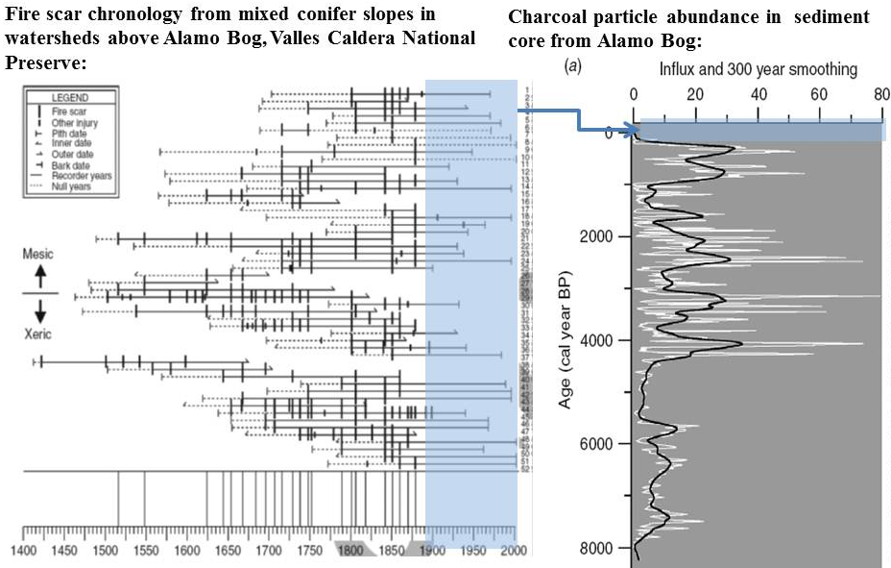
We have studied fire history at multiple elevations, in different forest types in the Jemez, and in a few studies we have also looked at very long-term fire history patterns. A combined study of both charcoal in sediments from Alamo Bog and fire scarred trees on surrounding slopes illustrates the somewhat longer intervals between surface fires that ocurred in mixed conifer forests before 1900 (below, Allen et al., Int. J. Wildland Fire 17(1), 2008). Charcoal was abundant throughout the sediment core going back nearly 8,000 years, except during the uppermost portion corresponding to the past century. The 20th century fire suppression period is the most anomalous hiatus in fire occurrence in the entire record.

FHiRE: Fire & Humans in Resilient Ecosystems
Tom Swetnam, University of Arizona: Chris Roos, Southern Methodist University, Matt Leibmann, Harvard University; TJ Ferguson, University of Arizona; Rachel Loehman, US Forest Service; Bob Keane, US Forest Service; John Welch, Simon Fraser University; Sara Chavarria, University of Arizona; Chris Baisan, University of Arizona, Chris Toya, Pueblo of Jemez, and other collaborators
Long-term vulnerability and resilience of coupled human-natural ecosystems to fire regime and climate changes at an ancient Wildland Urban Interface (National Science Foundation Proposal #1114898)
As global climates change, large wildfires have become regular features of national and international news. These fires are newsworthy because they affect the lives and livelihoods of thousands of people and because the types of fire are so different than in the recent history of these places. Certain types of fire are necessary to sustain key structures and functions of many environments around the world. Both people and climate can alter the types of fire that these environments experience through their effects on fire ignitions and on vegetation (fuels). In various circumstances these alterations may either increase or decrease the risk for types of fires that will not sustain those environments or the human societies dependent upon them. Although the physical and ecological responses of fire and vegetation to weather/climate are relatively well known, the interplay between human activities and fire are poorly understood, especially over time scales of centuries. Improved understanding of these interactions is needed for managing these forests today, and for anticipating future social and environmental vulnerabilities where high-density human settlements have developed -- also known as the Wildland-Urban Interface.

In the past half-century many thousands of homes have been built within North American forests dominated by ponderosa pine (Pinus ponderosa) trees. These forests and communities are now extremely vulnerable to large, severe fires during droughts as a consequence of fire exclusion and other land use practices. Through a historical case study, this project tests alternative hypotheses of how human activities at the Wildland Urban Interface affect the response of fire-adapted pine forests to climate change and conversely, how humans respond to these changes over multiple centuries. The study area is an ancient Wildland Urban Interface in northern New Mexico where large communities of Native American farmers lived within ponderosa pine forests through varying climate episodes over the last 1,000 years. Archaeology and paleoecology will be combined to build multi-century fire and forest histories across gradients of human population sizes, ranging from large towns to relatively unoccupied areas. Dynamic computer models will be developed, and using paleoclimatic data as input they will simulate fire and forest histories across the landscape and through time. Tested against the local fire histories, these simulations will be varied in the magnitude and location of human impacts to identify tipping points in the sustainability of these forests and human communities.

The understanding of long-term, landscape-scale dynamics of human societies, forests, and climate generated by this project will be necessary for sustainable management of similar forests at the Wildland Urban Interface across the American West and elsewhere. Information from the project will be provided directly to manager-partners who are engaged in landscape-scale fire and forest management initiatives on federal and tribal lands. Participatory research with American Indian tribes whose ancestors lived in these ponderosa pine forests will contextualize the fire and forest histories and human responses to environmental changes. Participation in both research and education will strengthen the relationships between scientists, managers, and community members, facilitating the use of scientific information in management decisions aimed at establishing resilient, sustainable forests. An educational program will establish a legacy of learning by developing and implementing K-12 lesson plans that integrate fire-society issues in science and history classrooms in the region. The involvement of undergraduate and graduate students, participation of American Indian research partners and underrepresented K-12 students, and the linkages to contemporary managers provide a broad capacity to disseminate project results in meaningful, applicable, and lasting ways.

