C:\Text\Text5\Papers\TreeRingBookChap\Firescar01.tifFig1Right.tif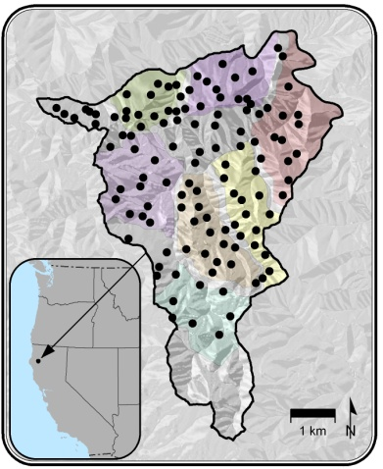Fig%203a%20copy