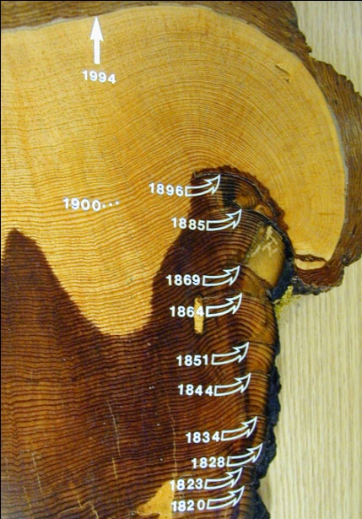Image5.tifScar.tifYos_Sequoia_firescar.tif

**mid-season fire scar**

**late-season fire scar**