Image5.tif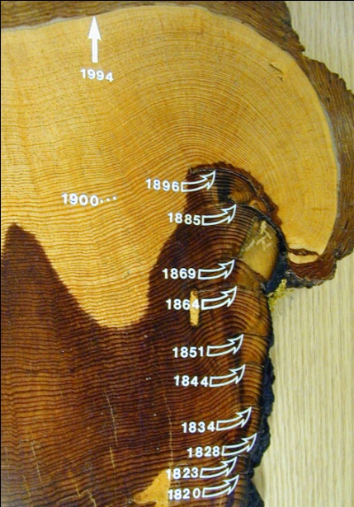Scar.tifRinconFirescar1.tif

**mid-season fire scar**

**late-season fire scar**