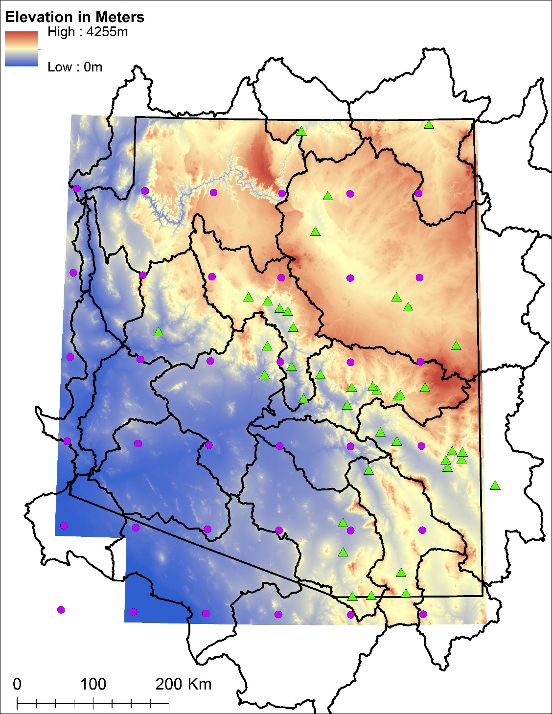

**Figure 1: Map of Arizona showing major watershed boundaries, elevation, and the location of the flood peak gauging stations used in this study** (**green triangles).**

Also shown are gridpoint locations of interpolated Integrated Water Vapor Transport (IVT) (purple circles) (see Section 3.2.2)

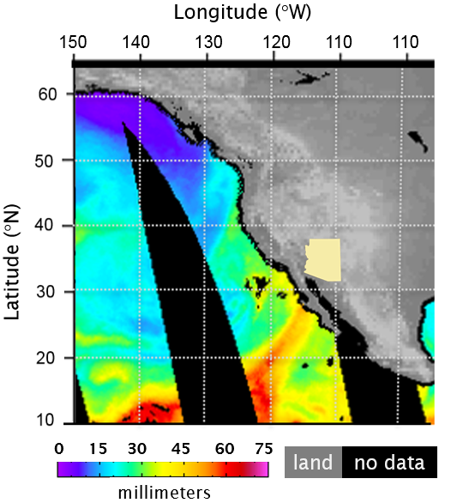

**Figure 2: Satellite-derived Integrated Water Vapor (IWV) Composite Image**

This 12-hour UTC PM composite shows column IWV (aka “Total Precipitable Water Vapor”) on October 31, 1987. An inset map of Arizona is superimposed. In the image, a plume of concentrated water vapor can be seen with a south-southwesterly trajectory that is targeted to cross Baja and enter Arizona. This AR event was associated with 10 flood peaks in the Arizona Flood Project Database (see Appendix A).

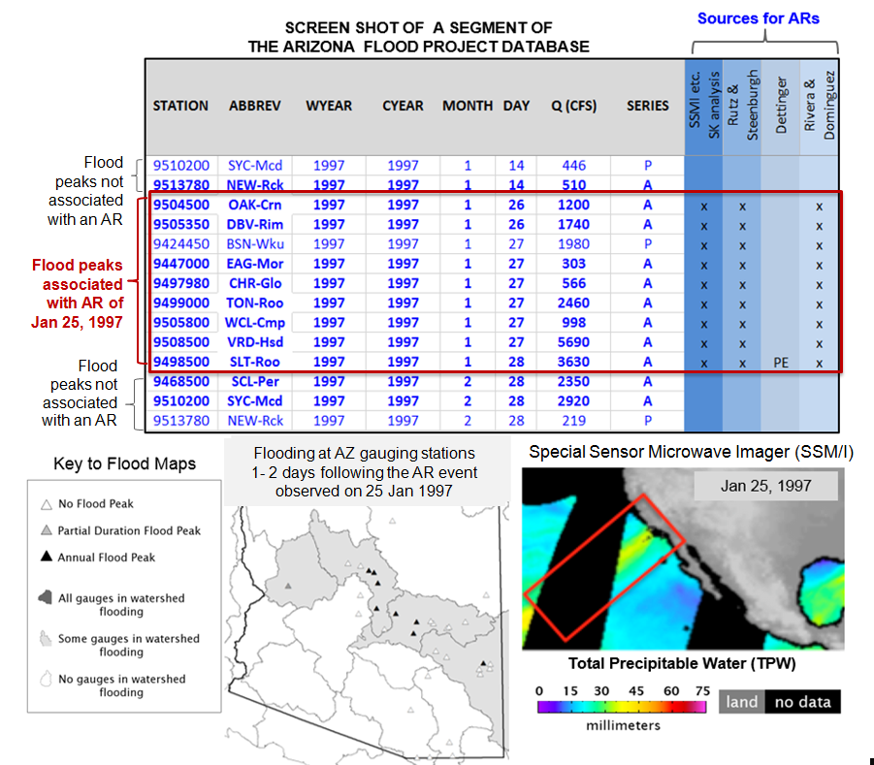

**Figure 3. Illustration of the procedure used to identify Arizona flood peaks associated with atmospheric rivers originating in the eastern North Pacific Ocean.**

The AR seen in SSM/I imagery on Jan 25, 1997 (red box) was also noted in each of the other AR published sources investigated for the January 26-28 flood peaks.

Figure 4. Generalized Physiography of Arizona. Flat Colorado Plateau to the North, complex topography in Central Highlands (Mogollon Rim) and Basin and Range to the South

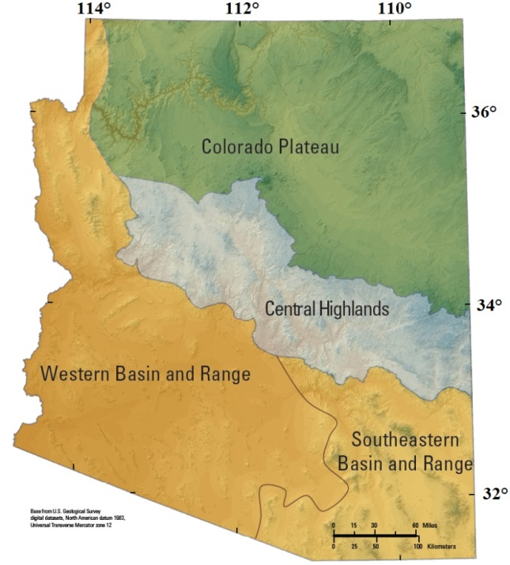

**Figure 5.** Monthly distribution of AR-related peaks in Arizona grouped by physiographic region for the cool season months during the WY 1988-2011 study period.

**Figure 6.** Yearly distribution of the total AR events observed during WYs 1988 – 2011. Red bars indicate an El Niño year.

W AZ

Central Highlands / Mogollon Rim

S AZ

NE AZ

**Figure 7.** AR fractions at selected gauging stations by watershed during WYs 1988 – 2011

**Figure 8.** Drainage basin area and AR fraction

**Figure 9.** Maximum elevation and AR fraction

**Figure 10.** Outlet elevation and AR fraction

**Figure 11.** Percentage of slope > 30 and AR fraction

**Figure 12.** Percentage of forest cover and AR fraction.

**Figure 13.** Soil permeability and AR fraction.

**Figure 14.**  Mean basin slope and AR fraction

|  |  |
| --- | --- |
| *February 21* |  |

**Figure 15.** SSM/I and watershed map for the 21 February 1996 event

|  |  |
| --- | --- |
| *January 5* |  |

**Figure 16.** SSM/I and watershed map for the 5 January 2008 event

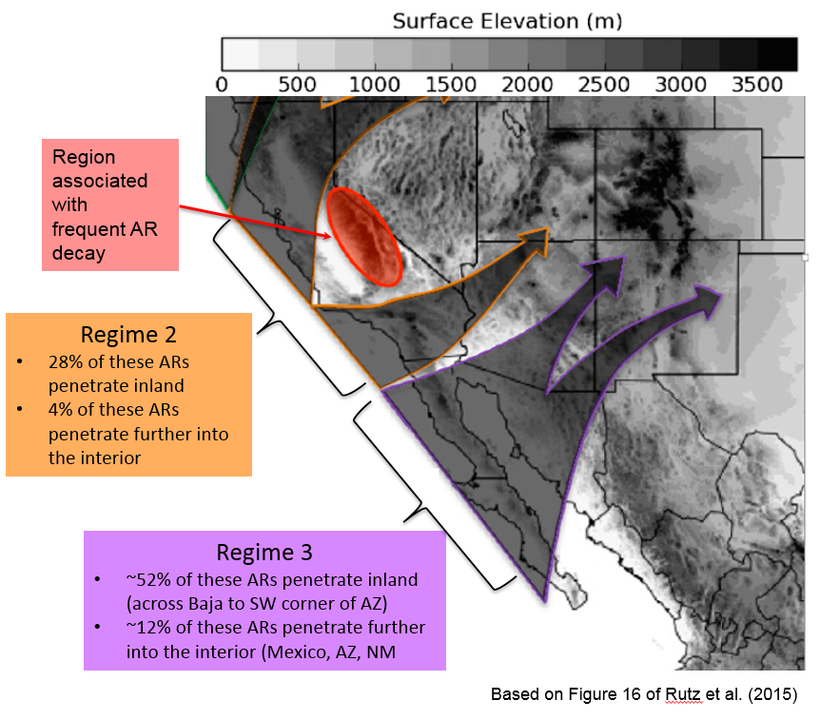

**Figure 17.** Schematic showing the primary pathways for the penetration of AR-related trajectories into the interior of western North America. Regime 3 and the southern branch of Regime 2 are the most likely pathways for ARs entering Arizona.  
(modified version of Figure 16 in Rutz et al. 2015).