 INDIVIDUAL TEST # ___
ANSWER FORM

NAME _______________________________
GROUP # __________

Each question is worth 2 pts. "Bubble in" the correct answer like this: example: [A] [B] [C] [D]

1. [A] [B] [C] [D]

2. [A] [B] [C] [D]

3. [A] [B] [C] [D]

4. [A] [B] [C] [D]

5. [A] [B] [C] [D]

6. [A] [B] [C] [D]

7. [A] [B] [C] [D]

8. [A] [B] [C] [D]

9. [A] [B] [C] [D]

10. [A] [B] [C] [D]

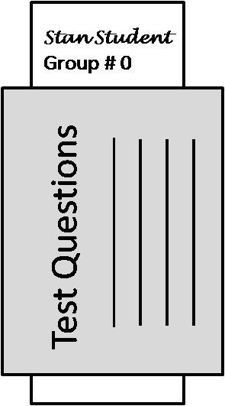 | When you are done, fold the TEST QUESTION SHEET in half and place this answer sheet inside with only your NAME & GROUP # showing at the top . Then raise your hand. Someone will pick it up from you.

Remember your answers
for the GROUP TEST that will follow!

TOTAL: out of 20
 INDIVIDUAL TEST # ___
ANSWER FORM

NAME _______________________________
GROUP # __________

Each question is worth 2 pts. "Bubble in" the correct answer like this: example: [A] [B] [C] [D]

1. [A] [B] [C] [D]

2. [A] [B] [C] [D]

3. [A] [B] [C] [D]

4. [A] [B] [C] [D]

5. [A] [B] [C] [D]

6. [A] [B] [C] [D]

7. [A] [B] [C] [D]

8. [A] [B] [C] [D]

9. [A] [B] [C] [D]

10. [A] [B] [C] [D]

When you are done, fold the TEST QUESTION SHEET in half and place this answer sheet inside with only your NAME & GROUP # showing at the top . Then raise your hand. Someone will pick it up from you.

Remember your answers
for the GROUP TEST that will follow!

TOTAL: out of 20

