Honors Preceptor Contract NATS 101-GC
Student Name: ______________________
- I agree to participate in the Teaching Teams Program as a preceptor in NATS 101, The Earth and Its Environment: Introduction to Global Change (Instructor Katie Hirschboeck) and in return receive Honors credit for the NATS 101 course.
- I agree to come to class regularly and to be prepared to lead and facilitate occasional in-class activities. I will make myself available to assist students in the classroom. I will be open to assisting students during occasional additional training sessions or pre-test study sessions held outside of class time, if my schedule allows.
- I will attend weekly NATS 101 GC Teaching Team meetings & Honors Section sessions, and I will participate actively and enthusiastically on our class teaching team. I understand that the degree and quality of my participation in these activities will be one measure of the fulfillment of my honors contract.
- I agree to complete the textbook reading and online self-checks in a timely manner and complete class assignments ahead of time (as needed), so that I will be prepared to help classmates with the same work. I understand that my timely completion of readings, self-checks, and assignments -- and my mastery of the course material needed to help my fellow students -- will be one measure of the fulfillment of my honors contract.
- I agree to submit weekly email feedback reports to Dr. Hirschboeck about how the class is going and how students are dealing with the activities, assignments, readings, quizzes, tests, and exams. I understand that the timeliness, thoroughness, and quality of these required reports will be one measure of the fulfillment of my honors contract.
- I agree to complete the additional Honors Section Activities (#1, #2, & #2) that will enhance my understanding of the course material and challenge me to probe deeper into how Global Change science is done and what the research is telling us. I understand that the effort, creativity, quality, effectiveness, and accuracy of my product and sharing will be one measure of the fulfillment of my honors contract.
- I will treat students in the class who come to me for help and advice with courtesy and respect, but I understand that I do not have to force help on students who do not want it.
- I understand that my role is not to give answers away to students, but to help them discover their own answers and solutions to problems.
- I understand that sometimes I will not know the answers to a question or how to address a student's problem. For situations beyond my level of expertise, I will personally see that the student gets appropriate attention from the GTA or instructor.
- I understand that the professor and GTAs are committed to making my honors preceptorship and my special topic investigation an educational and rewarding honors experience for me. I will reciprocate by using every opportunity to make my experience as an honors preceptor a positive learning experience.
Signed: _____________________________ (student) Date: _________________
Signed: _____________________________ (instructor) Date: ________________
HONORS SECTION ACTIVITY #1: In-Depth Reading on Science:
 | 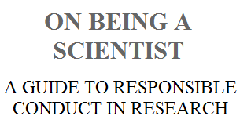 | Find it online at: http://tinyurl.com/nqe6mg  (You may read it online or download a PDF  copy for free for personal use at this site)
The scientific research enterprise is built on a foundation of trust. Scientists trust that the results reported by others are valid. Society trusts that the results of research reflect an honest attempt by scientists to describe the world accurately and without bias. But this trust will endure only if the scientific community devotes itself to exemplifying and transmitting the values associated with ethical scientific conduct.
On Being a Scientist was designed to supplement the informal lessons in ethics provided by research supervisors and mentors. The book describes the ethical foundations of scientific practices and some of the personal and professional issues that researchers encounter in their work. It applies to all forms of research--whether in academic, industrial, or governmental settings-and to all scientific disciplines.
Read through the Case Studies in the boxes on the pages indicated below, pick one, and share your ideas on the situation described. [You should post your insights on the NATS HONORS D2L Site which will be launched this weekend]. We’ll then discuss what everyone posted at our next meeting.

- A Change of Plans ( p 5)
- The Selection of Data ( p 10)
- Discovering an Error ( p 14)
- Fabrication in a Grant Proposal ( p 17)
- Is It Plagiarism (p 18)
- A Career in the Balance (p 22)
- Tests on Students ( p 25)
- A Change of Protocol ( p 26)
- Publication Practices ( p 32)
- Who Gets Credit ( p 36)
- A Commercial Opportunity ( p 42)
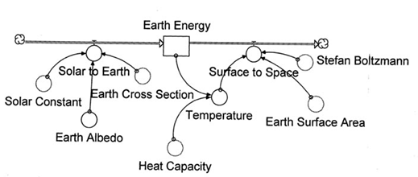
- A Conflict of Commitment ( p 45)

HONORS SECTION ACTIVITY #2: Creating Your Own Simple Computer Model & Exploring Global Climate Change using a Climate Model [ This will be a step-by-step activity with directions on how to do it – I think you will find this visual modeling process (using Stella software) very interesting and applicable to many disciplines, not just science!

HONORS SECTION ACTIVITY #3: In-Depth Reading on Global Change: The IPCC REPORT
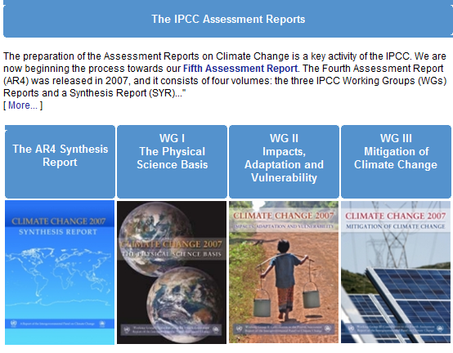
http://www.ipcc.ch/

You’ll read the Summary for Policymakers
for the AR4 Synthesis Report,
WG I, WG II, WG III

