HOW TO CREATE THE CRITTER POPULATION GROWTH MODEL
IN STELLA SYSTEMS MODELING SOFTWARE
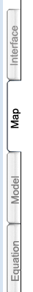
- Download, install, and open the 30-day trial of STELLA at: http://www.iseesystems.com/community/downloads/STELLA/STELLADemo.aspx
2. Check to be sure you are in “MAP MODE” mode by viewing the TABS along the left hand side of the screen.

3. Along the top of the screen, you’ll see a row with tiny icons --- the ones we’ll use are:
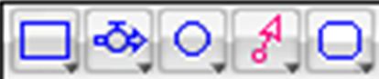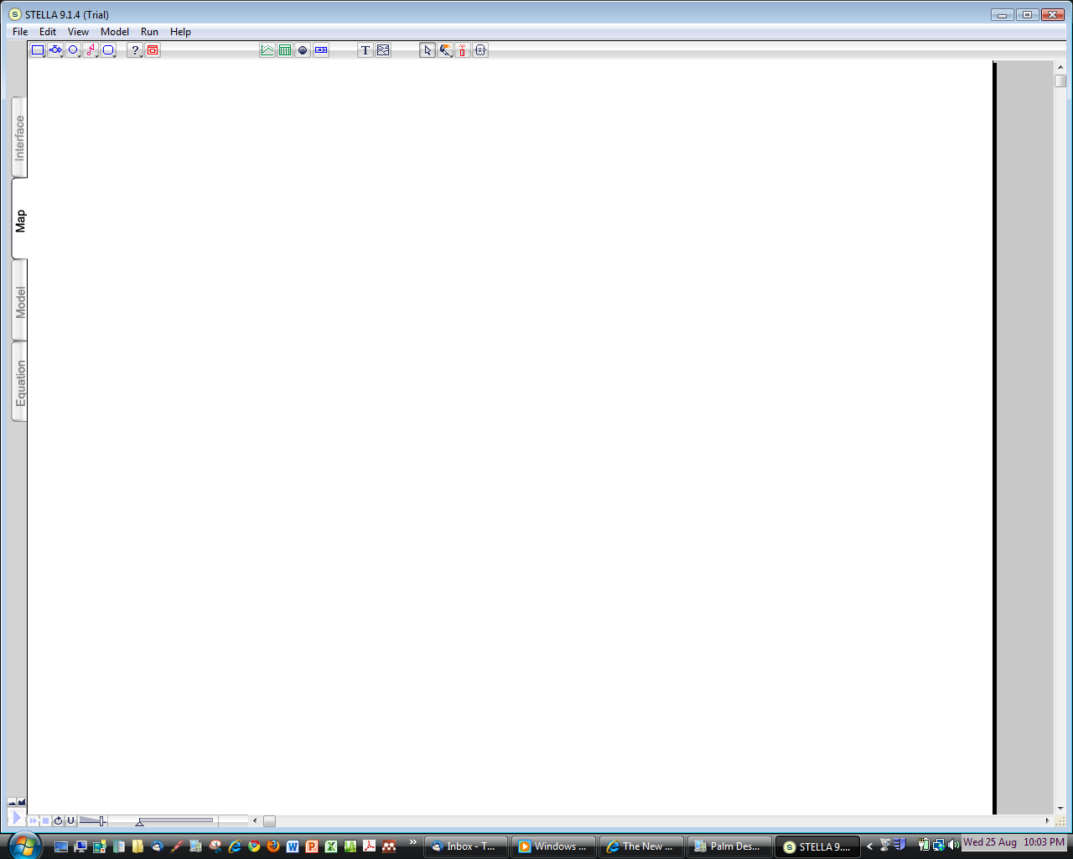
stock flow & converter connector graph table status numeric text arrow paintbrush dynamite ghost valve display
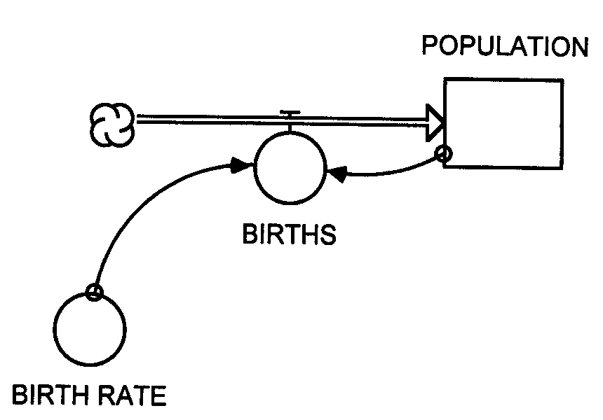
4. Your task is to put the STELLA symbols (stock, flow & valve, converter) together in MAP MODE to make the critter population model that you just reasoned through:

a) First put the STOCK in. Click on the stock symbol in the row of icons at the top of the screen to select it, then move your cursor to the center of the blank screen and click. Next give the stock a name (e.g., “Population,” “Critter Population” etc.) by deleting “Noname 1”(with a backspace) and typing in a new name.
Then click anywhere in the white background to see the changes.

b) Next send a FLOW & VALVE into the Critter Population stock from a source cloud. Click on the flow & valve symbol in the row of icons to select it, move your cursor an inch or two to the LEFT of the stock, CLICK AND HOLD as you slide the cursor toward the stock to direct the flow into it. (You’ll see the source cloud appear when you first click.) You may RELEASE the click when contact occurs between the flow’s arrow and the stock – the stock will temporarily change its appearance to look shaded to indicate that the connection has been made. If you release too soon, you will not have properly connected the flow to the stock. Now give the flow & valve a name, such as “births” or “Critter births.”

c) Next put in a CONVERTER to represent the information on Birth Rate needed to operate the flow and valve at the proper rate. Click on the converter symbol in the row of icons, move your cursor to somewhere near the flow & valve and CLICK to place the converter. Now give the converter a name, such as “Birth Rate” or “Critter Birth Rate.”

d) Next put in a CONNECTOR to connect the information in the Birth Rate converter to the Birth flow & valve so that the flow/valve knows at what rate to “give birth to” new critters with each time step of the model. Click on the connector icon to select it than click again on the Birth Rate converter (be sure the connecter’s arrow starts inside the converter) then CLICK AND HOLD as you slide the cursor toward the flow & valve. When the arrow at the end of the connector makes proper contact with the circular part of the flow and valve symbol, the flow & valve will temporarily change its appearance to look shaded. When the connection has been made, RELEASE the mouse button.

e) Lastly you need to put in a second CONNECTOR to connect the information contained in the Critter Population stock with the Birth flow & valve. (Recall that the number of new babies born every minute (each time step) is dependent on BOTH the birth rate (the converter) AND the current population of critters (the stock).

5. Now switch to MODEL MODE by clicking on the appropriate tab on the left of the screen.
As soon as you switch into MODEL MODE, Question marks (?) will appear on the symbols where INPUT is needed to make the model run.

6. DOUBLE CLICK each symbol that is asking for input (via ?) and fill in the pop up window with the requested input (see highlighted area in screen shot below asking for input):
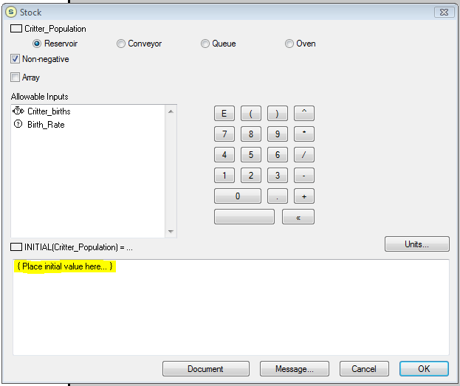
STOCK (Critter population)
Fill in the initial value = 2 (then click OK)

CONVERTOR (Critter birth rate)
Fill in the birth rate = 1.0 (then click OK)

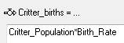
FLOW & VALVE (Critter births) Create the equation that will compute the number of births each time step by clicking on the first required variable (Critter Population) then the multiplier (*) and then the second required variable (Birth rate). The equation should look like this:
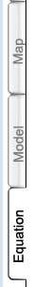
(then click OK)

NOTE: The above values will re-create the model you produced “by hand” in the previous exercise, but you can change the variables to try out different scenarios by changing the Birth rate and the Initial value of the stock – you’ll do this later after you get your model running.

7. Once you have filled in all the information required by the question marks, a little of the magic of STELLA can be revealed! Using the relationships represented by your model diagram, the STELLA software will automatically produce the necessary equations to make the model run
with the input you just provided. To see the equations, CLICK on the EQUATION tab and you’ll see:
This equation will compute the number of new births that take place during each time step and add them to the number of critters already in the stock. Also shown are the various INPUTS you just entered under Step 6. Now go back to MAP MODE by clicking on the appropriate tab.

You are getting closer to running the model, but first you have to set up a way to view the results.

8. Create a GRAPH to show the results. Click on the Graph Pad icon on the toolbar to select it and click again to deposit a graph in a spot on the screen. Then click on the graph to open it. You’ll see a graph with TIME on the x-axis, but no variable will appear on the y-axis. Double click on graph to get to a box where you can select the variable you want on the y-axis. Select the variable you want (Critter Population) by clicking on it and then move it to the right side of the box by clicking on >> Give the graph a title, such as “Critter Population Growth,” by filling in the Title box. Also select Make 5 Grid Segments. Then close the Graph by clicking OK. (You will view the results later.)

9. Next, create a TABLE to show the results. Click on the Table Pad icon and deposit it on the screen, then double click on the table (as you did with the graph) to set up the table the way you want it. Include these 3 variables: Critter Population, Critter Births and Birth rate. Give the Table a title, such as AModel Run Results@ or something like that. Then close the Table by clicking OK.
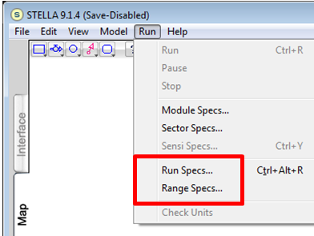
You=re almost ready to RUN the model!! A few more steps:

10. Before running the model, some specifications (Run Specs) need to be defined:

Click on Run in the Menu Bar at the top
and select Run Specs…
Then enter these values in the appropriate boxes:

Length of simulation:
From: 0 To: 5
DT = 1 ( for a one minute time step)
Click OK to close the box.

Then Click on Run in the Menu Bar again and select Range Specs…
Variable | min | max
Critter Population | 2 | 64
Critter Births | 0 | 100
Birth rate | 0 | 10
Enter the RANGE SPECS. To do this, select the variables one at a time and enter the min and max values shown at right. Click on SET after each variable’s entries have been made and go to the next variable. When all the ranges for each variable have been set, click OK.

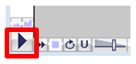
11. FINALLY to RUN the model, CLICK on the right-pointing triangle on the RUN Controller toolbar (in the lower left-hand corner of the screen) and the model should run and be animated!!

12. To see the results, click on the TABLE and then the GRAPH. If you did everything properly, the table should show the same results that you hand-calculated and the graph you get should look like the graph you plotted up by hand.

A FEW MORE STELLA TRICKS:
arrow paintbrush dynamite ghost graph table numeric text
display
If you make a mistake, you can “dynamite” it away!! Click on the DYNAMITE icon to select it, then move the stick of dynamite so that the “fuse end” lines up on the item you want to delete and click again. BLAST! It’s gone! [NOTE: when blasting away CONNECTORS, you must put the fuse on the connector at its starting point, i.e., the tiny little circle where it is attached to the stock or converter that it is connecting.]

You can use the ARROW to draw a box around an entire model diagram (or part of one) and select all the components inside the box at once – then you can move it around to a different location, etc.

The GHOST is used to make a copy of a component of your model and paste a “ghosted” copy of this same component elsewhere in the model or in a related model. This is useful in more complex models where a specific calculation (such as the conversion of degrees C to degrees F) may need to be made over and over again.

You can magnify the screen by clicking as follows in the lower left of the screen:
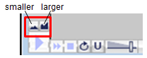

You can use the PAINTBRUSH to change the color of your model, add text by clicking on the TEXT icon to enter explanatory text in a block, and set up a NUMERIC DISPLAY to show the final value of different variables in your model after it has completed its run

To clear the results of a Table or Graph, click on the dynamite symbol that is located in the corner of the table or graph.

You can “push-pin” a Table or Graph to keep it open so you can watch it change during the model run by clicking on the little push pin symbol at the upper left corner of the Table or Graph.

Now have some fun playing around with your simple model!!!
TRY SEVERAL MORE MODEL RUNS:

- You can put the Critters on birth control be reducing the birth rate,

- You can make the Critters sterile by changing the birth rate to 0

- You can make the Critters very prolific by increasing the birth rate.
[ Observe that because the growth rate is EXPONENTIAL, small changes in the input variables can make very large changes in the growth response.]

- Play around with the Run & Range specs to run your model experiment over different time periods, time steps, etc. etc.

- Figure out how to add “critter deaths” to your model!

You won’t be able to save your model or the results in the software once you run them, but you can make a snip or screen shot of your results and paste that into a word document. When you do this, be sure you record what you changed in the model run to get the new result. For our next session, bring some copies of your runs in to share with your fellow students.

Now that you have become a successful computer modeler, you are ready to run and interpret a STELLA model of the ENERGY BALANCE
– our final step in this activity!!

