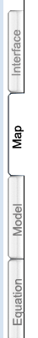
HOW TO CREATE THE CRITTER POPULATION GROWTH MODEL
IN STELLA SYSTEMS MODELING SOFTWARE

1. Open the STELLA program:
Click on the STELLA icon on the computer desktop. When it opens you’ll see the STELLA program screen.

2. Check to be sure you are in “MAP” mode by viewing the TABS along the left hand side of the screen. If you are in Map Mode, the tabs will look like this ==>

3. Along the top of the screen, you’ll see a row with tiny icons --- the ones we’ll use are:
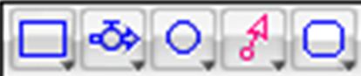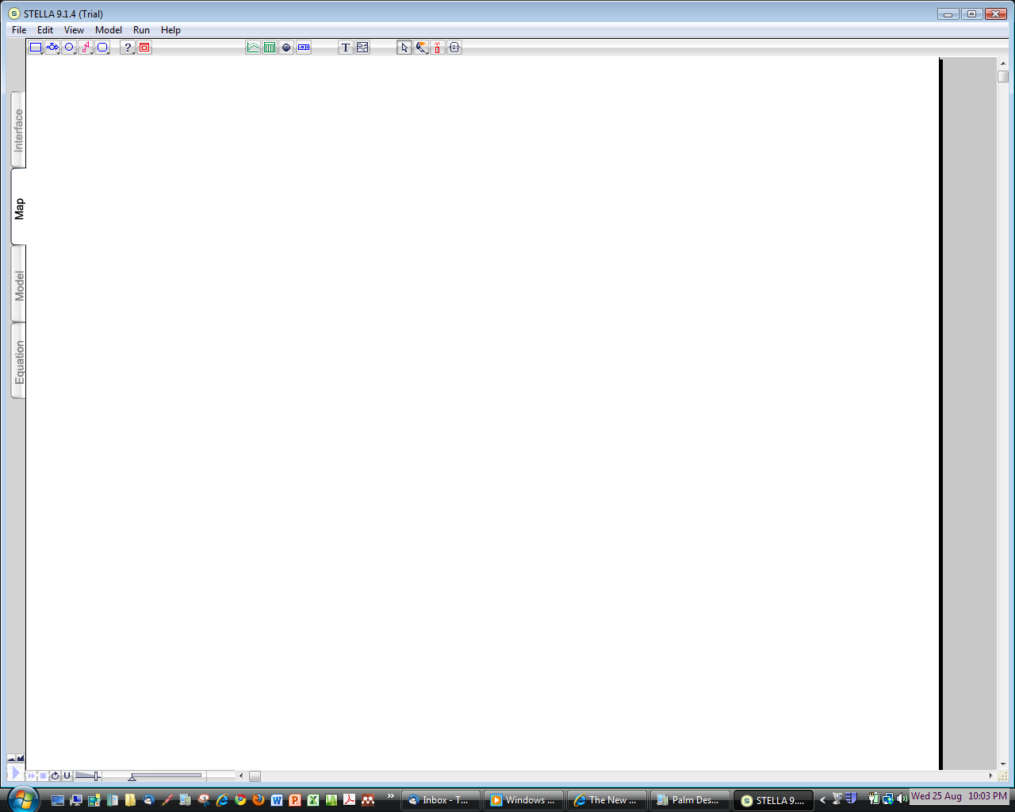
stock flow & converter connector graph table status numeric text arrow paintbrush dynamite ghost valve display
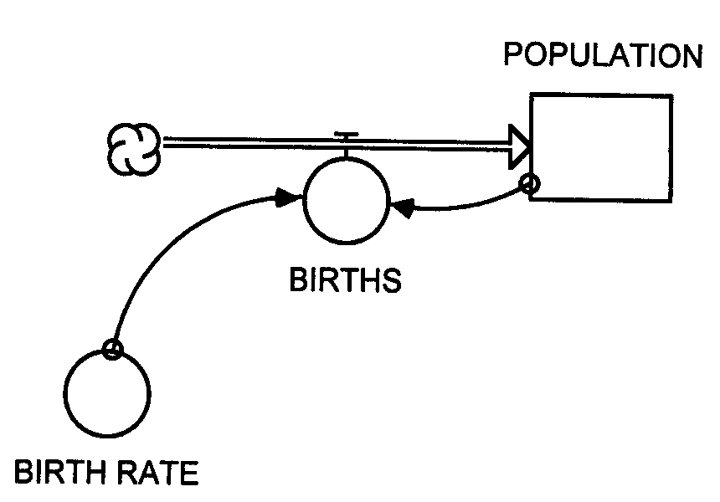
4. Your task is to put the STELLA symbols (stock, flow & valve, converter) together in MAP MODE to make the critter population model you just reasoned through:

a) First put the STOCK in. Click on the stock symbol in the row of icons at the top of the screen to select it, then move your cursor to the center of the blank screen and click. Next give the stock a name (e.g., “Population,” “Critter Population” etc.) by deleting “Noname 1”(with a backspace) and typing in a new name.
Then click anywhere in the white background to see the changes.

b) Next send a FLOW & VALVE into the Critter Population stock from a source cloud. Click on the flow & valve symbol in the row of icons to select it, move your cursor an inch or two to the LEFT of the stock, CLICK AND HOLD as you slide the cursor toward the stock to direct the flow into it. (You’ll see the source cloud appear when you first click.) You may RELEASE the click when contact occurs between the flow’s arrow and the stock – the stock will temporarily change its appearance to look shaded to indicate that the connection has been made. If you release too soon, you will not have properly connected the flow to the stock. Now give the flow & valve a name, such as “births” or “Critter births.”

c) Next put in a CONVERTER to represent the information on Birth Rate needed to operate the flow and valve at the proper rate. Click on the converter symbol in the row of icons, move your cursor to somewhere near the flow & valve and CLICK to place the converter. Now give the converter a name, such as “Birth Rate” or “Critter Birth Rate.”

d) Next put in a CONNECTOR to connect the information in the Birth Rate converter to the Birth flow & valve so that the flow/valve knows at what rate to “give birth to” new critters with each time step of the model. Click on the connector icon to select it than click again on the Birth Rate converter (be sure the connecter’s arrow starts inside the converter) then CLICK AND HOLD as you slide the cursor toward the flow & valve. When the arrow at the end of the connector makes proper contact with the circular part of the flow and valve symbol, the flow & valve will temporarily change its appearance to look shaded. When the connection has been made, RELEASE the mouse button .

e) Lastly you need to put in a second CONNECTOR ( as explained on p. 146 of the CLASS NOTES) to connect the information contained in the Critter Population stock with the Birth flow & valve. (Recall that the number of new babies born every minute (each time step) is dependent on BOTH the birth rate (the converter) AND the current population of critters (the stock).
5. Now switch to MODEL MODE by clicking on the Globe (it is a Atoggle@ switch that can take you back and forth between MAP and MODEL mode). When you are in MODEL MODE you will see this symbol on the upper left of the screen ==>

As soon as you switch into MODEL MODE, Question marks (?) will appear on the symbols where INPUT is needed to make the model run.

6. DOUBLE CLICK each symbol that is asking for input (via ?) and fill in the pop up window with the requested input as follows:

STOCK (Critter pop) Fill in the initial value = 2 (then click OK)
CONVERTOR (Critter birth rate) Fill in the birth rate = 1.0 (then click OK)
FLOW & VALVE (Critter births) Create the equation that will compute the number of births each time step by clicking on the first required variable (Critter Pop) then the multiplier * and then the second required variable (Birth rate): equation should look like this: = (Critter Population * Birth rate) (then click OK)

NOTE: The above values will re-create the model you produced “by hand@ on pp 138 –140 of CLASS NOTES, but you can change the variables to try out different scenarios by changing the Birth rate and the Initial value of the stock.

7. Once you have filled in all the information required by the question marks, a little of the magic of STELLA can be revealed! Using the relationships represented by your model diagram, the STELLA software will automatically produce the necessary equations to make the model run
with the input you just provided. To see the equations, CLICK on the DOWN-POINTING TRIANGLE just above the ² (Chi Square) symbol in the upper left side of the screen. The equation that computes the number of new births each time step and adds them to the number of critters already in the stock is revealed. (To get back to model mode, click on the upward pointing triangle.)

Getting closer to running the model, but first you have to set up a way to view the model results.. .

8. Create a GRAPH to show the results. Click on the Graph icon on the toolbar to select it and click again to deposit a graph in a spot on the screen. Then click on the graph to open it. You’ll see a graph, but no variable will appear on the y-axis. Double click on graph to get to a box where you can select the variable you want on the y-axis. Select the variable you want (Critter Population) by clicking on it and then move it to the right side of the box by clicking on >> Give the graph a title, such as “Critter Population Growth,” by filling in the Title box. Then close the Graph by clicking in the upper corner of the graph. (You will view the results later.)

9. Next, create a TABLE to show the results. Click on the Table icon and deposit it on the screen, then double click on the table (as you did with the graph) to set up the table the way you want it. Include these 3 variables: Critter Population, Births and Birth rate. Give the Table a title, such as AModel Run Results@ or something like that. Then close the Table by clicking in the upper corner of the table.

You=re almost ready to RUN the model!! A few more steps:
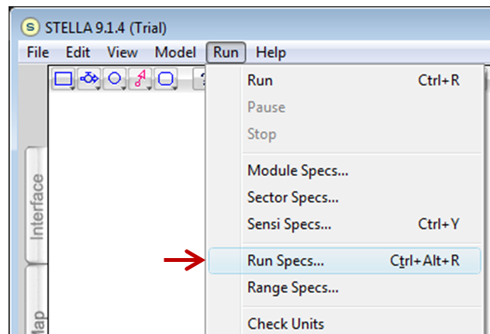
10. Click on Run in the Menu Bar at the top:

Before running, some specifications (SPECS) of the model need to be defined.
Click on the down triangle to the right of Specs to bring up the “Specs Box” and enter these values in the appropriate boxes, first for Time Specs and then for Range Specs:

Enter TIME SPECS:
from 0.00 to 5
DT = 1 ( for a one minute time step) Then click OK to close the box.

Enter RANGE SPECS: min max To do this, select the variables one at
Population: 2 64 a time and enter the min and max values.
Births: 0 100 Click on SET after each variables entries
Birth rate: 0 10 have been made and go to the next
variable. When all the ranges for each
variable have been set, click OK to close
the box.

11. To “animate” the graph and model diagram, go to the top of the screen and click on DIAGRAM (or MODEL in PC-based STELLA) and go to DIAGRAM PREFS (or MODEL PREFS in PC)
Then click on each of the symbols (stock, flow/valve, and converter) to select them for animation. Click OK to close the box.

12. FINALLY to RUN the model, CLICK on the right-pointing triangle on the RUN Controller toolbar) and the model should run and be animated!!

13. To see the results, click on the TABLE and then the GRAPH. If you did everything properly, the table should show the same results that you hand-calculated on p. 138 of CLASS NOTES and the graph you get should look like the graph on the bottom of p. 146 in CLASS NOTES.

14. Now TRY SEVERAL MORE MODEL RUNS, e.g., you can put the Critters on birth control be reducing the birth rate, make the Critters sterile by changing the birth rate to 0, or make the Critters very prolific by increasing the birth rate. Observe that because the growth rate is EXPONENTIAL, small changes in the input variables can make very large changes in the growth response.

15. The LAST STEP: Fill out a STELLA TRAINING CERTIFICATION FORM to document that you went through the STELLA training, have created and run your own version of the Critter Population Growth model, and have adjusted the model parameters and made one or more NEW model runs to get different output results.

LEAVE THE COMPLETED FORM WITH THE GTA OR PRECEPTOR WHO TRAINED YOU!!

A FEW MORE STELLA TRICKS:

hand paintbrush dynamite ghost graph table numeric text
display
If you make a mistake, you can “dynamite” it away!! Click on the DYNAMITE icon to select it, then move the stick of dynamite so that the “fuse end” lines up on the item you want to delete and click again. BLAST! It’s gone! [NOTE: when blasting away CONNECTORS, you must put the fuse on the connector at its start – the tiny little circle where it is attached to the stock or converter that it is connecting.]

You can use the HAND to draw a box around an entire model diagram (or part of one) and select all the components inside the box at once.

The GHOST is used to make a copy of a component of your model and paste a “ghosted” copy of this same component elsewhere in the model or in a related model. This is useful in more complex models where a specific calculation (such as the conversion of degrees C to degrees F) may need to be made over and over again.

You can use the PAINTBRUSH to change the color of your model, add text by clicking on the TEXT icon to enter explanatory text in a block, and set up a NUMERIC DISPLAY to show the final value of different variables in your model after it has completed its run

To clear the results of a Table or Graph, click on the dynamite symbol that is located in the corner of the table or graph.

You can “push-pin” a Table or Graph to keep it open so you can watch it change during the model run by clicking on the little push pin symbol at the upper left corner of the Table or Graph.

NOTE: You can download a free Runtime version (i.e., save-disabled demo) of the latest version of STELLA for your own PC or MAC from the High Performance Software website:

http://www.hps-inc.com/edu/stella/demo_gate.htm

Finally, for a neat story that starts with the model you’ve just made and takes it a bit further, visit the “Stella Classroom Fable” by clicking it on the High Performance Software Stella Demo Download site above or going directly to: http://www.hps-inc.com/edu/fable/fable1.htm

