How to Register your Turning Technologies Response Card (“clicker” device) for use in NATS 101 GC
STEP #1: Go to: student.turningtechnologies.com to fill out the Web Registration Form.
Stella Student has filled hers out below to show you how: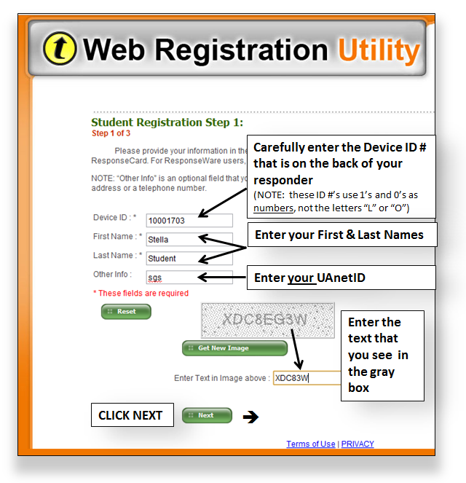

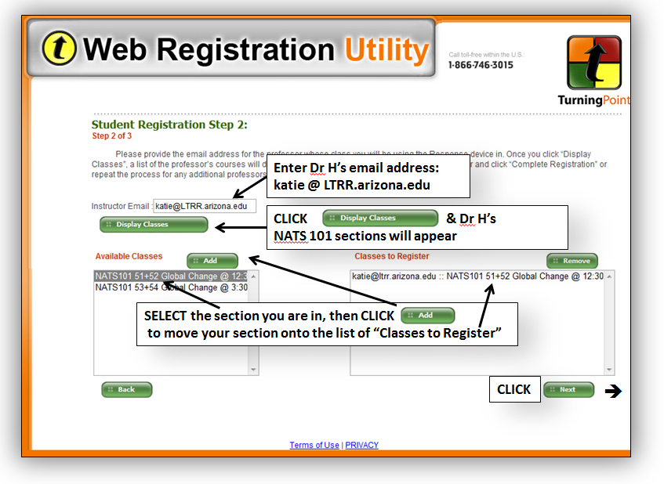
STEP #2: Use Dr H’s email address to locate her sections so you can register your device with our NATS class:
(NOTE: If you have more than one class using Turning Tech’s response systems, you can enter another instructor's email address now or later to add additional classes to your device registration. When all the classes you are using your response device are in your list, click "Next".

STEP #3: Verify that your registration is accurate, then click "Complete Registration." 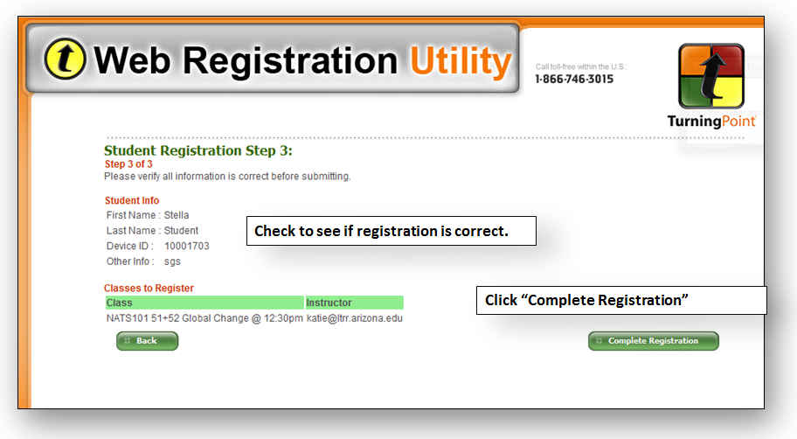
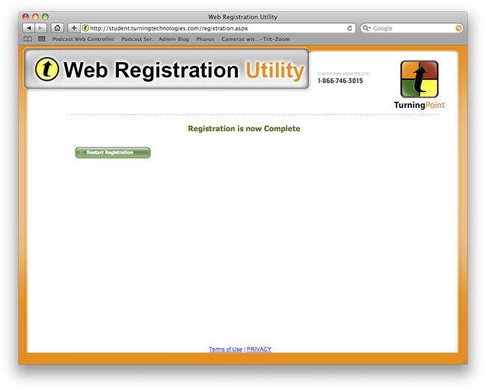
You and your device are now added to the list of students and their Device IDs in Dr H’s NATS 101 class.

If you need assistance, contact the 24/7 IT Support Center at 247.arizona.edu or 626-TECH (8324).

