A SKIT ABOUT CLIMATE CHANGE DENIAL: THE “CLIMATEGATE” INCIDENT

[Lee Learner & Stella Student, two NATS 101-GC students, enter and begin talking.]

Lee: Hey, so what ABOUT this ClimateGate thing?? I’ve heard that thousands of emails by a bunch of climate researchers were hacked a year ago and that what the emails say PROVES that global warming is a fraud – just like the deniers have been claiming!

Stella: Yeah! I was really freaked out when I heard about that last year so I went and looked up some information to get the real scoop!

Lee: Well, it’s totally bogus! I’m sure you read about that email that talked about the scientists doing this “trick” of adding in temperature records to “hide the temperature decline”! Sounds nefarious! I thought they said that the temperature was increasing!

Stella: Yeah, if you actually read the REST of the email which was sent TEN years ago, you would see that the “decline” he talks about isn’t in temperature data but is in tree-ring measurements.

Lee: But I thought tree rings were good for climate reconstructions?

Stella: Well remember from class how some trees were moisture sensitive and some were temperature sensitive and didn’t show the same trends? Well, these particular trees were becoming more moisture sensitive and they were trying to figure out why. So they DID figure it out and published a paper on that very subject two years afterwards! Here it is!

Holds out a copy of the article: K. R. Briffa, F. H. Schweingruber, P. D. Jones, T. J. Osborn, S. G. Shiyatov‡ & E. A. Vaganov (1998) Reduced sensitivity of recent tree-growth to temperature at high northern latitudes. NATURE, 39:678-682)

Lee: Oh…ok. Well- what about this using a “trick”???

Stella: Well- the trick was just using the real temperature data to correct that tree-ring problem. And even if you totally removed that whole tree-ring reconstruction- there is still more than enough evidence for warming! As you can see here in this figure- that line the red arrow is pointing to is the tree-ring record in “question”.
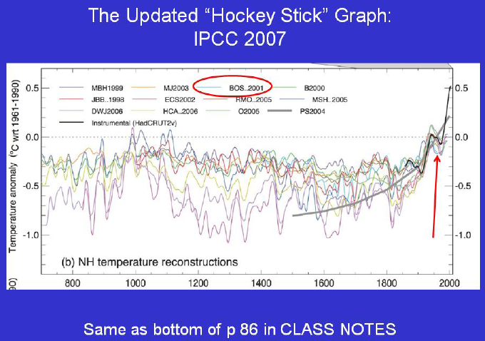

Lee: Oh! That looks like the figure from p 47 in our Dire Predictions textbook! But I see a whole bunch of other reconstruction lines on the figure that provide evidence of warming even if you take that one out! So that whole confusion was about information in an email sent more than 10 years ago which was written about at length in a public journal article?? Sheesh! [ponders for a moment]

Lee: OK -- so that makes sense. But what about that email that says “that we can’t account for the lack of warming at the moment and it is a travesty that we can’t”. Now that’s a cover-up if I’ve ever heard one!!

Stella: Yeah…. Like I said before, if you read the REST of the email, he’s talking about a specific report that shows that there should be even more warming in the Pacific but that the OBSERVING system there is inadequate to test the report’s conclusions. The “travesty” he was talking about is that we need a better observing system!
Lee: So the lack of warming was in the Pacific Ocean reports because of inadequate observing systems- I guess that is a travesty! [ponders again for a while]

Lee: Well, it’s true- we always need more data- but they’re trying to keep data out!! How about that email that talked about keeping papers that are anti-climate change out of the IPCC? That’s terrible!

Stella: Yeah, there WERE two papers that the researchers thought were so bad they should be excluded. But- the guys who sent the emails actually did NOT end up trying to keep them out of the IPCC. It’s good that they were INCLUDED because the authors of the IPCC were able to discuss what was wrong with them in the IPCC for everyone to see!

Lee: Oh, so dissenting views were included in the IPCC??

Stella: Yes- the point of the IPCC was to survey the ENTIRE body of literature on the subject- and that is what they did!

Lee: So when it came down to it, the scientists didn’t try to keep the articles out of the IPCC, and they are discussed there for everyone to see. Humpf! [ponders some more]

Lee: OK, well, what about the email that said that they were going to boycott journals that were publishing skeptical views- there’s no getting around that! The email said: “we have to stop considering Climate Research a legitimate journal and we should encourage our colleagues not to submit papers to the journal”!

Stella: Well for this, you actually need to know the background- first of all do you know how peer-review works?

Lee: Yeah, isn’t that where scientists submit a paper to a journal that will send it out to other scientists to independently review the article to see if it is actually valid science?

Stella: Totally! Well, in THIS case, that whole process broke down.

Lee: Oh no- how did that happen?
Stella: Well an article was sent to a SPECIFIC anti-global warming editor at the journal, who sent it out to be reviewed by reviewers who agreed with the paper already- and then the paper was published without the knowledge of the editor-in-chief! Then the editor-in-chief and half of the editorial board (including a dean here at the U of A) resigned in disgust! The president of that journal’s parent company even made a statement to the press that “that paper’s findings could not be concluded convincingly from the evidence provided in the paper.”

Lee: Oh! Scandalous! So this paper was bad science and the journal didn’t follow the peer-review process!

Stella: Yeah- this just goes to show you, you shouldn’t just believe the sounds bites you hear on the news without checking the whole story!!

Lee: Tell me about it! I wouldn’t want people picking through MY emails and taking things out of context like that! So, do you want to check out Netflix and see if we can get “The Day After Tomorrow?” I hear the hero is a paleoclimatologist!”

Stella: Sounds good!

==========================================

For more information:

A Wikipedia article on Climategate (recently renamed “Climatic Research Unit E-mail Controversy”) has a fairly balanced presentation of the Climategate issue. It includes additional links so you can follow up on your own. See: http://en.wikipedia.org/wiki/Climategate

For additional insights, watch: Video #6 “Climate Change --- Those Hacked Emails” and #7” Climate Change - "Those" E-mails and Science Censorship” two of several climate change YouTube videos prepared by science journalist "Potholer54"

[Skit originally written by Rebecca Franklin & Adam Csank of the LTRR]

