<http://www.nature.org/initiatives/climatechange/calculator/>

<http://coolclimate.berkeley.edu/>

<http://www.waterfootprint.org/>

The water-footprint concept is part of a larger family of concepts that have been developed in the environmental sciences over the past decade. A “footprint” in general has become known as a quantitative measure showing the appropriation of natural resources or pressure on the environment by human beings. The ecological footprint is a measure of the use of bio-productive space (hectares). The carbon footprint measures the amount of greenhouse gases produced, measured carbon dioxide equivalents (in tonnes). The water footprint measures water use (in cubic metres per year). The three indicators are complementary, since they measure completely different things. Methodologically there are many similarities between the different footprints, but each has its own peculiarities related to the uniqueness of the substance considered. Most typical for the water footprint is the importance of specifying space and time. This is necessary because the availability of water highly varies in space and time, so that water appropriation should always be considered in its local context.

**Some facts and figures**

* The production of one kilogram of beef requires 16 thousand litres of water. There is a huge variation around this global average. The precise footprint of a piece of beef depends on factors such as the type of production system and the composition and origin of the feed of the cow.
* To produce one cup of coffee we need 140 litres of water. This, again, is a global average.
* The water footprint of China is about 700 cubic meter per year per capita. Only about 7% of the Chinese water footprint falls outside China.
* Japan with a footprint of 1150 cubic meter per year per capita, has about 65% of its total water footprint outside the borders of the country.
* The USA water footprint is 2500 cubic meter per year per capita.

<http://www.waterfootprint.org/images/infographics/swf1/map_12_MayMODIF.swf>

1 lb = 16 oz = 0.45359 kg

<http://www.megaconverter.com/mega2/>

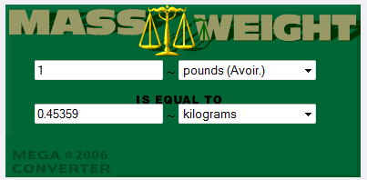

<http://www.thecalculatorsite.com/conversions/massandweight.php>

WATER FOOTPRINT

