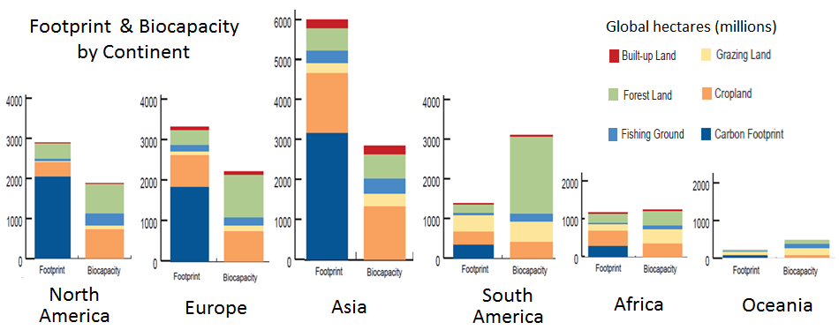Source: Ewing B., S. Goldfinger, A. Oursler, A. Reed, D. Moore, and M. Wackernagel. 2009*. The Ecological Footprint Atlas 2009.* Oakland: Global Footprint Network.