 GROUP ASSIGNMENT G-1: GROUP FOOTPRINTS & GLOBAL CHANGE
(worth 5 pts)
Before you turn in your paper, each Group Member should sign your name,
AND print your name next to your signature to indicate participation.

Select a Group Leader & Note Taker for today and sign on appropriate blue lines.

GROUP # ________ Today's Group Leader: ___________________________________

Today’s Note Taker: _____________________________________
Other members present:
___________________________________ ___________________________________

___________________________________ ____________________________________

____________________________________ ____________________________________

PART I. Enter each group member’s name & footprint data in the units indicated based on the I-1 PART A results. Then have a different member of your group total each column and enter her/his name at the bottom of that column to indicate this. (See the example for Stella, but do NOT enter her data into your sum or average)
NAME | ECOLOGICAL FOOTPRINT | # EARTHS NEEDED  Ecological  Footprint ÷Global Biocapacity | CARBON FOOTPRINT | WATER FOOTPRINT
 | global acres (ga) | Global Biocapacity = 4.5 ga | (tons of CO2 eq/year) | (m³ per year)
Stella Student | 18.4 | 4.1 | 18 | 1468
SUM OF EACH COLUMN:

AVERAGE OF EACH COLUMN:
First name of student who Computed each column:

After computing your Group’s Average Footprints, fill in this Comparison Table:

based on 2009 data | Ecological Footprint  (global acres) | Earth’s  Biocapacity  (global acres) | # Earth’s Needed | Carbon Footprint  (tons of CO₂ eq/year) | Water Footprint  (m³/cap/yr)
GLOBAL Avg | 6.4 | 4.5 | 1.4 | 5.5 | 1240
USA Avg | 22.3 | 4.5 | 5 | 27 | 2500
OUR GROUP Avg |  | 4.5

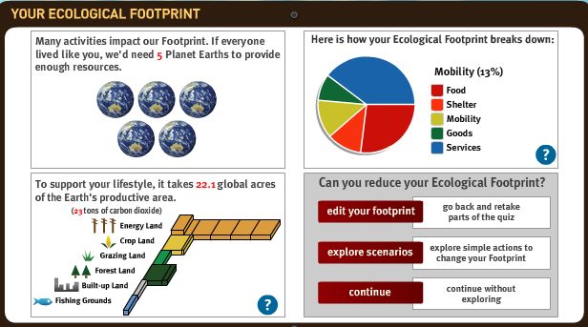
USA AVERAGE Ecological Footprint (based on 2008 data)

Recap: The Ecological Footprint calculator “represents the amount of land and sea area needed to provide
the resources a person needs (food, shelter, etc.), and absorb the wastes they create (including carbon dioxide)”
SOURCE: http://www.footprintnetwork.org/en/index.php/GFN/page/footprint_calculator_frequently_asked_questions/
In the Ecological Footprint results box above, the large amount of ‘Energy Land’ needed to support the average lifestyle of someone in the United States represents the global land area (primarily forest, but also ocean) needed to “uptake” the CO₂ “waste” emitted in the USA due to energy use (coal fire plants, auto emissions, etc.) The ‘Services’ category includes activities “ that are not considered personal, but societal. These areas include (but are not limited to) health care, entertainment, restaurants, real estate, legal services, government and the military. Everyone taking the quiz has a portion of their nation’s “services” Footprint allocated to them.
SOURCE http://www.footprintnetwork.org/en/index.php/GFN/page/footprint_calculator_frequently_asked_questions/#gen8

PART II. COMPARE YOUR GROUP’S 3 FOOTPRINT AVERAGES WITH USA AVERAGES:

(a) How do your group’s Average Ecological , Carbon & Water Footprints compare with the USA averages?

Ecological: _______________________ Carbon: ______________________ Water: __________________

(b) DISCUSS possible reasons for the differences within your group and between your group and the USA averages. You can do this by reviewing the “behavior breakdown” charts for each of the footprints to see which actions contribute most to each of your footprints. Do any common themes come up? What are the main differences between the person in your group with the smallest Footprint in each Footprint type and the person with the largest Footprint in each type? You’ll learn a lot about each other in the process!

The Note Taker should take notes during the discussion on a separate page.

PART III. COMPARE YOUR GROUP’S FOOTPRINT AVERAGES WITH GLOBAL AVERAGES:

(a) How do your group’s Average Ecological , Carbon & Water Footprints compare with the Global averages?

Ecological: _______________________ Carbon: ______________________ Water: __________________

(b) DISCUSS possible reasons for the differences between your group’s Footprints, the USA average Footprints, and the Global average Footprints.

The Note Taker should take notes during the discussion on a separate page.

(c) In the box below, summarize your discussion with 3 or 4 “bullet points” about the comparisons you made of YOUR GROUP’S 3 FOOTPRINTS, the U.S.A. Average Footprints, and the GLOBAL Average Footprints.

Please write in complete sentences or intelligent phrases (not single words). Be sure you explain possible reasons for any differences you have observed in your comparison.

The Group Leader should take charge of writing this section with input from everyone, especially the Note Taker.
Note Taker: Include your notes when you turn in your Group Form in the Group Folder.

●

●

●

●

The Group Leader & Note Taker will earn one credit toward their
GPR (Group Participation Responsibility) for today’s efforts.

