It’s all about carbon NPR

<http://www.npr.org/templates/story/story.php?storyId=9943298&ps=rs>

Climate and floods

<http://www.npr.org/templates/story/story.php?storyId=18022014>

NPR trees and GW

<http://www.npr.org/templates/story/story.php?storyId=17814049>

GEOENGINEERING – Pianatubo NPR

http://www.npr.org/templates/story/story.php?storyId=131094110

NASA Katrina & trees:

<http://learners.gsfc.nasa.gov/mediaviewer/KATRINA/>

YOU TUBES

Global Climate Change – H.S.

<http://www.youtube.com/watch?v=Zpu7IZcdzXE&feature=related>

Competitive Enterprise

CO2 friend #2

<http://www.youtube.com/watch?v=Wq_Bj-av3g0&feature=related>

GW – train

<http://www.youtube.com/watch?v=s-_LBXWMCAM&feature=related>

<http://www.youtube.com/watch?v=s-_LBXWMCAM&feature=related>

Tick

<http://www.youtube.com/watch?v=QU7BO35n47I&feature=related>

Tree:

<http://www.youtube.com/watch?v=x5THtEq2fvY&feature=related>

Australia snow globe

<http://www.youtube.com/watch?v=yRTXmURGmSY&feature=related>

award winning <http://www.youtube.com/watch?v=I9tCenQh3Rw&feature=related>

Editorial cartoon –

<http://www.youtube.com/watch?v=MoErCbT7_D4&feature=related>

BIG problem

<http://www.youtube.com/watch?v=rvKuMznpYDc&feature=related>

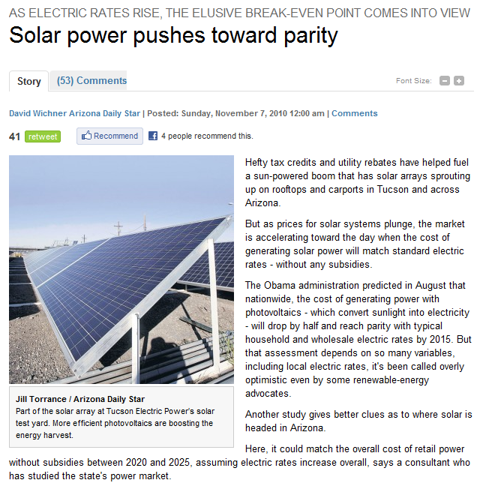

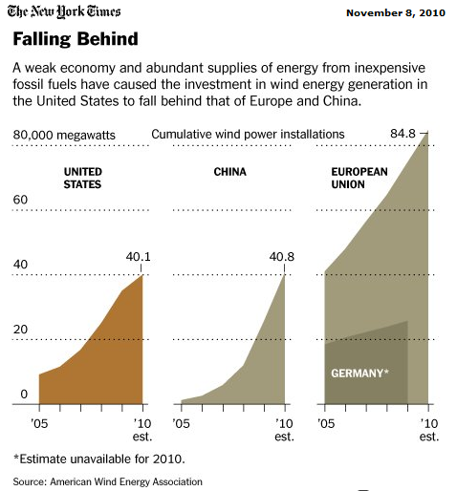

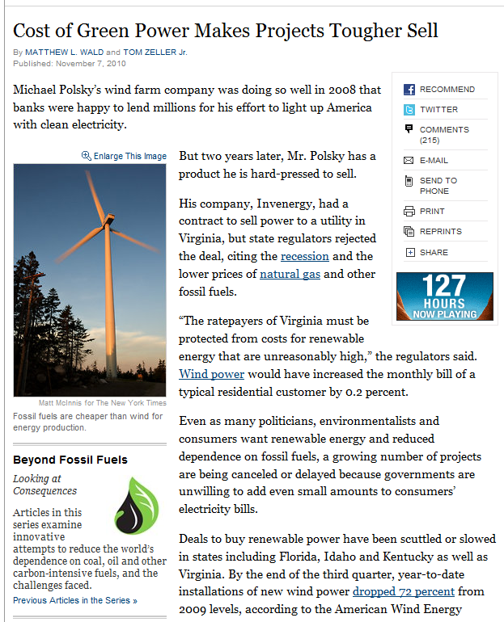

NYT 11-7-2010

