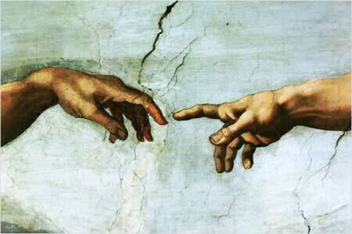
A Meditation
on
The Spirituality of Work
A PowerPoint
presentation for Our Mother of Sorrows Parish
Prepared by
by K. Hirschboeck
& the Christian Life Commission 2006
A Meditation
on
The Spirituality of Work
A PowerPoint
presentation for Our Mother of Sorrows Parish
Prepared by
by K. Hirschboeck
& the Christian Life Commission 2006
CD Title
Date
This CD Contains:

