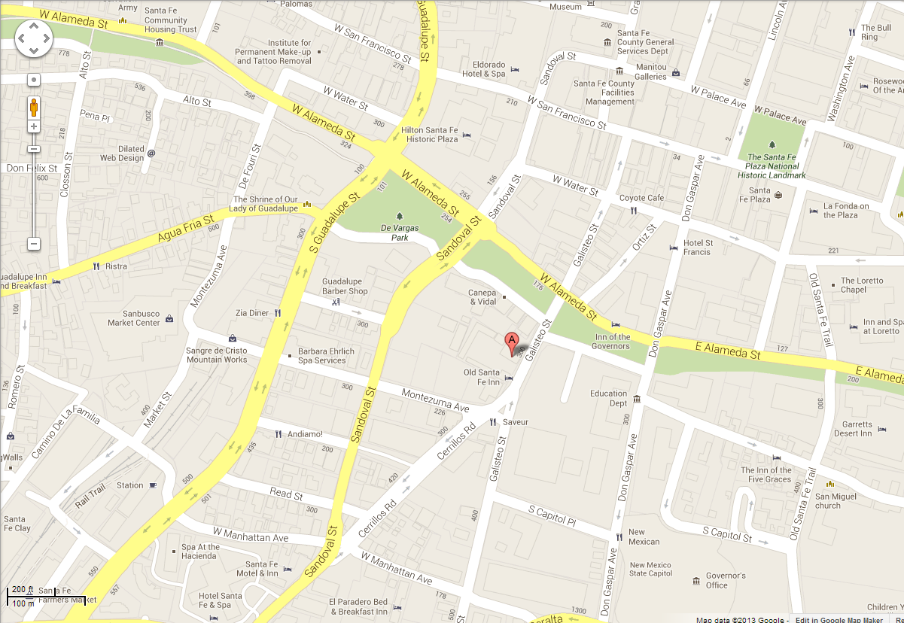
Old Santa Fe Inn 320 Galisteo Street Santa Fe, NM 87501 Front Desk: 505-995-0800
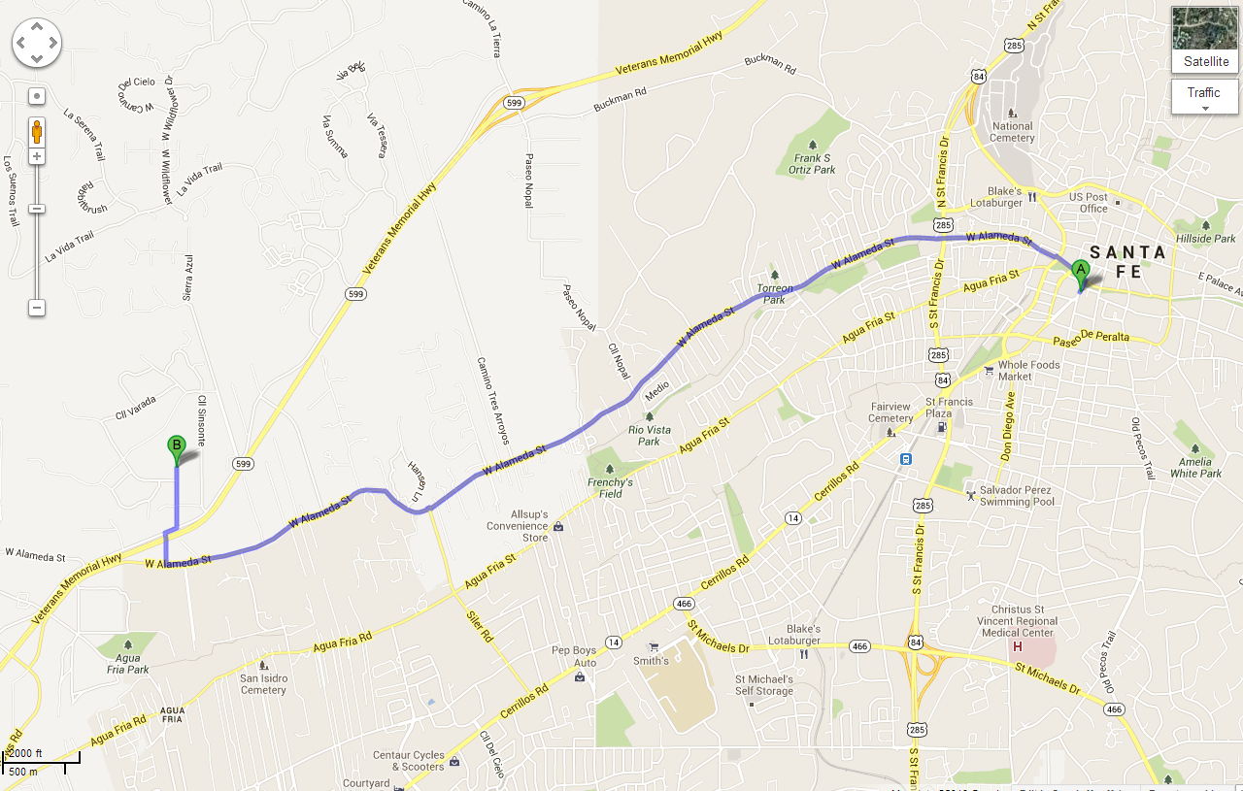
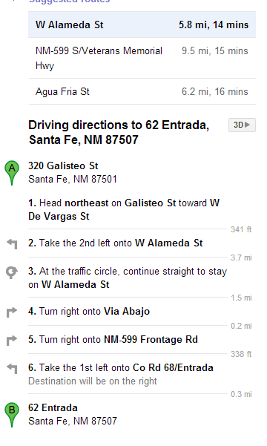

Laura & Phil Sena 62 Entrada Santa Fe, NM 87507 505-920-5009 Laura cell

