PASTORAL PLAN IMPLEMENTATION -- GENERAL IDEAS
- Booklet explaining the year’s theme mailed to all parishioners and available in vestibule
(see draft example for Year 1)
- Prayer / reflection cards highlighting various aspects of the theme in pews
(see example of Minister of Assembly Examination of Conscience)
- Lenten Mission theme is tied specifically to Pastoral Plan theme each year
- Annual Convocations of each Commission tied specifically to Pastoral Plan theme each year
- Ministries and/or commissions most directly linked to the year’s theme are charged with furthering the theme in one or more ways.
- One or two deacons assigned to a theme – get them on board
- Frequent and focused tie-in to yearly theme in homilies throughout the year.
- School activities developed to tie into yearly theme
- Film or speaker series devoted to theme throughout the year

Year 1: Worship & Welcome Ideas / Suggestions
- Worship and Welcome booklet & prayer cards in pew (see drafts)
- More focused catechesis from pulpit and choir on the role and responsibilities of the Ministry of the Assembly
- New procedure for beginning of Mass to address the tension between welcoming chatter and quiet reverence: Commentator comes out, makes the basic intro announcements (including “greet your neighbor” on hospitality Sundays) then pauses for a moment and says: “Our liturgy is about to begin. Let us take a moment to quiet ourselves and reflect on what we are about to do together as a community.” Commentator remains at ambo as assembly quiets down, perhaps as long as 1 – 2 minutes of silence. After the silence and reverence permeates the church, commentator returns to seat, signaling to the choir to begin.

- Literature rack proposal – a tie in to Worship and Welcome theme and/or bridge between Worship & Welcome and 2011-2012 theme: To Reach out to the Least
Rationale: TWO-FOLD MEANING OF THE VESTIBULE: “In and Out”
Vestibule (def) a passage, hall, or antechamber between the outer door and the interior parts of a building.

- Worship & Welcome is about welcoming members of the assembly into the interior of the church for worship and to grow in an attitude of welcoming. But the assembly is then “sent forth” through the vestibule out into the world “To witness with love” and next year specifically, “to reach out to the least.”
- We equip the people with “handbooks” / “guidebooks” for worship (missalette, music issue) for their journey into the church, but how do we equip them for their journey as pilgrims out into the world??
- A literature rack (emphasizing the 7 Themes of Catholic Social Teaching) would serve this purpose.
Logistics:
- Literature rack could be organized around 7 themes of CST
- And /or organized around commissions and ministries
- Subcommittee of CLC & CEF Commissions would be charged with maintaining it, keeping it orderly and supplied, and working out what materials would go in it.
- If installed at end of Year 1 /beginning of Year 2 (Feast of Christ the King?) it would serve as a segue from “Worship and Welcome” theme to “Reach out to the Least” theme
Possible styles . . .

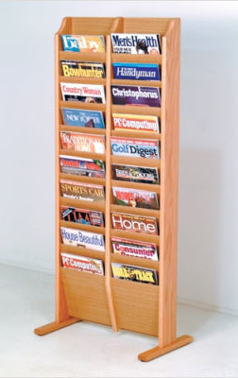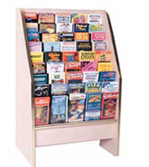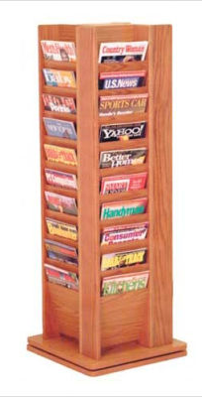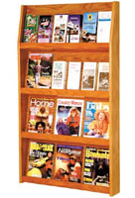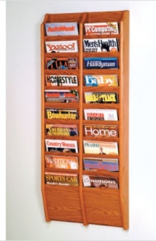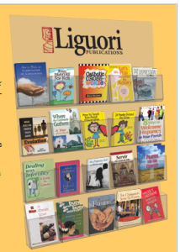

free standing racks wall racks

