We Are Sent Forth
To Witness With Love


The Christian Life Commission (CLC) consists of 26 ministries, established to serve many different needs in our parish and in the local and global communities.

“What you do
for the least of my people
you do to me.” Mt 25:40

AREA I - Community Building
Area I Ministries serve to promote the sense of fellowship among parishioners through
acts of welcoming and celebration.


“For I was a stranger
and you welcomed me."
Mt 25:35

Welcoming Committee – fosters Parish hospitality by greeting at doors and other activities

Fiesta Committee – plans and produces the annual Parish Fiesta, a weekend of friendship, fellowship, food

Ladies Guild – women who wish to follow
Christ more fully; oversees MOSES and Casa
Maria Outreach

Golden Agers – meet weekly for fellowship, cards and lunch

AREA II - Community Health & Caring

Area II Ministries in this area focus primarily on providing support for parishioners facing
problems of various types.

“Bear one another’s
burden and fulfill the
law of Christ.”
Gal 6:2

Stephen Ministry – Individuals offering pastoral care for those going through times of stress; after completing a 50-hour formation program

Bereavement Support – help for those who have lost a loved one

MOSES – hosts lunches for families after a funeral

TIHAN (Tucson Interfaith HIV/AIDS Network) --fosters HIV awareness, offers food, social occasions for HIV + persons

St. Peregrine Ministry – hosts Masses for those with cancer and venerates the patron saint of cancer victims

Eucharistic Ministers to the Homebound -- bring Holy Communion to shut-ins

Health Care & Parish Blood Drive – services by volunteer nurse and health care professionals; donor recruiting and assistance with blood drive

Parish Counseling & Legal Assistance --provides limited professional counseling or legal aid

AREA III - Charity and Outreach
Area III ministries offer outreach services
to the broader community.

"For I was hungry and you gave me food."
Mt 25:35

St. Vincent de Paul Society – provides food and other aid to those in need, within our parish boundaries


Casa Maria Outreach – makes sandwiches for Soup Kitchen; collects supplies, clothing, blankets, towels for the poor

"For I was . . naked and you clothed me."
Mt 25:36

Primavera Group – cooks a hot meal and provides lunches for the homeless

Blessed Nuno Society - fosters prayer and maintains projects and facilities for orphaned children, especially border orphans

Knights of Columbus – serves youth, the disadvantaged and many other needs throughout the community through a family-oriented fraternal service organization (Regina Cleri Chapter)
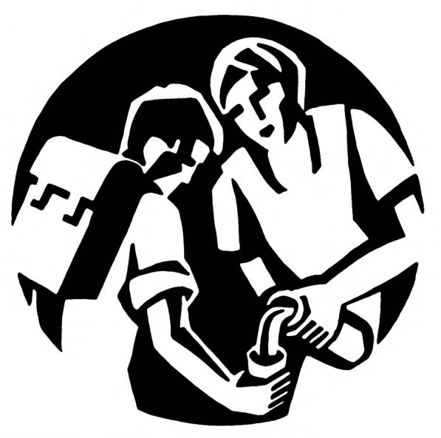
"I was thirsty and you gave me drink"
Mt 25:35
Area IV - Solidarity and Social Change
The ministries in this area engage in activities that promote justice and peace on a wider scale.

“Kindness & truth will meet;
justice & peace shall kiss." Ps 85:11

Just Faith – Intensive 30-week program to
develop consciousness of social justice by reflection, study, prayer, community

PCIC (Pima County Interfaith Council --build
relational power for collective actions in pursuit of justice and the common good

Detention Ministry – visit local prisons to offer
prayer, Scripture services and Holy Communion

Habitat For Humanity – works to end poverty
housing by creating opportunities for homeownership for low-income families

The Haiti Project – offers spiritual, financial and missionary support for the people of NW Haiti in our “twinning” parish, San François, and beyond.

Peregrinos Juntos – prays for just solutions to immigration and border issues and sponsors sale of Café’ Justo (JustCoffee).

Consistent Ethic Of Life – treasures and advocates for life in all its forms and honors the dignity of all persons

Care For Creation Committee -promotes good stewardship of God’s gift of creation and
advocates for environmentally sound practices
Artwork in this brochure is by Ade Bethune, a world-renowned liturgical artist, writer, and social activist who illustrated for The Catholic Worker. Used with permission from The College of St. Catherine, St. Paul MN, where the Ade Bethune collection is archived.
THE CLC VISION & MISSION

Anchored in prayer and worship and formed through preaching, education and reflection, the people of our parish engage in the Church’s social mission of charity, justice and peace within the framework of the Christian Life Commission, celebrating the fact that the Holy Spirit calls and speaks to each of us in our everyday lives.
The Commission supports and fosters efforts within the parish to fulfill the Church's social mission by responding in an organized way to individual and societal needs.

Within and beyond the parish, the Commission enriches the dimensions of faith, family, and social life through its I. Community Building and II. Community Health & Caring ministry areas. The Commission engages in outreach services and activities that promote charity, justice and peace through its III. Charity & Outreach and IV. Social Change & Solidarity ministry areas.

By these means, the Christian Life Commission seeks to build Our Mother of Sorrows Parish into a community of faith where all believers are challenged to bring God's charity, justice, and peace to a world in desperate need of the salt of the gospel and the light of Catholic teaching.

You can find more information on our CLC website www.omosclc.org or call the parish office at 747-1321 to request a follow-up phone call or personal contact from a CLC member.

“To Love is to Serve”

The Christian Life
Commission


Ministry Guide

Through grace in community,
we are called to image
the face of God to one another
in times of suffering,
times of joy,
times of giving
and times of receiving.

Our Mother of Sorrows Parish
www.omosclc.org

