TO WORSHIP & WELCOME
A PILGRIM’S GUIDE TO THE MASS
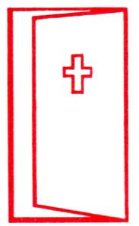
OPEN OUR DOORS, OPEN OUR HEARTS. We, as parishioners, enter the Church and slowly begin to assemble for Mass. Our church building is a constant reminder that what people don't have in their own homes they do have here in God's house. It provides shelter, a prayerful place, a place of peace and fellowship. This holy place is a challenge to recognize the sacredness of each parishioner's home and the lack of housing of so many.
People enter and sit where they may. Different ethnic and economic groups sit side by side in the same pew. In God's eyes we are all equal as human beings. We all have a place at the table of the Lord and are called to a common sense of awe and worship that for a brief moment transcends economic and ethnic differences.
Would that it were that way outside of our church? When we leave the building are we equal? Only in the church can we all come and find rest and refuge. In our city, many are homeless and without a place to stay warm. In our state, many are not welcome.
Would that our city and state could be more welcoming to those who find themselves on the streets and live as strangers in our midst. Our Church might be the only place where people are truly welcomed. Do I participate in that welcoming?
THE SIGN OF THE CROSS & PENITENTIAL RITE. Mass begins in the usual way. In the name of the Trinity we are welcomed and confess that we are all sinners and in need of God's forgiveness. We begin this celebration with an admission of our common humanity. In words and gestures and song, we proclaim our humanity and God's divinity, our frailty and God's mercy. Once again, we are all leveled by our own admission of our common humanity.
THE TABLE OF THE WORD. The readings and homily in the Liturgy of the Word are the common education that we all share. Our parish is diverse. For many of us what we hear at Mass is the only real education we will have. It is not enough. We want more both as children and as adults.
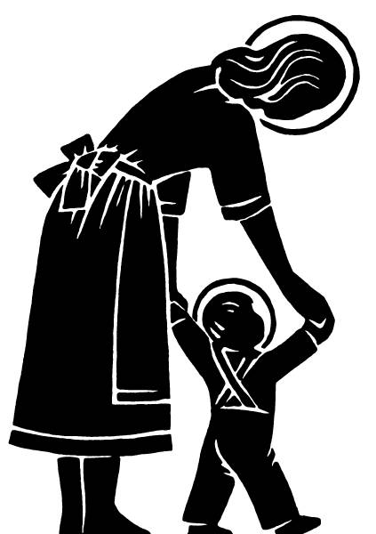
We look at the children. In the parish, we are blessed to have our school and religious education program. But we think about those children who are in the public school system and who will be seriously affected by the budget cuts at the State level. Will our children be properly prepared for their future? Will our young adults who are the future of our church and country be well educated because of the state budget cuts at the college and University level?
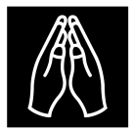
THE PRAYERS OF THE FAITHFUL. After our common profession of faith, we lift up our petitions to the Lord. We are invited to speak out our needs. Where else can all of us be heard? People are often not listened to. They are shunned. But here in this church, at this moment, people are ready to listen and to pray for everyone's concerns. For a brief moment, we listen, and we all pray for each other. I am grateful to be part of a universal Church because we always pray not only for those in our community, but for those throughout the world. What a privilege to be reminded of the larger world I am part of. Outside of the church, who is there to listen to us, especially the poor?
THE OFFERING OF GIFTS. Mass continues. We take up the collection and bring up the gifts. Each gives according to their conscience and ability. While the collection is a public act, there is no public embarrassment of those who give little or undue attention to those who give a lot.
Outside the church there is no such consideration of personal dignity. Our society values people who earn the highest salaries. We judge a person's worth by their income. The cost of living escalates and families fall further and further behind. Where is their dignity? I think of the families our parish. Many with two and three paychecks continue to live in poverty because of lack of skills and low wages. Who creates an economy that responds to their need?
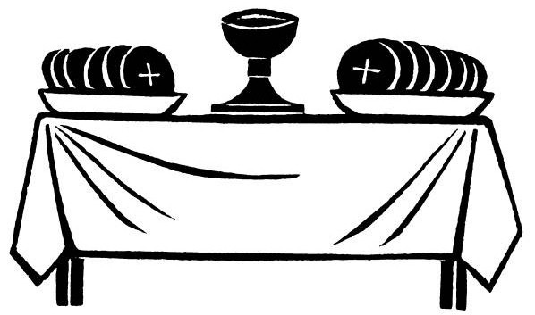
THE TABLE OF THE EUCHARIST. The gifts that are presented to the priest are the gifts of bread and wine. Bread and wine do not occur in nature; they are the fruit of human hands. The families that represent our community are proud to present the gifts in our name. When they are presented to the celebrant, the celebrant prays that they may become the body and the blood of Christ -- that those whom the gifts of bread and wine represent--all of us-- may become the body and blood of Christ.
THE EUCHARISTIC PRAYER. We proceed to the central part of our Mass. The great prayer of thanksgiving reminds us of those simple words uttered by Jesus to his Father. Is there any way to comprehend the mystery of the gift of life freely given for the sake of others? Who are we that God cares so much that He would send his son Jesus to die for us? Who are we that God loves us infinitely more than any other love we have experienced?
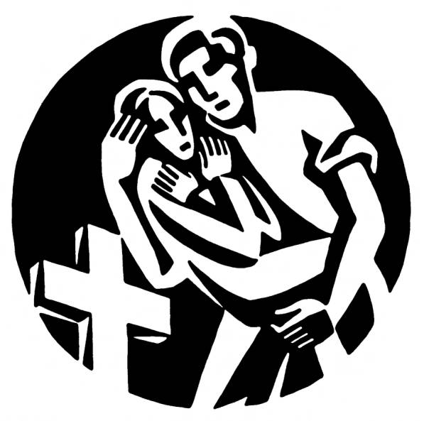
I try to understand this in the lives I see around me. Where does that come from, the willingness to give one's life for others? A woman spends her youth caring for her children; a man sacrifices his wants that his family might have a better future; and we, as children and adults, can only say “thank you” in profound gratitude for their love and sacrifice. A young soldier in war saves the life of his friends. Why does he do that? He does not know them that well. What I experience here is so different than what the world teaches and how it lives. I reflect on the narcissism and greed, the selfishness and cold indifference to the needs of others that I see around me during the week. We see the poor of the world die on television and change the channel.
The Mass reminds me that Christ is neither a painting not plaster nor wood, but flesh and blood and lives in our midst though us. He calls us to community, to care for others. Once more I am grateful for the example that Jesus has set for all of us in how we are to live where we are to find our salvation.
THE LORD’S PRAYER & THE SIGN OF PEACE. Mass continues with the Lord's Prayer--that bold proclamation that summarizes the whole of the good news and the challenge of Jesus to proclaim our loyalty to the God of heaven and our commitment to make his will be done on earth. The congregation stands together and proclaims as a community that they accept the invitation to be the body and the blood of Christ, i.e., the historical continuation of the mission of Jesus, which is the Kingdom of God.
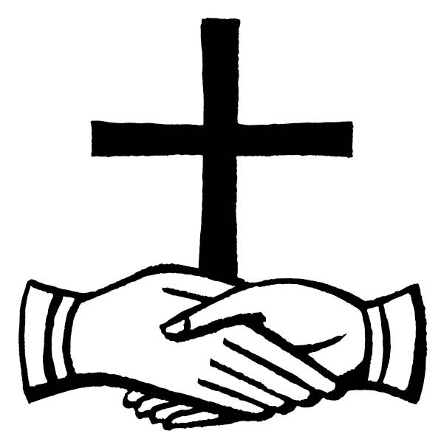
His will is our sustenance (our daily bread), our peace with each other (forgiveness) and our freedom from evil and all that tempts us to egoism. We say “Our Father” reminding us that we are brothers and sisters. For one brief moment, unlike what happens outside of the Eucharist, we hold hands and say yes we really are a family. What a prophetic testimony to the rest of the world! Together with the sign of peace, this brief moment dares to proclaim a common humanity acknowledging a common creator.
THE COMMUNION RITE. We see people line up to receive communion. As the Eucharistic ministers gather, we are reminded that we are not alone in this work of the Lord's Supper. Many ministers bring this celebration into a new reality. We think about several of them. The lector has been out of work for several months. Every Sunday he puts on his coat and tie and has a job. There is work for everyone at the Lord's table. We pray that this atmosphere could exist in the rest of our society. In Arizona many are out of work, many more don't have the skills for the jobs that do exist. Do we take the same care to help people get the education and skills they need for work outside the church?
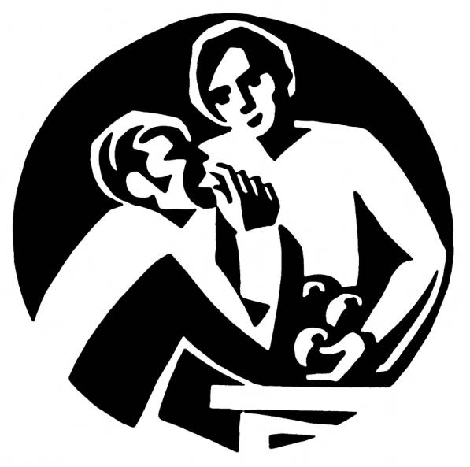
We receive the body of Christ, the blood of Christ. No one goes away hungry. To receive Holy Communion we simply stand up, get in line and come to the minister. We think about the poor and those in need who are subjected to a host of questions to determine if they are needy enough to receive food, clothing or assistance. We thank God that He does not judge us in the same way. We thank God that our parish ministers to their physical, emotional, economic, and spiritual needs.

WE ARE SENT FORTH. We end the Mass, being sent forth to "love and serve the Lord." To love and serve the Lord is to celebrate the Eucharist outside of Mass with the same fervor and intensity as we do inside of church. The Eucharist is a prophetic challenge to us to care for our people and their needs not just within our community, but throughout the world. We are sent forth to care for their spiritual needs, their housing needs, their educational needs, their economic needs, and their physical and social needs.
The community is "sent forth” to live the Eucharist so that the reign of God may be realized in our community, our nation and our world.
We are sent forth . . . Witness with Love.

