FINAL PRAYER EXPERIENCE
To Worship & Welcome

We envision a reverent and welcoming Eucharistic community in our common call to holiness, aware of its role as a priestly people in relationship with God and with one another, and actively involved in liturgical and sacramental celebrations as Ministers of the Assembly.

- Through the Eucharistic celebration and its ‘sending forth,’ those who worship here are called to live the liturgy as the source and summit of the life of the Church.

- Each person and family who enters the church for liturgy are to be respected as full, conscious, active participants, essential to the Eucharistic celebration.

- A spirit of welcome and hospitality is extended to, and by all, who participate in the liturgy.

How comfortable am I with the idea of worship and welcome at the Mass and other communal liturgies?

How much attention do I pay to those around me when I participate in the Mass and other liturgies?


What are one or two actions that I might wish to take to become more welcoming to those around me when we come together for prayer and worship?
[ Write your ideas on the index card, which will be collected. Please print or write clearly.]

NOTES
OPEN OUR EYES,
LORD
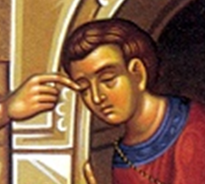

“One thing I do know
is that I was blind
and now I see.”

Jn 9:25

Christian Life Commission Areas I & II
Morning of Reflection
Convocation
2 April 2011
MORNING OF REFLECTION
SCHEDULE
You are invited to enter into the quiet of this Morning of Reflection

8:30 Mass in Church
9:10 Refreshments in PAC Dining Room
9:20 Assemble in PAC Auditorium
Welcome [ Katie Hirschboeck]
Blessing for the Morning [Msgr Tom]
9:30 Opening song
Introduction to the Parable [ Helen Devries]
10:00 Period of quiet personal reflection [ 60 minutes ]
11:00 Return to Auditorium for Sharing
11:30 Prayer experience on Worship & Welcome [ Helen DeVries ]
12:15 Closing song

OPENING & CLOSING SONG

Open My Eyes
Words and Music by Jesse Manibusan ©

1. Open my eyes, Lord.  Help me to see your face.  Open my eyes, Lord.  Help me to see.  2. Open my ears, Lord.  Help me to hear your voice.  Open my ears, Lord.  Help me to hear.  3. Open my heart, Lord.  Help me to love like you.  Open my heart, Lord.  Help me to love. | And the first shall be last,  and our eyes are opened,  and we'll hear like never before.  And we'll speak in new ways,  and we'll see God's face  in places we've never known.  4. I live within you.  Deep in your heart, O Love.  I live within you.  Rest now in me.

- 2 -

- 1 -

6) How well do I balance my family responsibilities with my ministry service? What are the considerations I must address?

7) How open am I to the ways in which God reveals himself to me
in my ministry?

8) How willing am I to go where God may lead me beyond the simple facts of people’s needs to the more difficult area of the systems that perpetuate those needs?

That
The
By pain too great to understand,
And shoulders those too weak to stand.
Compassion is the Shepherd’s name:
Who from the halls of heaven came
To travel landscapes bare and bleak
For those that only love would seek.
- 6 -

3) “What is my attitude toward the people I minister to?
Do I recognize only their needs or do I see the whole person?”

4) What is the main concern of our group ministry. . . taking care of people’s needs as efficiently as possible or treating them in a way that allows them to maintain their dignity?”

5) How aware am I of my family’s reaction to my service in ministry,
of whether they may resent the time I spend in helping others
rather than them?

- 2 -
- 5 -
THE MAN BORN BLIND
JOHN 9:1-38
As Jesus passed by he saw a man blind from birth. His disciples asked him, “Rabbi, who sinned, this man or his parents, that he was born blind?” Jesus answered, “Neither he nor his parents sinned; it is so that the works of God might be made visible through him. We have to do the works of the one who sent me while it is day. Night is coming when no one can work. While I am in the world, I am the light of the world.”
When he had said this, he spat on the ground and made clay with the saliva, and smeared the clay on his eyes, and said to him, “Go wash in the Pool of Siloam” (which means Sent).
So he went and washed, and came back able to see.
His neighbors and those who had seen him earlier as a beggar said, “Isn’t this the one who used to sit and beg?” Some said, “It is, “ but others said, “No, he just looks like him.” He said, “I am.” So they said to him, “How were your eyes opened?” He replied, “The man called Jesus made clay and anointed my eyes and told me, ‘Go to Siloam and wash.’ So I went there and washed and was able to see.” And they said to him, “Where is he?” He said, “I don’t know.”
They brought the one who was once blind to the Pharisees. Now Jesus had made clay and opened his eyes on a sabbath. So then the Pharisees also asked him how he was able to see. He said to them, “He put clay on my eyes, and I washed, and now I can see.” So some of the Pharisees said, “This man is not from God, because he does not keep the sabbath.” But others said, “How can a sinful man do such signs?” And there was a division among them. So they said to the blind man again, “What do you have to say about him, since he opened your eyes?” He said, “He is a prophet.”
Now the Jews did not believe that he had been blind and gained his sight until they summoned the parents of the one who had gained his sight. They asked them, “Is this your son, who you say was born blind? How does he now see?” His parents answered and said, “We know that this is our son and that he was born blind. We do not know how he sees now, nor do we know who opened his eyes. Ask him, he is of age; he can speak for himself.” His parents said this because they were afraid of the Jews, for the Jews had already agreed that if anyone acknowledged him as the Christ, he would be expelled from the synagogue. For this reason his parents said, “He is of age; question him.”
- 2 -
So a second time they called the man who had been blind and said to him, “Give God the praise! We know that this man is a sinner.” He replied, “If he is a sinner, I do not know. One thing I do know is that I was blind and now I see.”
So they said to him, “What did he do to you? How did he open your eyes?” He answered them, “I told you already and you did not listen. Why do you want to hear it again? Do you want to become his disciples, too?”
They ridiculed him and said, “You are that man’s disciple; we are disciples of Moses! We know that God spoke to Moses, but we do not know where this one is from.” The man answered and said to them, “This is what is so amazing, that you do not know where he is from, yet he opened my eyes. We know that God does not listen to sinners, but if one is devout and does his will, he listens to him. It is unheard of that anyone ever opened the eyes of a person born blind. If this man were not from God, he would not be able to do anything.” They answered and said to him, “You were born totally in sin, and are you trying to teach us?” Then they threw him out.
When Jesus heard that they had thrown him out, he found him and said, “Do you believe in the Son of Man?” He answered and said, “Who is he, sir, that I may believe in him?” Jesus said to him, “You have seen him, the one speaking with you is he.”He said, “I do believe, Lord,” and he worshiped him.
JOHN 9:1-38
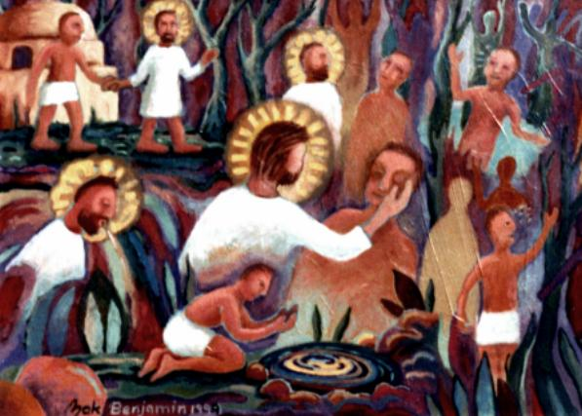
- 4 -
- 3 -
So he went and washed,
and came back able to see.
Jn 9:11

REFLECTION QUESTIONS:

- How did your service in ministry grow from your response to being able to see Jesus as he truly is?

- In what ways have you encountered opposition to your new understanding of God's nature?

