OPEN OUR EYES,
OPEN OUR HEARTS
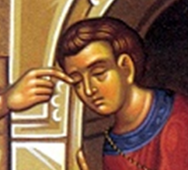
“One thing I do know
is that I was blind and now I see.”

God, help us to see and welcome you
In all who worship you as Lord of their lives,
In all who celebrate your sacrifice of Love,
In all who come to us for aid,
In all who minister to those in need,
In all who are lost and longing to be found,
In all who do not know your name
but hunger for your love.

Amen
OPEN OUR EYES,
OPEN OUR HEARTS
“One thing I do know
is that I was blind and now I see.”

God, help us to see and welcome you
In all who worship you as Lord of their lives,
In all who celebrate your sacrifice of Love,
In all who come to us for aid,
In all who minister to those in need,
In all who are lost and longing to be found,
In all who do not know your name
but hunger for your love.

Amen

OPEN OUR EYES,
OPEN OUR HEARTS
“One thing I do know
is that I was blind and now I see.”

God, help us to see and welcome you
In all who worship you as Lord of their lives,
In all who celebrate your sacrifice of Love,
In all who come to us for aid,
In all who minister to those in need,
In all who are lost and longing to be found,
In all who do not know your name
but hunger for your love.

Amen
OPEN OUR EYES,
OPEN OUR HEARTS
“One thing I do know
is that I was blind and now I see.”

God, help us to see and welcome you
In all who worship you as Lord of their lives,
In all who celebrate your sacrifice of Love,
In all who come to us for aid,
In all who minister to those in need,
In all who are lost and longing to be found,
In all who do not know your name
but hunger for your love.

Amen

