TO WORSHIP & WELCOME
The opening of a door has forever been treated
as a symbol of welcome and acceptance;
a symbol of opening to the possibilities and new hope
offered by the person standing before us,
seeking entrance into our hearts.

Unless the doors of our hearts are open
to the presence of God in those around us,
How can the King of Glory enter in?
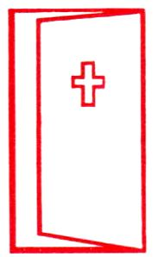

O gates, lift high your heads;
grow higher, ancient doors.
Let him enter, the King of Glory!
Ps 24:7

TO WORSHIP & WELCOME
The opening of a door has forever been treated
as a symbol of welcome and acceptance;
a symbol of opening to the possibilities and new hope
offered by the person standing before us,
seeking entrance into our hearts.

Unless the doors of our hearts are open
to the presence of God in those around us,
How can the King of Glory enter in?

O gates, lift high your heads;
grow higher, ancient doors.
Let him enter, the King of Glory!
Ps 24:7

TO WORSHIP & WELCOME
The opening of a door has forever been treated
as a symbol of welcome and acceptance;
a symbol of opening to the possibilities and new hope
offered by the person standing before us,
seeking entrance into our hearts.

Unless the doors of our hearts are open
to the presence of God in those around us,
How can the King of Glory enter in?

O gates, lift high your heads;
grow higher, ancient doors.
Let him enter, the King of Glory!
Ps 24:7

TO WORSHIP & WELCOME
The opening of a door has forever been treated
as a symbol of welcome and acceptance;
a symbol of opening to the possibilities and new hope
offered by the person standing before us,
seeking entrance into our hearts.

Unless the doors of our hearts are open
to the presence of God in those around us,
How can the King of Glory enter in?

O gates, lift high your heads;
grow higher, ancient doors.
Let him enter, the King of Glory!
Ps 24:7

