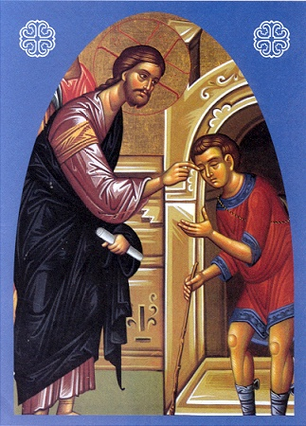
Then Jesus said,
"I came into this world for judgment,
so that those who do not see might see,
and those who do see might become blind."
Jn 9:39

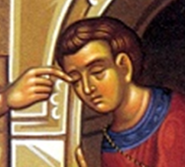

“One thing I do know
is that I was blind
and now I see.”

Jn 9:25

Christian Life Commission
Morning of Reflection
April 2, 2011
MORNING OF REFLECTION
SCHEDULE

8:30 Mass
9:15 Refreshments in dining room
9:30 Welcome/opening prayer
9:40 Introduction
9:50 Input for reflection
10:10 Quiet personal reflection
11:00 Sharing in small groups
11:35 Prayer experience
11:55 Closing prayer



OPENING SONG

YOU ARE MINE LYRICS
DAVID HAAS

i will come to you in the silence
i will lift you from all your fear
you will hear my voice
i claim you as my choice
be still, and know i am near

i am hope for all who are hopeless
i am eyes for all who long to see
in the shadows of the night,
i will be your light
come and rest in me

refrain:

Do not be afraid, i am with you
I have called you each by name
Come and follow me
I will bring you home
I love you and you are mine

I am strength for all the despairing
Healing for the ones who dwell in shame
All the blind will see, the lame will all run free
And all will know my name
refrain

i am the word that leads all to freedom
i am the peace the world cannot give
i will call your name, embracing all your pain
stand up, now, walk, and live
refrain

OVERARCHING VISION
of the
CHRISTIAN LIFE COMMISSION
Parishes are called
to help people live their faith in the world;
to help them understand and act on the social dimension
of the gospel in their everyday lives as they live their roles as:
parents, friends, workers, students, owners, investors,
citizens, caregivers, advocates, policy makers, and
members of both local and global communities.
Through grace, in community,
we are called to image the face of God
to one another in times of suffering, times of joy,
times of giving, and times of receiving.

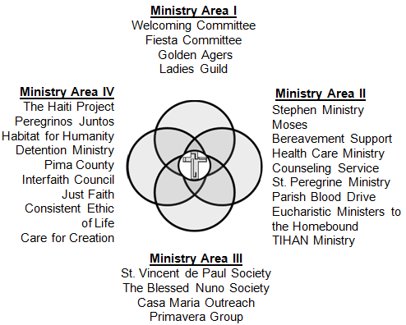
- 9 -
- 2 -
A Lord’s Prayer for Justice
- 3 -
- 8 -

Our Father who art in heaven . . . who always stands with the weak, the poor, the abandoned, the sick, the aged, the very young, the unborn and those who, by circumstance, bear the heat of the day.
Hallowed be thy name . . . may we acknowledge your holiness, respecting that your ways are not our ways, your standards are not our standards. May the reverence we give your name pull us from the selfishness that prevents us from seeing our neighbor’s pain.
Your will be done on earth as it is in heaven . . . may the work of our hands, the temples and structures that we build in the world, reflect the temple and the structure of your glory so the joy, graciousness, tenderness and justice of heaven will show forth within all our structures on earth.
Give us . . . life and love and help us to see always everything as gift. Help us to know that nothing comes to by right and that we must give because we have been given to. Help us realize that we must give to the poor, not because they need it, but because our own health depends on our giving to them.
This day . . . not tomorrow. Do not let us push things off into some indefinite time so we can continue to live justified lives in the face of injustice because we can make excuses for our own inactivity.
Our daily bread . . . so that each person in the world may have enough food, enough clean water, enough clean air, adequate health care and sufficient access to education so as to have the substance for a healthy life. Teach us to give from our sustenance and not just from our surplus.
Forgive us our trespasses . . . forgive us our blindness toward our neighbor, our self-preoccupation, our racism, our sexism and our propensity to worry only about ourselves and our own. Forgive us our capacity to watch the evening news and do nothing about it.
As we forgive those who trespass against us . . . help us to mellow in spirit and to not grow biter with age, to forgive the imperfect parents and system that wounded, cursed and ignored us.
And do not put us to the test . . . do not judge us only by whether we have fed the hungry, given clothing to the naked, visited the sick or tried to mend the system that victimized the poor. Spare us the test for none of us can stand before your gospel scrutiny. Give us, instead, more days to mend our ways, selfishness and systems.
But deliver us from evil . . . from the blindness that lets us continue to participate in anonymous systems within which we need not see who gets less as we get more.
Amen 
(Adapted from The Holy Longing by Fr. Ronald Rolheiser)
- 4 -

5) Although I desire God’s mercy for me , am I angered by his generosity toward others I may think do not deserve it?

6) How willing am I to reach out to and cooperate with the efforts or those who do not agree with my viewpoint and actions?
THE MAN BORN BLIND
- 7 -
As Jesus passed by he saw a man blind from birth. His disciples asked him, “Rabbi, who sinned, this man or his parents, that he was born blind?” Jesus answered, “Neither he nor his parents sinned; it is so that the works of God might be made visible through him. We have to do the works of the one who sent me while it is day. Night is coming when no one can work. While I am in the world, I am the light of the world.” When he had said this, he spat on the ground and made clay with the saliva, and smeared the clay on his eyes, and said to him, “Go wash in the Pool of Siloam” —which means Sent—. So he went and washed, and came back able to see.
His neighbors and those who had seen him earlier as a beggar said, “Isn’t this the one who used to sit and beg?” Some said, “It is, “ but others said, “No, he just looks like him.” He said, “I am.” So they said to him, “How were your eyes opened?” He replied, “The man called Jesus made clay and anointed my eyes and told me, ‘Go to Siloam and wash.’ So I went there and washed and was able to see.” And they said to him, “Where is he?” He said, “I don’t know.”
They brought the one who was once blind to the Pharisees. Now Jesus had made clay and opened his eyes on a sabbath. So then the Pharisees also asked him how he was able to see. He said to them, “He put clay on my eyes, and I washed, and now I can see.” So some of the Pharisees said, “This man is not from God, because he does not keep the sabbath.” But others said, “How can a sinful man do such signs?” And there was a division among them. So they said to the blind man again, “What do you have to say about him, since he opened your eyes?” He said, “He is a prophet.”
Now the Jews did not believe that he had been blind and gained his sight until they summoned the parents of the one who had gained his sight. They asked them,
“Is this your son, who you say was born blind? How does he now see?”
His parents answered and said, “We know that this is our son and that he was born blind. We do not know how he sees now, nor do we know who opened his eyes.
Ask him, he is of age; he can speak for himself.” His parents said this because they were afraid of the Jews, for the Jews had already agreed that if anyone acknowledged him as the Christ, he would be expelled from the synagogue. For this reason his parents said, “He is of age; question him.”
So a second time they called the man who had been blind and said to him, “Give God the praise! We know that this man is a sinner.” He replied,
“If he is a sinner, I do not know. One thing I do know is that I was blind and now I see.” So they said to him, “What did he do to you? How did he open your eyes?”
He answered them, “I told you already and you did not listen. Why do you want to hear it again? Do you want to become his disciples, too?” They ridiculed him and said, “You are that man’s disciple; we are disciples of Moses! We know that God spoke to Moses, but we do not know where this one is from.” The man answered and said to them, “This is what is so amazing, that you do not know where he is from, yet he opened my eyes. We know that God does not listen to sinners, but if one is devout and does his will, he listens to him. It is unheard of that anyone ever opened the eyes of a person born blind. If this man were not from God, he would not be able to do anything.” They answered and said to him,
“You were born totally in sin, and are you trying to teach us?” Then they threw him out.
When Jesus heard that they had thrown him out, he found him and said, “Do you believe in the Son of Man?” He answered and said, “Who is he, sir, that I may believe in him?” Jesus said to him, “You have seen him, the one speaking with you is he.” He said, “I do believe, Lord,” and he worshiped him. Then Jesus said,
“I came into this world for judgment, so that those who do not see might see,
and those who do see might become blind.”
Some of the Pharisees who were with him heard this and said to him, “Surely we are not also blind, are we?” Jesus said to them,“ If you were blind, you would have no sin; but now you are saying, ‘We see,’ so your sin remains.
JOHN 9:1-41

Reflection Questions:
- 4 -

1) How often am I challenged by the magnitude and complexity of problems in my daily life and ministry that call for my compassion?

2) To what degree is my compassion affected by what I perceive to be the worthiness and gratitude of those who receive it?

3) How well do I understand and support the need for both charity and social justice in God’s mission of compassionate service?
- 5 -

4) In what ways may I offer my service to those in need more a means of earning God’s love rather than sharing in his joy?

- 6 -

