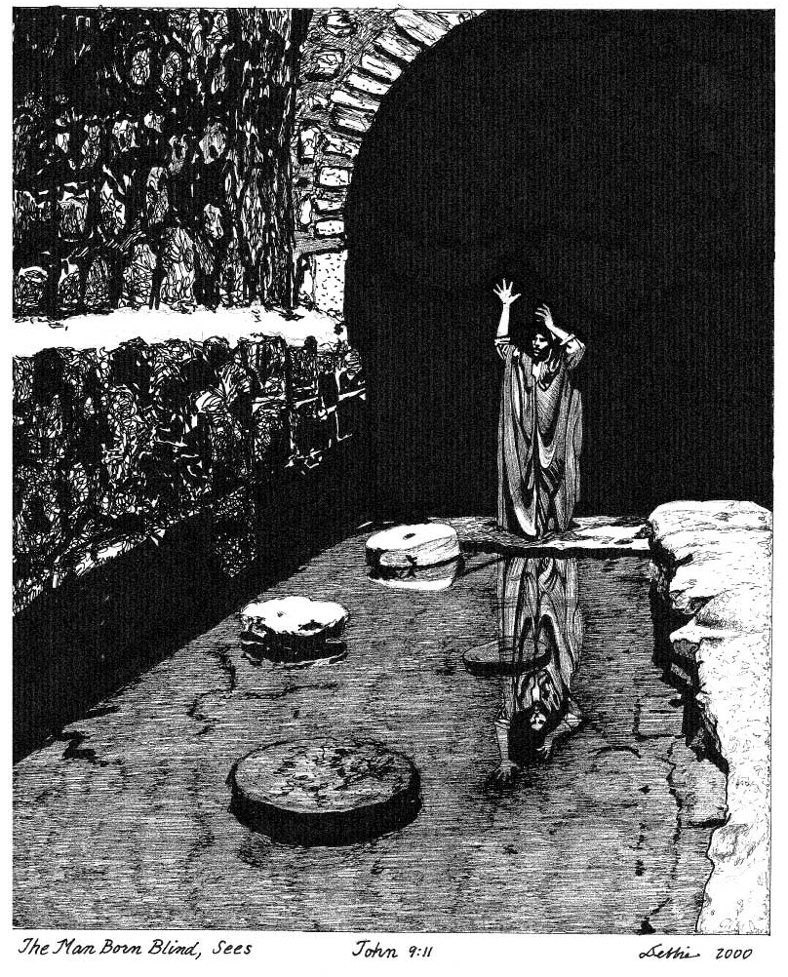
The man called Jesus made clay
and anointed my eyes and told me,
'Go to Siloam and wash.'
So I went there and washed and
was able to see."
Jn 9:11

OPEN OUR EYES
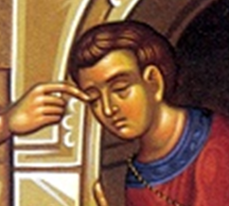

“One thing I do know
is that I was blind
and now I see.”

Jn 9:25

Christian Life Commission
Morning of Reflection
Convocation
2 April 2011
OVERARCHING VISION
of the
CHRISTIAN LIFE COMMISSION
Parishes are called
to help people live their faith in the world;
to help them understand and act on the social dimension
of the gospel in their everyday lives as they live their roles as:
parents, friends, workers, students, owners, investors,
citizens, caregivers, advocates, policy makers, and
members of both local and global communities.
Through grace, in community,
we are called to image the face of God
to one another in times of suffering, times of joy,
times of giving, and times of receiving.

- 9 -
Ministry Area I
Welcoming Committee
Fiesta Committee
Golden Agers
Ladies Guild
Ministry Area IV  Just Faith  Peregrinos Juntos  The Haiti Project  Habitat for Humanity  Detention Ministry  Pima County Interfaith  Council (PCIC)  Care for Creation  Consistent Ethic  of Life |  | Ministry Area II  Stephen Ministry  Moses  Bereavement Support  Health Care Ministry  Counseling Service  St. Peregrine Ministry  Parish Blood Drive  Eucharistic Ministers to  the Homebound  TIHAN Ministry
Ministry Area III
St. Vincent de Paul Society
The Blessed Nuno Society
Casa Maria Outreach
Primavera Group
Knights of Columbus

- 1 -
Compassion walks the city streets
And listens for uncertain feet
That CLOSING PRAYER
Any Ideas???
t a home they cannot find
Because the heart that leads is blind.
Compassion holds a steady light
To show the way through chill of night
And takes the homeless by the hand
To guide them to a warmer land.
Compassion walks the prison halls
in search of those affliction walls
In hopelessness beyond despair
Because no voice speaks solace there.
Compassion breaks the bars and locks
To forge a path through all that blocks
The way to every lonely cell,
Where anguish pines in silent hell.
Compassion walks the empty waste
Where dust and ash are all they taste
Who lose their way in barrenness
And eat the bread of bitterness.
Compassion sets a table there
With bread and wine both rich and rare
For all who faint in hunger’s hold,
And carries them to plenty’s fold.
Compassion walks where life is hard,
Where eyes are blank and faces marred
By pain too great to understand,
And shoulders those too weak to stand.
Compassion is the Shepherd’s name:
Who from the halls of heaven came
To travel landscapes bare and bleak
For those that only love would seek.
Compassion does not tire or sleep
But walks wherever sufferers weep
Through ages past and still to come,
Until the world is gathered home
To rest at last where Mercy reigns
And heals all ills and stills all pains.
And there Compassion’s walk will cease,
Where God is all, and all is peace.
- 10 -
- Genevieve Glen, OSB
Insert text, poem , quotes, or reflection

MORNING OF REFLECTION
SCHEDULE
You are invited to enter into the quiet of this Morning of Reflection

8:30 Mass in Church
9:10 Refreshments in PAC Dining Room
9:20 Welcome {Katie Hirschboeck]
Remarks and Blessing for the Morning [Msgr Tom]
9:30 Assemble in PAC Auditorium
Opening song
Introduction to the Parable [ Helen Devries]
10:00 Period of quiet personal reflection [ 60 minutes ] ???
11:00 Return to Auditorium for group assignment ???
11:05 Sharing in small groups [ 30 minutes ] ????
11:35 Reassemble in Auditorium
Prayer experience on Worship & Welcome [ Helen DeVries ]
12:00 Sharing????
12:30 Closing prayer???

OPENING SONG

Open My Eyes
Words and Music by Jesse Manibusan ©

1. Open my eyes, Lord.  Help me to see your face.  Open my eyes, Lord.  Help me to see.  2. Open my ears, Lord.  Help me to hear your voice.  Open my ears, Lord.  Help me to hear.  3. Open my heart, Lord.  Help me to love like you.  Open my heart, Lord.  Help me to love. | And the first shall be last,  and our eyes are opened,  and we'll hear like never before.  And we'll speak in new ways,  and we'll see God's face  in places we've never known.  4. I live within you.  Deep in your heart, O Love.  I live within you.  Rest now in me.

- 9 -
- 2 -
- 2 -

THE MAN BORN BLIND
JOHN 9:1-49

Jesus Heals a Man Born Blind

As he went along, he saw a man blind from birth. His disciples asked him, “Rabbi, who sinned, this man or his parents, that he was born blind?”

“Neither this man nor his parents sinned,” said Jesus, “but this happened so that the works of God might be displayed in him. As long as it is day, we must do the works of him who sent me. Night is coming, when no one can work. 5 While I am in the world, I am the light of the world.”

After saying this, he spit on the ground, made some mud with the saliva, and put it on the man’s eyes. “Go,” he told him, “wash in the Pool of Siloam” (this word means “Sent”). So the man went and washed, and came home seeing.

His neighbors and those who had formerly seen him begging asked, “Isn’t this the same man who used to sit and beg?” Some claimed that he was. Others said, “No, he only looks like him.” But he himself insisted, “I am the man.”

“How then were your eyes opened?” they asked.

He replied, “The man they call Jesus made some mud and put it on my eyes. He told me to go to Siloam and wash. So I went and washed, and then I could see.”

“Where is this man?” they asked him. “I don’t know,” he said.

The Pharisees Investigate the Healing

They brought to the Pharisees the man who had been blind. Now the day on which Jesus had made the mud and opened the man’s eyes was a Sabbath. Therefore the Pharisees also asked him how he had received his sight. “He put mud on my eyes,” the man replied, “and I washed, and now I see.”

Some of the Pharisees said, “This man is not from God, for he does not keep the Sabbath.” But others asked, “How can a sinner perform such signs?” So they were divided.

Then they turned again to the blind man, “What have you to say about him? It was your eyes he opened.”

- 3 -

- Do I take it for granted that my family is glad that I am in ministry?

Might they be resentful of the time I spend in taking care of others, thus taking away from what I spend with them?

How well do I balance my family responsibilities with my ministry of service?

What are the considerations I must address?

- 8 -

t
3) How open am I to the new ways in which God reveals himself to me in my ministry?

How deep am I willing to go where he may lead me beyond the simple fact of needs to the difficult area of systems that perpetuate those needs?

- 4 -
- 7 -
- 7 -
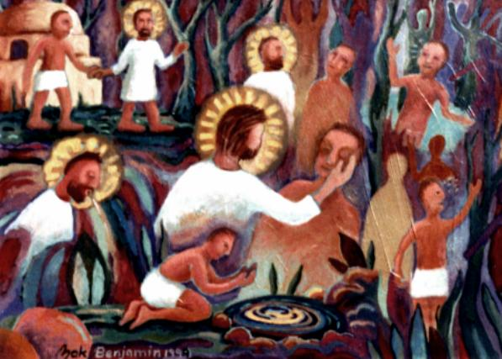

The man replied, “He is a prophet.”

They still did not believe that he had been blind and had received his sight until they sent for the man’s parents.

“Is this your son?” they asked. “Is this the one you say was born blind? How is it that now he can see?”

“We know he is our son,” the parents answered, “and we know he was born blind. But how he can see now, or who opened his eyes, we don’t know. Ask him. He is of age; he will speak for himself.” His parents said this because they were afraid of the Jewish leaders, who already had decided that anyone who acknowledged that Jesus was the Messiah would be put out of the synagogue. That was why his parents said, “He is of age; ask him.”

A second time they summoned the man who had been blind. “Give glory to God by telling the truth,” they said. “We know this man is a sinner.”

He replied, “Whether he is a sinner or not, I don’t know. One thing I do know. I was blind but now I see!”

Then they asked him, “What did he do to you? How did he open your eyes?”
- 4 -

He answered, “I have told you already and you did not listen. Why do you want to hear it again? Do you want to become his disciples too?”

Then they hurled insults at him and said, “You are this fellow’s disciple! We are disciples of Moses! We know that God spoke to Moses, but as for this fellow, we don’t even know where he comes from.”

The man answered, “Now that is remarkable! You don’t know where he comes from, yet he opened my eyes. We know that God does not listen to sinners. He listens to the godly person who does his will. Nobody has ever heard of opening the eyes of a man born blind. If this man were not from God, he could do nothing.”

To this they replied, “You were steeped in sin at birth; how dare you lecture us!” And they threw him out.

Spiritual Blindness

Jesus heard that they had thrown him out, and when he found him, he said, “Do you believe in the Son of Man?”

“Who is he, sir?” the man asked. “Tell me so that I may believe in him.”

Jesus said, “You have now seen him; in fact, he is the one speaking with you.”
Then the man said, “Lord, I believe,” and he worshiped him.

Jesus said, “For judgment I have come into this world, so that the blind will see and those who see will become blind.”

Some Pharisees who were with him heard him say this and asked, “What? Are we blind too?”

Jesus said, “If you were blind, you would not be guilty of sin; but now that you claim you can see, your guilt remains.
JOHN 9:1-41

- 5 -

REFLECTION QUESTIONS:

- When I serve someone with a need, do I see a whole person or only the problem?

Is my concern only to “take care of” the need as efficiently as possible, or do I see the people I deal with?

In our group’s ministry do we treat the recipients in a way that permits them to keep their dignity? Or is our main attitude one of pity, rather than the Body of Christ reading out to his people?

- 6 -

