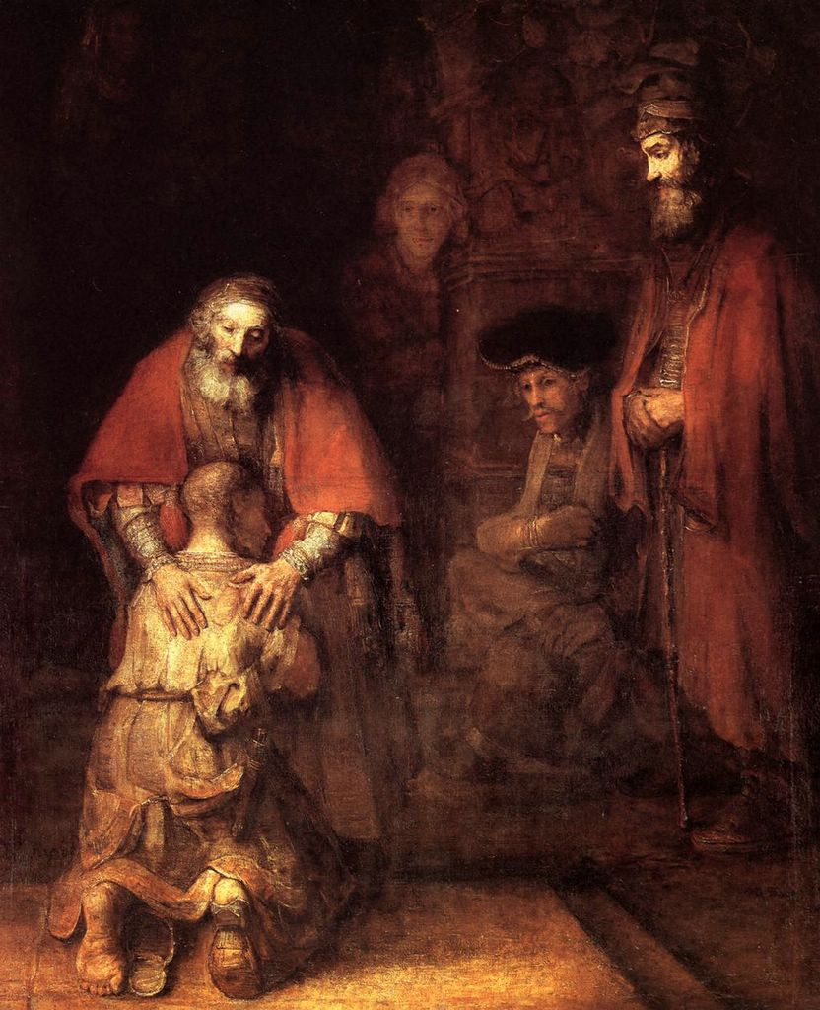
“My son, you are here with me always;
everything I have is yours.
But now we must celebrate and rejoice,
because your brother was dead and has come to life again;
he was lost and has been found.”
Lk 15:31-32

COMPASSION


“Be compassionate
as your heavenly Father
is compassionate”

Lk 6:36

Christian Life Commission
Morning of Reflection
Convocation
6 March 2010
OVERARCHING VISION
of the
CHRISTIAN LIFE COMMISSION
Parishes are called
to help people live their faith in the world;
to help them understand and act on the social dimension
of the gospel in their everyday lives as they live their roles as:
parents, friends, workers, students, owners, investors,
citizens, caregivers, advocates, policy makers, and
members of both local and global communities.
Through grace, in community,
we are called to image the face of God
to one another in times of suffering, times of joy,
times of giving, and times of receiving.

- 9 -
Ministry Area I
Welcoming Committee
Fiesta Committee
Golden Agers
Ladies Guild
Ministry Area IV  Just Faith  Peregrinos Juntos  The Haiti Project  Habitat for Humanity  Detention Ministry  Pima County Interfaith  Council (PCIC)  Care for Creation  Consistent Ethic  of Life |  | Ministry Area II  Stephen Ministry  Moses  Bereavement Support  Health Care Ministry  Counseling Service  St. Peregrine Ministry  Parish Blood Drive  Eucharistic Ministers to  the Homebound  TIHAN Ministry
Ministry Area III
St. Vincent de Paul Society
The Blessed Nuno Society
Casa Maria Outreach
Primavera Group
Knights of Columbus

Compassion Walks the City Streets
- 1 -

Compassion walks the city streets
And listens for uncertain feet
That hunt a home they cannot find
Because the heart that leads is blind.
Compassion holds a steady light
To show the way through chill of night
And takes the homeless by the hand
To guide them to a warmer land.
Compassion walks the prison halls
in search of those affliction walls
In hopelessness beyond despair
Because no voice speaks solace there.
Compassion breaks the bars and locks
To forge a path through all that blocks
The way to every lonely cell,
Where anguish pines in silent hell.
Compassion walks the empty waste
Where dust and ash are all they taste
Who lose their way in barrenness
And eat the bread of bitterness.
Compassion sets a table there
With bread and wine both rich and rare
For all who faint in hunger’s hold,
And carries them to plenty’s fold.
Compassion walks where life is hard,
Where eyes are blank and faces marred
By pain too great to understand,
And shoulders those too weak to stand.
Compassion is the Shepherd’s name:
Who from the halls of heaven came
To travel landscapes bare and bleak
For those that only love would seek.
Compassion does not tire or sleep
But walks wherever sufferers weep
Through ages past and still to come,
Until the world is gathered home
To rest at last where Mercy reigns
And heals all ills and stills all pains.
And there Compassion’s walk will cease,
Where God is all, and all is peace.
- Genevieve Glen, OSB
Thoughts on Compassion
“The whole idea of compassion is based on a keen awareness of the interdependence of all these living beings, which are all part of one another, and all involved in one another.”
- Thomas Merton

Let us not underestimate how hard it is to be compassionate. Compassion is hard because it requires the inner disposition to go with others to the place where they are weak, vulnerable, lonely, and broken. But this is not our spontaneous response to suffering. What we desire most is to do away with suffering by fleeing from it or finding a quick cure for it. As busy, active, relevant ministers, we want to earn our bread by making a real contribution. This means first and foremost doing something to show that our presence makes a difference. And so we ignore our greatest gift, which is our ability to enter into solidarity with those who suffer. Those who can sit in silence with their fellowman, not knowing what to say but knowing that they should be there, can bring new life in a dying heart. Those who are not afraid to hold a hand in gratitude, to shed tears in grief and to let a sigh of distress arise straight from the heart can break through paralyzing boundaries and witness the birth of a new fellowship, the fellowship of the broken.

- Henri Nouwen

Compassion asks us to go where it hurts, to enter into places of pain, to share in brokenness, fear, confusion, and anguish. Compassion challenges us to cry out with those in misery, to mourn with those who are lonely, to weep with those in tears. Compassion requires us to be weak with the weak, vulnerable with the vulnerable, and powerless with the powerless. Compassion means full immersion in the condition of being human.

- Henri Nouwen

MORNING OF REFLECTION
SCHEDULE
You are invited to enter into the quiet of this Morning of Reflection
8:30 Mass
9:15 Refreshments in PAC Dining Room
9:30 Assemble in PAC Auditorium
Welcome [ Katie Hirschboeck ]
Opening song
9:40 Introduction to the Parable [ Msgr Tom ]
Input for reflection [ Helen Devries]
10:10 Period of quiet personal reflection [ 50 minutes ]
11:00 Return to Auditorium for group assignment
11:05 Sharing in small groups [ 30 minutes ]
11:35 Reassemble in Auditorium
Prayer experience [ Helen DeVries ]
11:55 Closing prayer [ Rich Sherwood ]

OPENING SONG

Here I am Lord
Words and Music by Daniel L Schutte © 1981

I, the Lord of sea and sky, I have heard my people cry.
All who dwell in dark and sin, my hand will save.

Refrain: Here I am, Lord. Is it I, Lord?
I have heard you calling in the night.
I will go, Lord, if you lead me.
I will hold your people in my heart.

I, who made the stars of night, I will make their darkness bright.
Who will bear my light to them? Whom shall I send? R.

I, the Lord of snow and rain, I have borne my people’s pain.
I have wept for love of them. They turn away. R.

I will break their hearts of stone, give them hearts for love alone.
I will speak my words to them. Whom shall I send? R.

I, the Lord of wind and flame, I will send the poor and lame.
I will set a feast for them. My hand will save. R.
Finest bread I will provide, 'til their hearts be satisfied.
I will give my life to them. Whom shall I send? R.
- 9 -
- 2 -

THE TWO SONS
LUKE 15 : 11-32
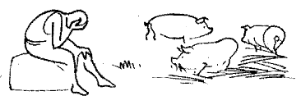

While he was still a long way off, his father caught sight of him and was filled with compassion. He ran to his son, embraced him and kissed him. His son said to him, “father, I have sinned against heaven and against you. I no longer deserve to be called your son.”
Coming to his senses he thought, “How many of my father’s hired workers have more than enough food to eat, but here am I, dying from hunger. I shall get up and go to my father and I shall say to him, “Father, I have sinned against heaven and against you. I no longer deserve to be called your son; treat me as you would one of your hired workers.” So he got up and went back to his father.
“A man had two sons, and the younger son said to his father: “Father, give me the share of your estate that should come to me.” So the father divided the property between them. After a few days the younger son collected all his belongings and set out to a distant country where he squandered his inheritance on dissipation.

When he had freely spent everything, a severed famine struck that country and he found himself in dire need. So he hired himself out to one of the local citizens who sent him to his farm to tend the swine. And he longed to eat his fill off the pods on which the swine fed, but nobody gave him any.

CLOSING PRAYER
A Lord’s Prayer for Justice
- 3 -
- 3 -

Our Father who art in heaven . . . who always stands with the weak, the poor, the abandoned, the sick, the aged, the very young, the unborn and those who, by circumstance, bear the heat of the day.
Hallowed be thy name . . . may we acknowledge your holiness, respecting that your ways are not our ways, your standards are not our standards. May the reverence we give your name pull us from the selfishness that prevents us from seeing our neighbor’s pain.
Your will be done on earth as it is in heaven . . . may the work of our hands, the temples and structures that we build in the world, reflect the temple and the structure of your glory so the joy, graciousness, tenderness and justice of heaven will show forth within all our structures on earth.
Give us . . . life and love and help us to see always everything as gift. Help us to know that nothing comes to us by right and that we must give because we have been given to. Help us realize that we must give to the poor, not because they need it, but because our own health depends on our giving to them.
This day . . . not tomorrow. Do not let us push things off into some indefinite time so we can continue to live justified lives in the face of injustice because we can make excuses for our own inactivity.
Our daily bread . . . so that each person in the world may have enough food, enough clean water, enough clean air, adequate health care and sufficient access to education so as to have the substance for a healthy life. Teach us to give from our sustenance and not just from our surplus.
Forgive us our trespasses . . . forgive us our blindness toward our neighbor, our self-preoccupation, our racism, our sexism and our propensity to worry only about ourselves and our own. Forgive us our capacity to watch the evening news and do nothing about it.
As we forgive those who trespass against us . . . help us to mellow in spirit and to not grow bitter with age, to forgive the imperfect parents and system that wounded, cursed and ignored us.
And do not put us to the test . . . do not judge us only by whether we have fed the hungry, given clothing to the naked, visited the sick or tried to mend the system that victimized the poor. Spare us the test for none of us can stand before your gospel scrutiny. Give us, instead, more days to mend our ways, selfishness and systems.
But deliver us from evil . . . from the blindness that lets us continue to participate in anonymous systems within which we need not see who gets less as we get more. Amen 
(Adapted from The Holy Longing by Fr. Ronald Rolheiser)
- 4 -

5) Although I desire God’s mercy for me, am I angered by his generosity toward others who I may think do not deserve it?

Now the older son had been out in the field and, on his way back, as he neared the house, he heard the sound of music and dancing. He called one of the servants and asked what this might mean. The servant said, “Your brother has returned and your father slaughtered the fatted calf because he has him back safe and sound.”

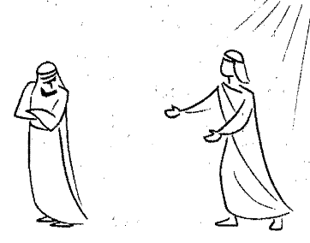

He became angry and, when he refused to enter the house, his father came out and pleaded with him.

6) How willing am I to reach out to, and cooperate with, the efforts of those who do not agree with my viewpoint and actions?
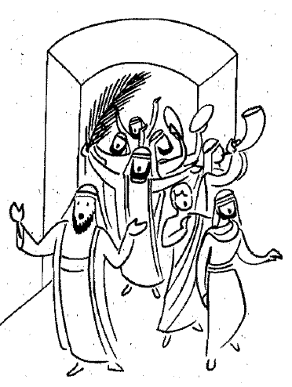
- 4 -
- 7 -
But the father ordered his servants, “Quickly bring the finest robe and put it on him; put a ring on his finger and sandals on his feet. Take the fatted calf and slaughter it. Then let us celebrate with a feast, because this son of mine was dead and has come to life again; he was lost and has been found.” Then the celebration began.
He said to him, “My son, you are here with me always; everything I have is yours. But now we must celebrate and rejoice, because your brother was dead and has come to life again. He was lost and has been found.”
He said to his father in reply, “Look, all these years I served you and not once did I disobey your orders; yet you never gave me even a young goat to feast on with my friends. But when your son returns who swallowed up your property with prostitutes, for him you slaughter the fatted calf.”

Reflection Questions:

1) How often am I challenged by the magnitude and complexity of problems in my daily life and ministry that call for my compassion?

2) To what degree is my compassion affected by what I perceive to be the worthiness and gratitude of those who receive it?

3) How well do I understand and support the need for both charity and social justice in God’s mission of compassionate service?
- 5 -

4) In what ways do I offer my service to those in need as more a means of earning God’s love rather than sharing in his joy?

- 6 -

