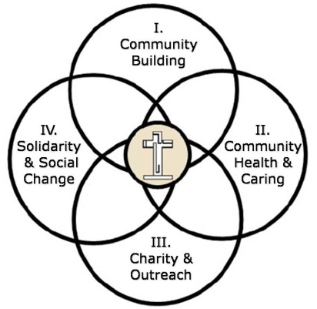 **The Christian Life Commission  
 CLC Core Committee 2012 Parish Council Report**

*Core Committee Members: Katie Hirschboeck (Commission Chair), Laura Stehle (Current CLC Staff Liaison), Sr. Jeanette Mariani OSF (former CLC Staff Liaison), Helen DeVries, Rich Sherwood, Jeff Allen, Maggie Medina, Brenda Carrillo, Fran Nutt.*

The Christian Life Commission consists of the ministry groups which serve in the four intersecting Ministry Areas of Christian Life depicted in our logo.

The **CLC Core Committee** oversees the four Ministry Areas, interacts with individual ministry groups as needed, organizes and presents annual convocation/retreats for the ministry areas, and provides vision and leadership for the commission as a whole in implementing the OMOS Pastoral Plan. Following are just a few highlights of some the CLC activities, including those sponsored by the CLC Core in 2012:

**∙** In 2012 the CLC experienced a major transition with the departure of Sr Jeanette, our former staff liaison. The CLC is now doubly blessed to have **Laura Stehle** as our principle Staff Liaison with **Diana Maugans** who is now assuming Sr Jeanette's pastoral ministry activities under Areas I & II. The transition has been nearly seamless because of Laura's longterm dedication to the CLC commission and her faithful participation at all the CLC Core meetings in the past.

**∙ The CLC Convocation** “Reaching Out to the Least” (14 April 2012) was offered for **Ministry Areas III & IV** and based on the Matthew 25 scripture. Helen DeVries facilitated a deeply meaningful and well-received morning of reflection on our **2012 Pastoral Plan theme**.

**∙**  The **Care for Creation Committee** (**Area IV)** sponsored the first annual **Parish Earth Fair** after all Masses an Earth Day (April 22). The Committee also continued its recycling effort at the **Parish Fiesta** (**Area I**) which once again brought the parish together in fellowship and celebration. The CLC Core is deeply grateful for the leadership of **Hank Krzysik** and his many efforts, including the environmental upgrades for the new **Women's Shelter** facility (which is supported by many of our CLC members) .  
  
**∙**The **Consistent Ethic of Life Committee (Area IV)**  sponsored **evenings of formation and reflection** after the Peace and Justice Mass and the CLC Core met with Tim Heinan to strategize on ways to increase the visibility of the **Blessed Nuno Society** (**Area III)** and its new orphanage in Agua Prieta.

**∙** The **Haiti Project (Area IV)** outreach continued, driven by Joan Martin's leadership even in the midst of her significant heath challenges. The CLC and Haiti Committee asks for your prayers for Joan.

**∙** The **CLC Core Committee** established even stronger bonds with the newly thriving **Hispanic Ministry   
Commission** through the addition of CLC Core member Fran Nutt.

**∙** The **Reach Out to the Least Resource Rack** in the church vestibule was envisioned, designed, and implemented by the CLC Core. The purpose of the rack is to equip our parish community with the resources to live the Gospel in our everyday lives when we are “Sent Forth” into the world at the end of Mass . The rack is filled with information on ways to: “Lovingly Promote a Consistent Ethic of Life,” “Live Out Your Gospel Call through Action,” “ Reach Out to Those In Need in Our Midst,” and “Embrace the World with Your Love and Care.” Response thus far has been positive and fruitful.  
  
The above represent only a portion of what the CLC Commission as a whole has accomplished in 2012. The Core Committee is humbled and grateful for the abundant gifts of time, treasure and talent from our many CLC minsters and the continued outpouring of generous assistance that our parish bestows on all of our ministries.

*Respectfully submitted by Katie Hirschboeck, Christian Life Commission Chair*