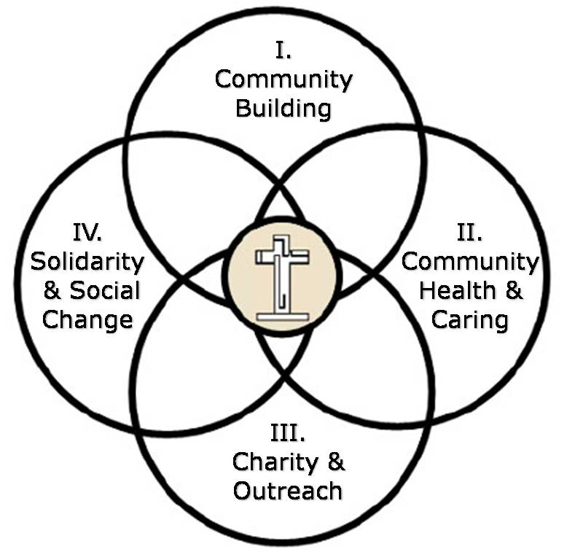
The Christian Life Commission
CLC Core Committee 2011 Parish Council Report
Submitted by Katie Hirschboeck, CLC Chair
Core Committee Members: Katie Hirschboeck (Commission Chair), Sr. Jeanette Mariani OSF (CLC Staff Liaison), Helen DeVries, Rich Sherwood, Jeff Allen, Maggie Medina, Brenda Carrillo, and Laura Stehle ( Christian Education Formation Staff Liasion).
The Christian Life Commission consists of 25 ministry groups which serve the people of God in the four intersecting Ministry Areas of Christian Life depicted in our logo. See also: www.omosclc.org
The CLC Core Committee oversees the four Ministry Areas, interacts with individual ministry groups as needed, organizes and presents annual convocation/retreats for the ministry areas, and provides vision and leadership for the commission as a whole in implementing the OMOS Pastoral Plan.
Following are just a few highlights of some the CLC ’s activities in 2011:
-- The CLC sponsored a parish celebration for the Jubilee of Sr. Jeanette, CLC Staff Liaison. This Commission is immensely grateful for and inspired by the outstanding leadership and gifts of Sr. Jeanette, especially all she does to facilitate the Community Health and Caring ministries in Area II!
-- The CLC Convocation “Open Our Eyes, Lord” (2 April 2011) was offered for Ministry Areas I & II and based on the gospel story of the Man Born Blind. Helen DeVries facilitated a deeply meaningful and well-received morning of reflection.
-- The 2011 Pastoral Plan theme “To Worship and Welcome” was featured in the CLC Convocation through reflection, discussion, and a resulting list of “actions” for becoming more welcoming .
-- The Parish Fiesta (Area I) once again brought the parish together and this year the Care for Creation Committee (Area IV) implemented a more effective recycling system at the event . (See also Hank Krzysik’s CFCI report)
-- The Consistent Ethic of Life Committee (Area IV) presented the Circle of Life Journey program again and sponsored evenings of formation and reflection after the Peace and Justice Mass.
-- The Blessed Nuno Society (Area III) saw the opening of its new orphanage in Agua Prieta and the ministry of Joan Martin and the Haiti Project (Area IV) has continued to thrive
-- The CLC’s Welcoming Committee along with representatives from many of our ministry groups participated in the Ministry Fair in October, and a new CLC Brochure was produced for the event. The CLC Core Committee established stronger bonds with the Hispanic Ministry and our CLC Brochure was produced in Spanish for the first time for distribution at the Ministry Fair.
-- Through the facilitation and leadership of both Sr Jeanette and Laura Stehle and the dedication of many other ministry leaders in the CLC, Charity and Outreach opportunities (Area III) expanded via: St. Vincent de Paul Society , Casa Maria outreach, new leadership in the Primavera Group, the dedicated volunteers of the Sr .Jose Women’s Shelter (especially, Jean Fedigan recently featured in the Arizona Star), Thanksgiving meals, Angel Tree, and the charity work of the Knights of Columbus (now affiliated with the CLC) – just to name a few.
The above represent only a small sampling of what the CLC has accomplished this past year. The Core Committee is humbled and grateful for the great generosity of time, treasure and talent that our parish bestows on the ministries of the Christian Life Commission!

