
CLC CORE MEETING AGENDA

Feat of St Lucy -- Tuesday December 12, 2011 / 5:30 – 7:00 pm Kino Room
I . Call to Order (Katie) & Opening Lectio – ( Sr Jeanette)
II. Review of last meeting’s minutes
III. Reports / Updates / Events:
- Thanksgiving Outreach
- Welcoming: Quiet time at Mass / Handicapped accessibility
- Update on Women's shelter / Counseling / Primavera / Detention
- Blessed Nuno – how can CLC help to promote?
- Consistent Ethic of Life re Respect Life - plans for 2012
- Co-Workers in the Vineyard – Registration open! www.workersvineyard.com
IV. Pastoral Plan Theme: To Reach Out to the Least (how will the CLC teach, witness, and live this theme? )
- Literature Rack
- “Immersion” experiences (Msgr witness)
- Implementation Comm. re method of teaching Catholic Social Teachings
- Catholic Update: Economic Justice for All: 25th Anniversary, Wisdom for Today
VI. Planning for Convocation for Areas III & IV -- April 14 (Easter Saturday)

VII. CLC Annual Report to Parish Council on 1/21/12
VIII. Other Items, New Business
VIII. Request for Prayers / Closing Prayer
Next meeting: Jan 19, 2012 Prayer / Lectio leader: ______________

CLC CORE MEETING AGENDA

Feat of St Lucy -- Tuesday December 12, 2011 / 5:30 – 7:00 pm Kino Room
I . Call to Order (Katie) & Opening Lectio – ( Sr Jeanette)
II. Review of last meeting’s minutes
III. Reports / Updates / Events:
- Thanksgiving Outreach
- Welcoming: Quiet time at Mass / Handicapped accessibility
- Update on Women's shelter / Counseling / Primavera / Detention
- Blessed Nuno – how can CLC help to promote?
- Consistent Ethic of Life re Respect Life - plans for 2012
- Co-Workers in the Vineyard – Registration open! www.workersvineyard.com
IV. Pastoral Plan Theme: To Reach Out to the Least (how will the CLC teach, witness, and live this theme? )
- Literature Rack
- “Immersion” experiences (Msgr witness)
- Implementation Comm. re method of teaching Catholic Social Teachings
- Catholic Update: Economic Justice for All: 25th Anniversary, Wisdom for Today
VI. Planning for Convocation for Areas III & IV -- April 14 (Easter Saturday)
VII. CLC Annual Report to Parish Council on 1/21/12
VIII. Other Items, New Business
VIII. Request for Prayers / Closing Prayer
Next meeting: Jan 19, 2012 Prayer / Lectio leader: ______________

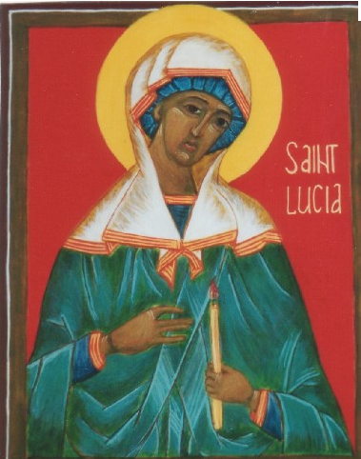
Prayer to Saint Lucy
you did not hide your light under a basket,
but let it shine for the whole world,
for all the centuries to see.
We may not suffer torture in our lives the way you did,
but we are still called to let the light of our Christianity
illumine our daily lives.
Please help us to have the courage
to bring our Christianity into our work, our recreation, our relationships, our conversation
every corner of our day. Amen

Prayer to Saint Lucy
you did not hide your light under a basket,
but let it shine for the whole world,
for all the centuries to see.
We may not suffer torture in our lives the way you did,
but we are still called to let the light of our Christianity
illumine our daily lives.
Please help us to have the courage
to bring our Christianity into our work, our recreation, our relationships, our conversation
every corner of our day. Amen

