“The environment is God's gift to everyone, and in our use of it
we have a responsibility towards the poor, towards future generations
and towards humanity as a whole.”
Pope Benedict XVI,
Caritas in Veritate, No. 48, 2009
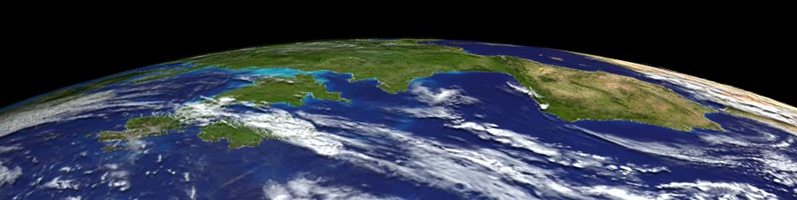

The St. Albert the Great Forum on Theology & Science presents:
Caring for God’s Creation in the 21st Century:
Reflections on Theology, Science, and
Our Interconnected Global Environment
Dr. Katie Hirschboeck
Monday, May 2, 2011 at 7:30 p.m.
The University of Arizona Newman Center, Green Hall

Dr. Hirschboeck is a climate scientist on the faculty of the Laboratory of Tree-Ring Research and Chair of the Global Change Graduate Interdisciplinary Program.
She holds joint appointments in Hydrology & Water Resources,
Atmospheric Sciences, and the School of Geography & Environment.
She is also trained as one of 24 national Catholic Climate Ambassadors
for the Catholic Coalition on Climate Change.

CatholicClimateCovenant.org

