“The environment is God's gift to everyone,  and in our use of it we have a responsibility  towards the poor, towards future generations  and towards humanity as a whole.”  Pope Benedict XVI, Caritas in Veritate, No. 48, 2009  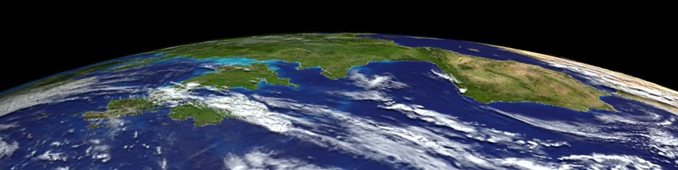  The St. Albert the Great Forum on Theology & Science presents:  Caring for God’s Creation in the 21st Century:  Reflections on Theology, Science,  Climate Change and Our Interconnected  Global Environment  Dr. Katie Hirschboeck  Monday, May 2, 2011 at 7:30 p.m.  The University of Arizona Catholic Newman Center  Dr. Hirschboeck is a climate scientist on the faculty of the Laboratory of  Tree-Ring Research and Chair of the Global Change Graduate Interdisciplinary Program. She holds joint appointments in Hydrology & Water Resources, Atmospheric Sciences, and the School of Geography & Environment.  She is also trained as one of 25 national Catholic Climate Ambassadors  for the Catholic Coalition on Climate Change.  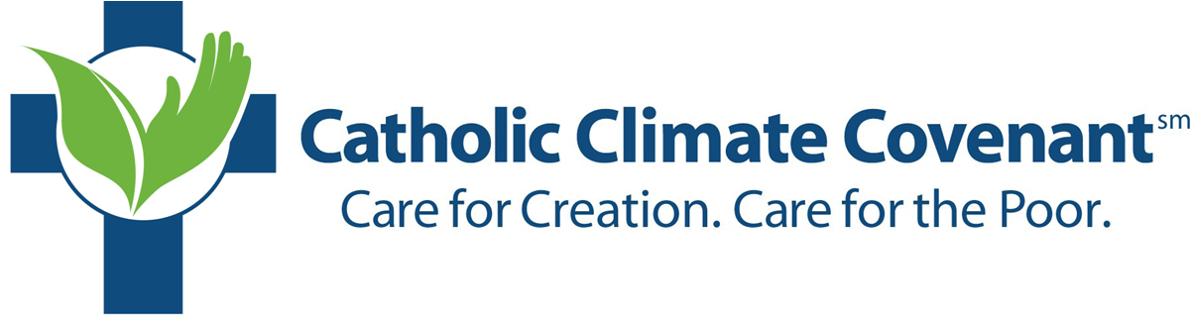  CatholicClimateCovenant.org  The Newman Center is located on the northeast corner of Cherry Avenue & Second Street.  Parking is available in back; enter on First Street. The Forum meets downstairs in Green Hall. |  | “The environment is God's gift to everyone,  and in our use of it we have a responsibility  towards the poor, towards future generations  and towards humanity as a whole.”  Pope Benedict XVI, Caritas in Veritate, No. 48, 2009  The St. Albert the Great Forum on Theology & Science presents:  Caring for God’s Creation in the 21st Century:  Reflections on Theology, Science,  Climate Change and Our Interconnected  Global Environment  Dr. Katie Hirschboeck  Monday, May 2, 2011 at 7:30 p.m.  The University of Arizona Catholic Newman Center  Dr. Hirschboeck is a climate scientist on the faculty of the Laboratory of  Tree-Ring Research and Chair of the Global Change Graduate Interdisciplinary Program. She holds joint appointments in Hydrology & Water Resources, Atmospheric Sciences, and the School of Geography & Environment.  She is also trained as one of 25 national Catholic Climate Ambassadors  for the Catholic Coalition on Climate Change.  CatholicClimateCovenant.org  The Newman Center is located on the northeast corner of Cherry Avenue & Second Street.  Parking is available in back; enter on First Street. The Forum meets downstairs in Green Hall.

