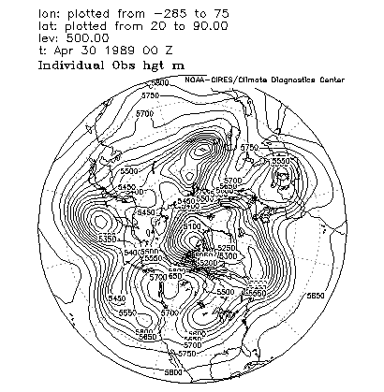

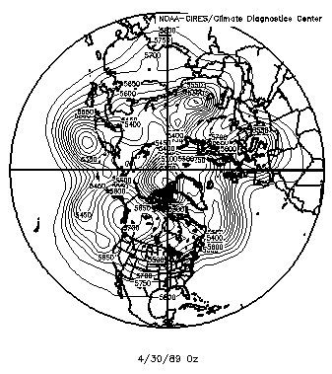

http://www.cdc.noaa.gov/cdc/data.nmc.reanalysis.html http://www.cdc.noaa.gov/Composites/Hour/
then choose variable & click on "Make plot" in 4-times daily obs table

