GC-GIDP APR FILES
Official Records (compiled from system 9/4/2009)

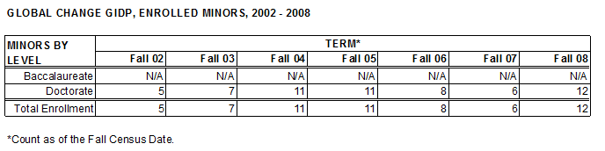
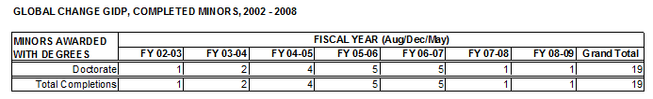
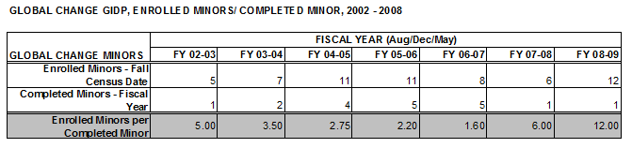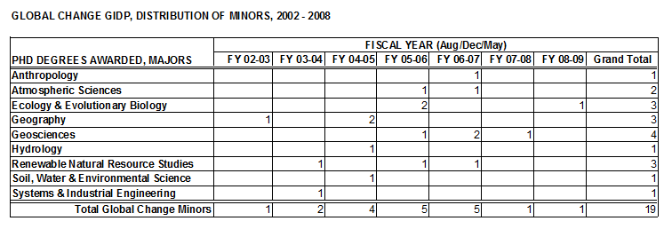
Global Change Committee, APR 2009-10
GIDP in the Graduate College
Questions on Data for Self Study Report
Prepared by Celeste Pardee, 9/8/09

- Enrolled Minors: The Global Change (GC) minor was an attractive option for doctoral candidates, with enrollment ranging from 5 to 12 during the APR period. There’s no apparent upward or downward trend. Based on student inquiries and your recruitment efforts, what kind of growth do you anticipate during the next APR period?

- Completed Minors: Students who complete the GC minor do not necessarily complete their requirements for the PhD Degree. The Graduate College verified that 19 PhD completers had a GC minor during the APR period—an average of 2.7 per year. If minor programs were held to the same productivity standards as degree programs (majors), you would need to submit a Low Productivity Report, as there were fewer than 9 minors awarded in the past 3 years. How does the Global Change GIDP fill a vital niche?

- Enrolled Minors Per Completers: There is little correlation between the number of enrolled minors and documented completers. The variability between enrolled and completed GC minors is much greater than that for enrolled/completed majors, because the GC committee doesn’t necessarily work with the students throughout their degree program. It seems mere coincidence that 5 of 8 enrolled minors completed in FY06-07 but only 1 of 12 minors completed in FY08-09. Your comments on this variability would be helpful.

- Distribution of Minors: Based on completions, the GC minor apparently appeals to students majoring in the biological and physical sciences (College of Science) more-so than to majors in Agriculture & Life Sciences, Social & Behavioral Sciences, and Engineering. What factors might account for this?

- UA Organizational Units for Comparison: Please select 2 GIDP committees or UA college departments with which to compare your data on Enrolled Minors per Completers. Academic Affairs staff will obtain equivalent data for you to present in your self-study report.

