★ ASSIGNMENT G-3: BRISTLECONE PINE ACTIVITY (worth 5 pts)
GROUP # ________
Each Group Participant’s SIGNATURE: PRINT NAME legibly next to the signature:
__________________________________ ___________________________________
___________________________________ ___________________________________
___________________________________ ___________________________________
___________________________________ ___________________________________
___________________________________ ___________________________________
___________________________________ ___________________________________

TEST HYPOTHESES

❑ Discuss and develop various hypotheses about site-to-site comparisons in tree-ring variability and the evidence of global change the trees at the study sites might contain.
(NOTE: to review what a hypothesis is, see Topic #2 in Class Notes)
A hypothesis must be stated in a way that can be tested by the available data.
Hypotheses #1 & # 2 are stated for you to get you started:

❑ Hypothesis #1: Trees in sites that are closer together will pattern-match and crossdate better than sites that are far apart.
(Discuss and figure out how to test this hypothesis. HINT: use the master skeleton plots!)

❑ Determine which sites are near each other and which are far apart (e.g. CA sites vs. CO sites), TEST Hypothesis #1 and RECORD YOUR FINDINGS HERE:

Do the California sites pattern-match and crossdate with each other? | Do the Colorado sites pattern-match and crossdate with each other? | Do the California sites pattern-match and crossdate with the Colorado sites?
Is Hypothesis #1 supported? (State YES or NO and explain why or why not)

❑ SPECULATE on what factors (similar local climate, similar species, similar elevation, etc.) might influence whether sites pattern-match & crossdate or not.

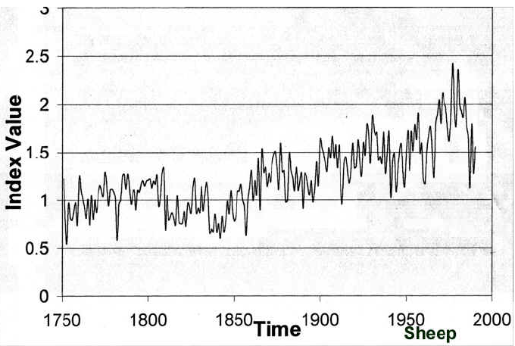
❑ Scientists have proposed different hypotheses for why the tree growth at some of the study sites exhibits a prominent increasing trend in the 1900s ,
as seen in one or more of the Ring Width Indices plots ➔

One of these hypotheses is:

Hypothesis #2: The increasing growth trend in the 1900s is evidence of a local or regional temperature response to the Northern Hemisphere / Global warming trend.

This hypothesis can NOT be tested with the tree-ring data alone -- additional data would have to be collected to test it.

❑ DISCUSS & DESCRIBE WHAT ADDITIONAL DATA would be useful to test Hypothesis #2 to determine if it is correct:

❑ CONSTRUCT A TESTABLE HYPOTHESIS about Frost Rings in the trees at the study sites.

(Hints: Might the frost ring frequency be expected to change under warmer conditions? Might frost rings be expected to occur more often in some locations rather than others? Do frost rings always occur in otherwise stressful years, or stress the tree’s growth in a future year? etc. etc.)

Your Hypothesis #3:

❑ Now examine the frequency and characteristics of frost rings over time at the various sites, TEST your Hypothesis #3, and DESCRIBE YOUR FINDINGS & EXPLAIN THEM:.

