The following sections are from our SRP – II project Final Report:

LTRR-SRP II - The Current Drought In Context: A Tree-Ring Based Evaluation Of Water Supply Variability for the Salt-Verde River Basin 2008

http://fp.arizona.edu/kkh/srp2.htm

----------------------------------------------------------------------------------------------------------------------

(3-d) Wet years are extremely important during an extended drought period. How well can the reconstruction track the high flow years? What about extreme flood peaks?

We investigated these questions via a case study of Verde River flows. Figure 14 is a graphical comparison of the time series of observed, reconstructed, and instantaneous peak flows for the Verde. Overall, tree ring reconstructions that rely on log-transformed flow data tend to do a better job capturing low flow extremes than high flow extremes. Figure 14 shows excellent correspondence between observed
and reconstructed annual flow values in low flow years, and a reasonably strong agreement in high flow
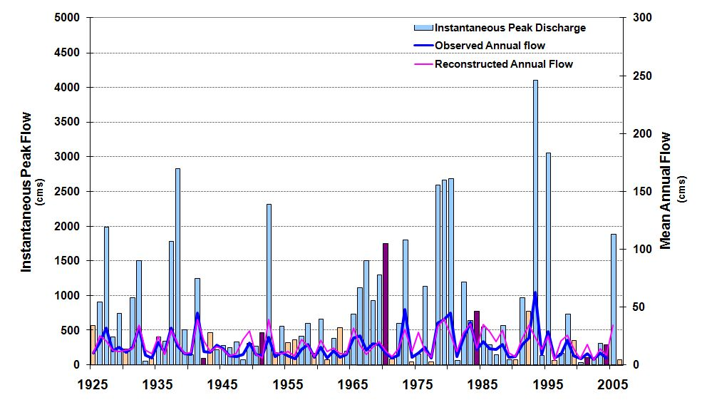
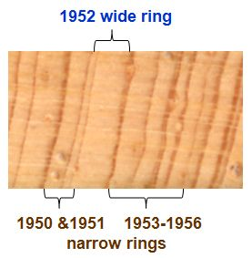
Figure 14. Verde River Basin Comparison of Observed, Reconstructed, & Instantaneous Peak Flows. Plotted for each year are the observed mean annual flow (dark blue line) and the tree-ring reconstructed mean annual flow (magenta line) in cubic meters per second (cms) for the Verde River⁷ (scaled on the right axis). Also plotted is the instantaneous annual peak flow (vertical bars) in cms, (scaled on the left axis). The instantaneous peaks are classified and color coded to show the hydroclimatic cause of each event. The tree-ring core inset depicts a wide ring occurring within an otherwise narrow-ring sequence during the 1950s drought.
⬅ 1950s Drought ➔
1952
years, including the capture of high annual values for most (but not all) years with exceptionally large instantaneous annual peak flows. The ability of the reconstruction to track both low and high flows in the observed record lends confidence to the use of the streamflow reconstruction to identify drought-relieving high flow years in both the observed and reconstructed records. The tree-ring core inset in Figure 14 shows an example of a very wide ring occurring in the middle of the extended 1950s drought period. The wide ring corresponds to the drought-relieving wet year of 1952 which is also captured in the reconstructed flow. The magnitude of the reconstructed value for 1952 may also be an indicator of the large annual flood peak (2,311 cms) that occurred on December 31, 1951. Flood peaks produced by synoptic-scale winter storms tend to be better reflected in reconstructed streamflows than floods produced by summer convective or tropical-storm related flood events.

(3-e) What does the reconstruction reveal about the length of intervals between drought-relieving wet years in the long-term record?

For drought planning, our Salt River Project collaborators wanted to know what the long-term record indicates about high flows as well as low flows—especially with respect to the typical length of time interval (or “gap”) between drought-relieving high flows. Based on the positive results from our Verde case study on the ability of the reconstruction to track high flows as well as low flows, we concluded that this question could be addressed using the long-term record of reconstructed flows. For comparison, we first examined the gaps between wet years in the observed record (Figure 15.) We defined wet years as those above a threshold of the 75th percentile of observed annual flow ( > 1504 kaf). Based on this criterion, 23 of the 94 years in the record were classified as wet (indicated by circles in Figure 15.) We then computed the interval, or gap, as the number of consecutive years between successive designated wet years. (This interval was 0 if wet years were adjacent). Results indicated that the median interval between wet years in the observed record is only 2 years. The widest wet-year gap of the observed record was 13 years and occurred during the 1950s drought (pink shading). If not for the wet year of 1952 (see Figure 14), this interval would have been 25 years. The wet-year gap during the current drought was 9 years (gold shading).
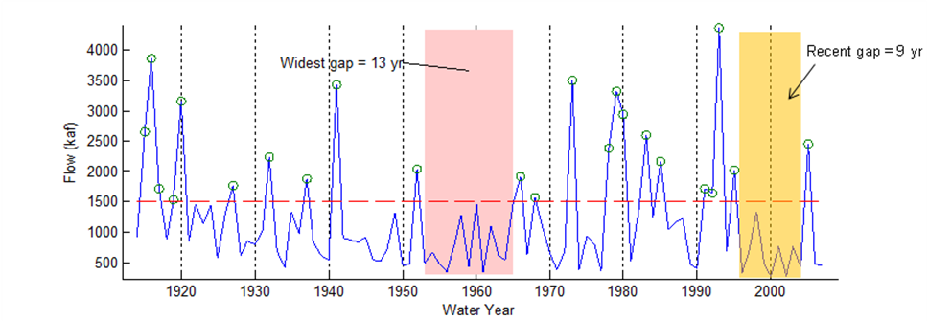
Figure 15. Length of intervals between wet years for the Salt + Verde + Tonto based on observed flows, 1914-2007. Values are mean annual in thousands of acre feet (kaf). “Wet Years” are identified with circles and are defined as years having an annual flow > the 75th percentile = 1504 kaf (dashed red line).

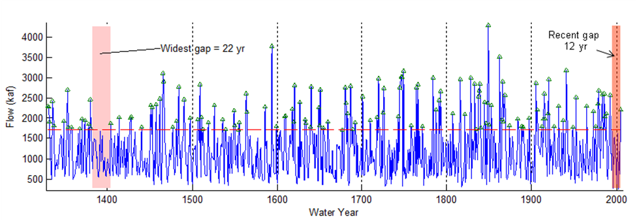
We then performed the same analysis on the 676-year S+V+T reconstructed flow record (Figure 16) and compared the results in the observed and reconstructed records (Figure 17). We found that, in the reconstructed low flows, the median interval between wet years was 3 years, and the longest interval was 22 years (1382-1403). Other large intervals were the 20-yr gap ending in 1585 and the two 16-yr gaps ending in 1676 and 1742. Note that the reconstruction for the S+V+T does not perfectly classify the wet years of the observed record. (For example, 1993 was a wet year in the observed, but not in the tree-ring record.) This is why the “recent gap” associated with the current drought is 12 years long when derived from reconstructed flows (Figure 16), compared to the shorter 9-year gap derived from observed flows (Figure 15). Another 12-year interval took place in conjunction with the 1950s drought (1953-1964). Overall in the reconstructed flows, there were 10 intervals between wet years that were greater than, or equal to, 12 years. This suggests that the persistence of the current drought—unrelieved by an intervening high flow for up to 12 years— is by no means unique in the context of the long-term record.
Figure 16. Length of intervals between wet years for the Salt + Verde + Tonto based on reconstructed flows, 1330-2005. Wet years defined as in Figure 15, but for the reconstructed flow, and identified by triangles. The horizontal red line represents the 75th percentile threshold for classifying wet years in the long-term record. Red shading highlights two of the intervals noted in the text.

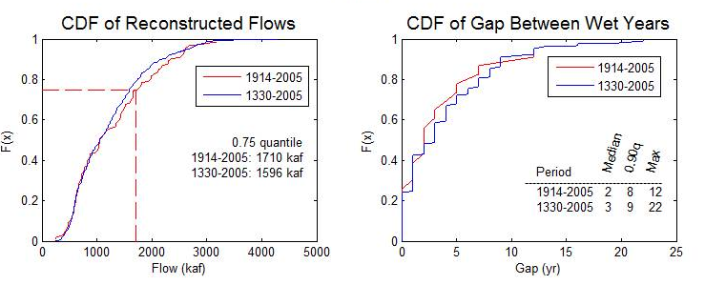
Figure 17. Comparison of the length of intervals between wet years in the instrumental and long-term records. (a) Cumulative distribution functions (cdfs) of the reconstructed flows for the entire reconstruction (blue line) and for the period of the reconstruction that overlaps observed flows (red line), (b) Cumulative distribution functions of the gap, or interval, between wet years, again for both the full-length reconstruction (blue) and the part that overlaps observed flows (red).

Figure 17 compares wet-year gaps in the observed (instrumental) and reconstructed records. Figure 17a shows the cumulative distribution functions (cdfs) of reconstructed flows for the entire period of record (blue line) and for the period of the reconstruction that overlaps with the observed flow record (red line). This depiction of the results reveals that the 0.75 quantile (used for classifying the wet years) is slightly lower for the 1330-2005 than for 1914-2005. The difference is a bit over 100,000 acre-ft. This is consistent with general observation that the long-term record is a bit drier than the instrumental period.

Figure 17b summarizes the time, or gap, between wet years. It shows the cumulative distribution functions (cdfs) of the time interval (gap), between wet years, for the entire period of record (blue line) and for the period of the reconstruction that overlaps with the observed flow record (red line). If two consecutive years are above the 0.75 quantile, the “gap” is defined as zero. The median gap for both the long-term and the observed period is 3 years. The 0.90 quantiles are also equal, at 9 years. The difference emerges in the extremes. The 1330-2005 record contains a 22-year gap, around the start of the 15th century. In contrast, the longest gap in the more recent 1913-2005 part of the reconstruction is 12 years (1953-1964 and 1993-2004). This depiction of the data echoes the discussion for Figure 16 above and confirms that the persistence of the current drought is not unprecedented, and at least one drought occurred in the past that was nearly twice as long as the current drought.

-----------------------------------------------------------------------------------------------------------------------------
<snip >
-----------------------------------------------------------------------------------------------------------------------------

(4-c) What regional atmospheric circulation patterns are associated with extreme low flow years and high flow years in the SVT streamflow record?

The updated streamflow reconstruction for the Salt + Tonto + Verde basin provides exceptional information about the range of variability of low and high flow extremes in this basin over the past 6+ centuries. Determining the likely climatic causes of these past extreme episodes is more difficult. Our approach is to gain an understanding of how the observed and reconstructed flows vary in response to climatic drivers and atmospheric circulation patterns during the instrumental record, and then use this knowledge to infer the most likely causes for past extreme streamflow episodes.

As noted above, the LTRR-SRP-I project addressed the joint occurrence of low flow years and high flow years in both the SVT and Upper Colorado River (UCRB) basins. We found that distinctly different— and inverse— atmospheric circulation patterns were dominant during joint low flow vs. high flow years. Figure 20 shows these contrasting patterns, updated with additional low-flow years from the current drought. The figure indicates that anomalously high 700 mb geopotential heights (upper-level ridges) dominated the North Pacific Ocean and western United States, extending over a broad latitudinal band in winter during extreme regional drought years in both the SVT and UCRB. The high flow years in both basins were linked to anomalously low 700 mb heights (upper level troughs) concentrated in the eastern North Pacific and the far western states, also over a broad latitudinal band. In our earlier study we had noted an apparent shift in the position of seasonal anomaly centers in the composites of the joint high flow (HH) and low flow (LL) years. We had observed that (in LL years especially) a positive (high)

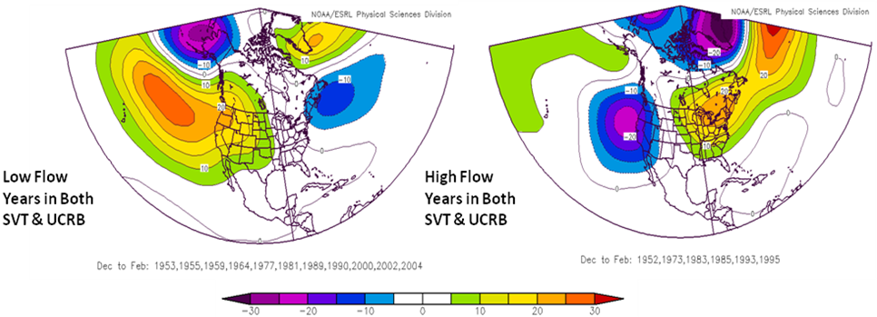
Low Flow Years in Both SVT & UCRB
High Flow Years in Both SVT & UCRB
b.
a.
Figure 20. Winter atmospheric circulation patterns during years with joint occurrence of (a) low flow and (b) high flow in both the Salt-Verde-Tonto (SVT) and Upper Colorado River Basin (UCRB). The figures depict composite anomaly charts of the Dec – Feb 700 millibar (mb) geopotential heights for those years in which exceptional annual low flow or high flow predominated in both basins. Anomaly values are in meters and are based on the period 1968-1996. Red/orange = strong positive height anomaly or dominance of upper level high pressure; purple/blue = strong negative height anomaly or dominance of upper level low pressure.
seasonal pressure height anomaly was situated over the western continental U.S. during the early half of the cool season (Oct-Dec), but shifted to the eastern North Pacific Ocean during the second half of the cool season (Jan-Mar). To see if this seasonal shift was evident in the SVT, we constructed early- and late-season winter composite anomaly maps for six SVT low-flow years of the 1950s drought (Figure 21) and the current drought (Figure 22). We also constructed maps for each year to see how representative the 6-year seasonal composites were of individual year variability. The left hand panel in each figure depicts anomaly maps for three different seasonal groupings: (a) the core winter (Dec-Jan-Feb), (b) the early cool season (Oct- Nov-Dec) and (c) the late cool season (Jan-Feb-Mar). The right hand panel shows early- and late-winter circulation patterns for each of the individual years.

The resulting patterns underscore the importance of separating the winter/cool season into early and late portions when assessing climatic anomalies. The early→ late westward shift of the positive pressure anomaly can be seen in the 6-year composites of both the 1950s and current droughts, as well as in most of the individual years. A correlation map analysis (not shown) indicated that both early- and late-winter circulation patterns influence annual flow variability in the SVT but in different ways— a result which echoes the seasonal anomaly patterns in Figures 21 and 22. These results indicate a strong similarity between the 1950s and current drought in their associated large-scale circulation patterns. However, the positive height anomalies over the continent in OND, and ocean in JFM, were
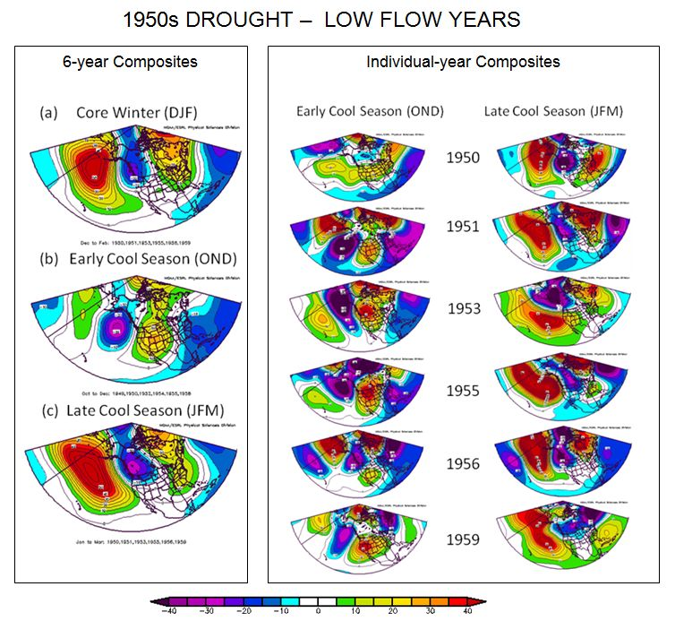
Figure 21. Seasonal circulation anomaly patterns for 6 low flow years during the 1950s drought in the Salt+Verde+Tonto. Maps are composite anomalies as in Figure 20. (a), (b) and (c) in the left panel
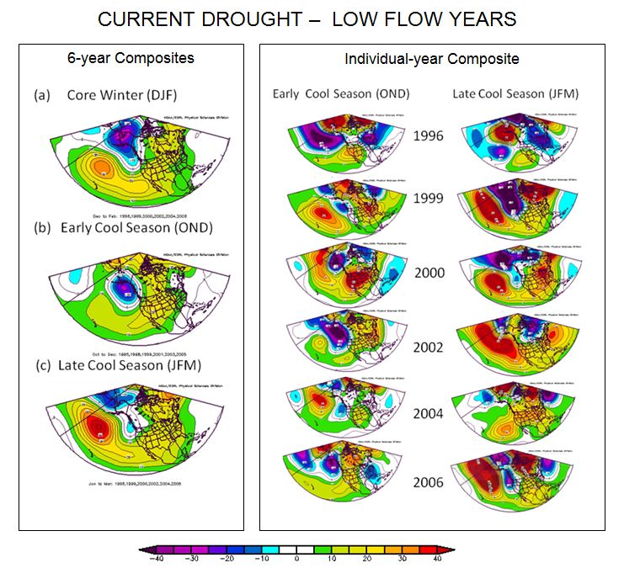
Figure 22. Seasonal circulation anomaly patterns for 6 low flow years during the current drought in the Salt+Verde+Tonto. Same as Figure 21, but for low-flow years during the current drought.

stronger during the 1950s drought overall, and in most individual years— which explains why its severity and persistence exceeded that of the current drought, except in 2002.

Figure 20 suggests that high flow years are associated with a circulation pattern that is inverse to that of the low flow years. We found this same result in the SVT when we mapped the anomaly patterns for 1952 (an important drought-relieving year during the 1950s with a wide tree ring, see Figure 14), and 2005 ( a relatively wet year with a moderately wide tree ring during the current drought) ( Figure 23). The negative (low pressure) anomalies were stronger in 1952 than 2005 in both early and late winter.

The strength of the positive and negative circulation anomalies during the extreme flow years in the SVT is indicative of one or more of several factors: the persistence (or repeated development) of a ridge or trough pattern in the same general location, the intensity of upper-level high or low pressures, and/or the unusual or unseasonal location of the circulation features. We observed that atmospheric blocking, or
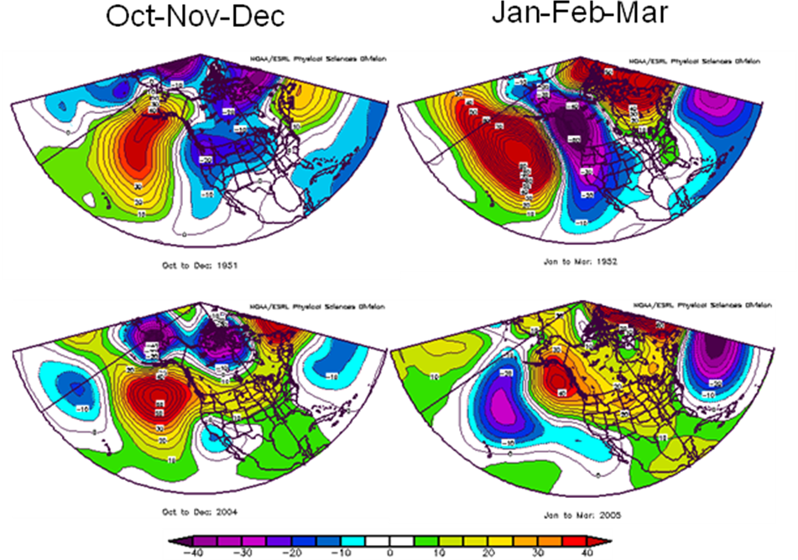
Oct-Nov-Dec
Jan-Feb-Mar
Figure 23. Seasonal circulation patterns for two drought-relieving years occurring during the 1950s and current drought. Maps are composite anomalies as in Figure 20.
2005
1952
Early & Late Cool Season Patterns
for Two Drought-Relieving High Flow Years

blocking-like behavior—along with its associated upper level upstream and downstream troughs—played a role in several of the synoptic circulation patterns for individual winter months during the extreme low and high flow years in the SVT. Figure 24 presents two examples of episodes with persistent blocking-like, high amplitude trough-ridge-trough patterns that affected the flow in the SVT. As Figure 23 illustrates, blocking-like patterns can be linked to both droughts and floods, depending on the longitudinal positioning of the trough-ridge-trough pattern with respect to a watershed Because of their persistence, we expect that blocking-related circulation patterns are likely to be reflected in unusually wide or narrow tree ring widths. We hope to explore this connection in more detail during future research, especially in the context of recent literature that has identified associations between North Pacific blocking patterns, early and late-winter dynamical trends in the Northern Hemisphere, trends in some climate indices, and a possible link to greenhouse gas forcing (Thompson and Wallace 2001, Fei et al. 2002, Carrera et al. 2004, Hu et al. 2005)

Figure 25 summarizes the discussion above by annotating the Verde River time series of observed, reconstructed and peak flows with examples of some of the key circulation anomaly patterns associated with low, high, and peak flows in the basin to answer the question: What regional atmospheric circulation patterns are associated with extreme low flow years and high flow years in the SVT streamflow record? We propose that these same patterns can be applied to the long-term record of reconstructed SVT flows to explain how the extremes of the past may have occurred.

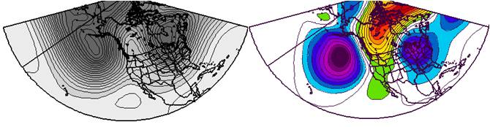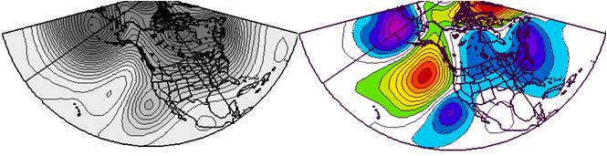
700 mb composite anomaly map
(a) Persistent ridge over west
12/23/01 – 12/30/01
(b) Southerly displaced trough
2/27/52 - 3/1/52
DRY
WET
Figure 24. Examples of episodes with persistent blocking-like, high amplitude trough-ridge-trough patterns. (a) depicts an 8-day composite and anomaly map for a blocking-like episode in December 2001 that exacerbated the extremely dry conditions of water year 2002. (b) depicts a 4-day composite and anomaly map for a blocking-like episode that displaced the Pacific storm track unusually far south, leading to one of several drought-relieving wet episodes during 1952.

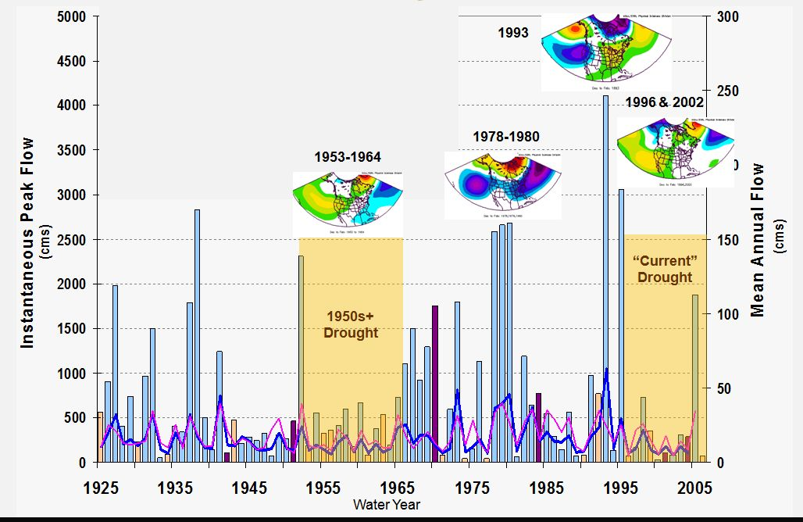
Atmospheric circulation anomaly patterns (700 mb) associated with notable dry and wet episodes in the Verde Basin
Figure 25. Atmospheric circulation anomaly patterns (700 mb) associated with notable dry and wet episodes in the Verde Basin. Observed, reconstructed, and peak flow as in Figure 14. The inset circulation patterns are examples of representative composite anomaly patterns for the different episodes.
(4-d) Are there any factors related to global climate that would cause a change in the magnitude, frequency, or location of the regional circulation patterns associated with low and high flows?

As noted above, recent literature has suggested some possible linkages between hemispheric-wide atmospheric dynamics, circulation indices, and regional climate extremes, such as those related to blocking-like patterns. A detailed inspection of these proposed linkages in the context of the current drought was beyond the scope of this project. We did, however, explore the relationship between a few circulation/sea surface temperature indices and SVT low and high flow years (Figure 26). As in the LTRR-SRP-I study, low flow years were more frequent in association with +AMO and – PDO, but not limited to this association. La Niña years (as defined by + SOI) were more likely to be associated with low flow than high flow, but some low flow years also occurred in association with –SOI and a weak El Niño. In contrast, high flows did not occur in association with any moderate or strong La Niña years, instead they were associated with either a neutral or strongly negative SOI. High flow years were also more frequent in association with +PNA (which is in keeping with the tendency for the positive phase of the PNA to be associated with El Niño). These results agree with similar findings for the same indices and Arizona precipitation variability.

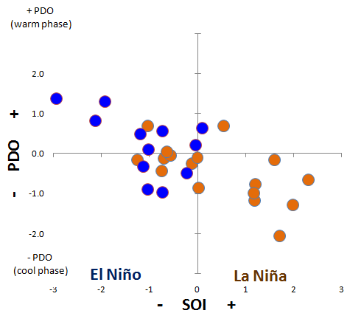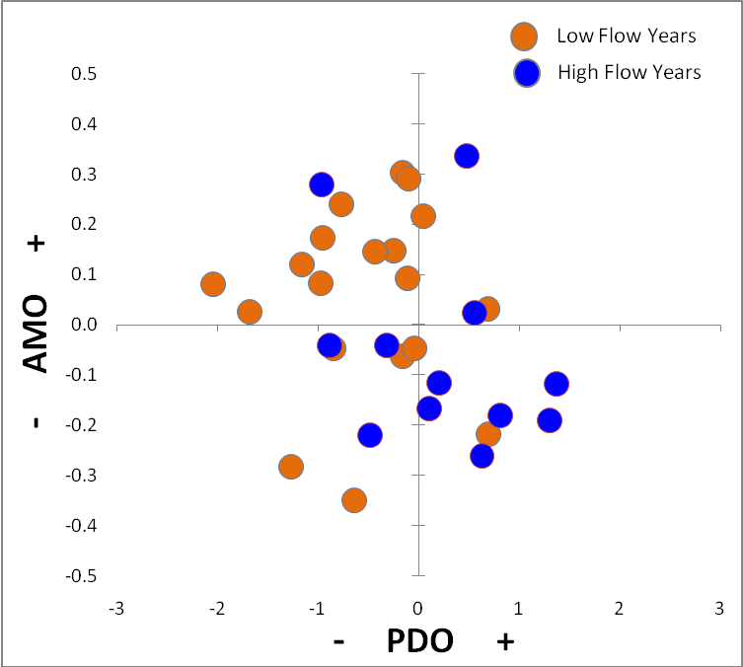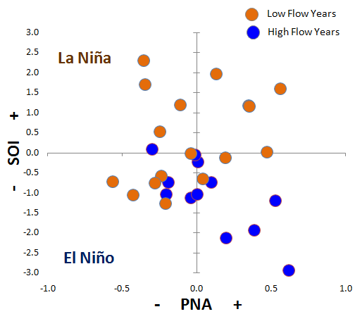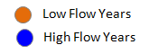
Figure 26. S+V+T+ low and high flow years plotted according to selected climate indices.
Periods of record: AMO vs. PDO = 1950-2006, SOI vs. PNA, PDO vs .SOI = 1952-2006.
Low and high flow years were classified based on the 0.25 and 0.75 quantiles of the SVT observed flow record.
AMO = Atlantic Multi-decadal Oscillation,
PDO = Pacific Decadal Oscillation
SOI = Southern Oscillation Index
PNA = Pacific North American Pattern
Indices obtained from: http://www.cdc.noaa.gov/ClimateIndices/.
PDO vs. SOI
AMO vs. PDO
SOI vs. PNA
+ AMO (warm North Atlantic)
- AMO (cool
North Atlantic)
- PDO (cool Tropical Pacific)
+ PDO (warm Tropical Pacific)

The utility of the index-based method for differentiating between low and high flow years in the SVT watershed may be hindered by the generalized geographic range of synoptic patterns that can be associated with different index phases. This reinforces the importance of a companion approach that focuses on the synoptic circulation patterns specifically linked to low and high flows in a given watershed (as described in section 4-c). Such an approach can also identify the weather and climate patterns that lead to wide and narrow tree rings, thereby providing a mechanistic basis for the causes of the variations and extremes seen in both streamflow and ring widths.

The question posed at the beginning of this section — Are there any factors related to global climate that would cause a change in the magnitude, frequency, or location of the regional circulation patterns associated with low and high flows? — remains the central question for determining whether the severity of the current drought is a manifestation of climate change and/ or global warming. Further research is needed on several fronts to determine the answer.

Observed mean annual flow values were compiled from daily streamflow records of the Verde River below Bartlett Dam (USGS # 09510000) and, beginning in September 1945, from the Verde River below Tangle Creek, above Horseshoe Dam (USGS #09508500). The peak flow values are from the Verde River below Tangle Creek, above Horseshoe Dam. See Appendix 1.
A notable exception is the record-breaking winter flooding year of 1993, which was not captured well by the reconstruction. One explanation for this is that the soil was so saturated during this event that large amounts of excess runoff were unusable by the trees and did not affect their growth.
“The obstructing, on a large scale, of the normal west-to-east progress of migratory cyclones and anticyclones.” (AMS Glossary of Meteorology). More specifically, it “ involves the formation of quasi-stationary, long-lived 7-days), closed anticyclonic circulation cells that temporarily divert the prevailing west-to-east flow of air at middle and upper tropospheric levels..” (Thompson & Wallace 2001, p. 85)
Namias made this same observation with respect to the Far Western drought of winter 1977, an extreme low flow year in the SVT: “ . . the isobaric signature of drought suggest anticyclonic vorticity associated with high pressure ridges, or at times, high pressure cells. These ridges serve as blocks to cyclonic activity from the Pacific, and often displace storm tracks north of the United States/Canadian border. . . . the anticyclonic ridge may often be responsive to an upstream trough over the eastern United States.” Namias 1983, p 35).

