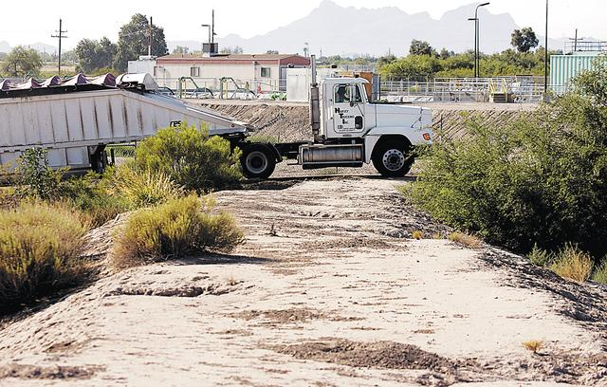
The levy at Santa Cruz River, just north of the Marana Wastewater Treatment Facility, was breached in the 2006 floods, allowing flood water to spread to fields and property just to the north. The county has repaired the levy and removed some debris and brush from the river to prevent more flooding.

Buy Daily Star photo reprints
Michael Burbage owns property hit by flood water in 2006 in Berry Acres in Marana. He wants to build a new home on the property, but the town will not issue permits for land in floodways.

Buy Daily Star photo reprints
Treated effluent flows in the Santa Cruz River at the Trico-Marana bridge, where Pima County has filled in dirt along the bank. Flooding in 2006 covered parts of Berry Acres to the north.

Buy Daily Star photo reprints
A farm stands in flood waters of the Santa Cruz River in Marana in this photo from July 2006. About 80 homes in the area were evacuated.
Jeffry Scott / Arizona Daily Star 2006

Buy Daily Star photo reprints
Bruce Dewey, a Marana resident, said the 2006 floods covered most of his land along Trico-Marana Road near the Santa Cruz River.
Jim Davis / Arizona Daily Star


Published: 07.26.2007
Fight over floodways
Marana residents hit by 2006 floods want more protection from town, county
By Aaron Mackey
ARIZONA DAILY STAR
One year after flooding damaged homes and farms in an older Marana neighborhood, county and town officials have provided the residents few solutions to preventing future floods, short of selling their property and moving.
Complete roads and transportation coverage

Live traffic cams plus the Star's coverage of transportation issues.

Go to site

Traffic blog

Star transportation reporter Andrea Kelly will use this space to post daily updates on I-10 lane and exit closures, as well as other snarl-inducing road work and closures.

Go to blog
The worst Northwest Side storm in more than 20 years dropped 1.1 inches of rain on Marana last July. The resulting flooding damaged homes, forced evacuations and caused an estimated $100,000 in damage to a farm after levees along the Santa Cruz River were breached.
In the aftermath, property owners living in the floodway — the path that flooding water takes — were given two options: clean up and prepare for future flooding or sell their land to Pima County.
As summer storms begin again this year, only one property owner has sold to the county for $105,000. Other residents criticized the approach of the town and county, saying officials should do more to help protect residents who live in flood-prone areas.
And because the town and county won't allow residents to improve their property or rebuild, officials have essentially forced people to sell, one resident said.
Officials said it's too expensive to create better protection along the banks of the Santa Cruz and that their offers for property are fair.
Residents living in the floodway — some of whom own houses built before the area was designated as flood-prone — say they'll probably end up selling to the county.
But for now, they plan to dig in and hope for less rain than last year.
"I'm gambling it'll be another year" without extensive flooding, said Bruce Dewey, a resident who lives in Berry Acres in Northwest Marana. "Have it rain, but not that hard."
Selling the only option
When Dewey bought his property in 1981, there was no floodway or flood-plain designation. That came after years of studies by the Federal Emergency Management Agency.
But complex engineering and hydrology studies mean little to Dewey. All he knows is that last year, there was two feet of water in his home.
The 74-year-old repaired some of the damage himself, but he hasn't been able to get to it all, including some water damage inside his house and landscaping that washed away in the flooding.
After the flooding, Dewey contacted Pima County to see if it would buy his land. The county, which provides flood control in Marana and elsewhere in the Tucson area, has a fund set up to purchase land from people who live in flood-prone areas.
Talks broke down after Dewey said the county didn't appraise his property correctly. He will probably end up selling, but he thinks the county could easily prevent future flooding with improvements along the Santa Cruz.
But making improvements to that area of the Santa Cruz wouldn't be cost-effective, said Chris Cawein, deputy director of the Pima County Regional Flood Control District.
It would cost more to protect property in the area than the affected properties are worth, Cawein wrote in an e-mail.
And even if the county had the ability to construct levees and provide better bank protection, it would need to purchase several homes to make way for the improvements, Cawein said.
"Buying them to complete construction of a levee to protect them would not make much sense," he said.
The flooding proved too much for Matt and Cheryl Cathey, who lived along Grier Road in Berry Acres.
The couple told Pima County flooding left 7 feet of water on the back of their property. They sold the home in April for $105,000
A resident's dilemma
Marana officials said they've left it to residents to decide whether to sell their property, though one accuses officials of using heavy-handed tactics to get him off of his land.
Michael Burbage went before the Town Council in November, seeking approval to build a home on 4.5 acres he owns near the Santa Cruz.
Burbage wants to replace two trailers with a house that would be comparable in size.
The council wouldn't let Burbage build, even though he'd hired an engineer who said the worst flooding would only bring a foot and a half of standing water to his property.
The new home would be built on stilts, so the water wouldn't come close to flooding it, Burbage said.
"They just don't want me to build up here," he said.
That's the truth, Mayor Ed Honea said. "If you live in a floodway, we won't issue permits," he said.
Allowing Burbage to rebuild would not only put him in danger but could potentially cause other residents to be hit with higher insurance premiums, Town Manager Mike Reuwsaat said.
"It still is not prudent," Reuwsaat said. "By allowing those kind of things, it can jeopardize everybody's interest."
But by refusing to let him do what he wants on his property, Burbage said the town is forcing him to sell to the county, something he doesn't want to do.
Burbage likes the area because it's quiet and gives him privacy.
"I plan to stay here as long as I can," he said. "The town's employing scare tactics, but I'm not worried."
Councilman Tim Escobedo, who lives down the street from Burbage, said he can understand the resident's unwillingness to sell.
Escobedo doesn't want to move, either, though he said it's almost impossible to find another willing buyer.
"You're not going to get the full value of your home," he said. "If you have all this property, other than (selling to the county), what else are you going to do?"
Flood causes and prevention
One of the main causes of last year's flooding, according to residents, was the elevation of Trico-Marana Road along the banks of the Santa Cruz.
Rather than flowing over the road, the water backed up onto properties such as Dewey's. The water washed out a portion of the road, too.
If the road had been lowered, residents and Marana officials said, the flooding wouldn't have been as severe. But the county balked at a request to lower the road, Honea said.
As it stands now, the county has no plans to lower the road, said Priscilla Cornelio, the county's transportation director.
The county has cleaned up debris and brush in the Santa Cruz near the Trico-Marana bridge, Cawein said.
That should help more water move through the area, preventing some of the backup seen during last year's floods.
But if there's a big flood, it won't be long before debris from upstream gets stuck in the bridge, Dewey said.
"In my estimation, that was a waste," he said. "It's a token better, but it ain't a lot more."
The county also has repaired a levee that was breached during last year's flooding.
Construction crews had cut into the levee as part of their work on the county-owned Marana Wastewater Treatment Facility.
The opening allowed water to flood Dennis Taylor's dairy and feed farm, causing an estimated $100,000 in damage.
Taylor didn't qualify for disaster relief, so he repaired the farm himself.
"Pretty much, we just fell through the loopholes," he said.
While local officials said they sympathize with Taylor, there's little that can be done to help the problem.
"Some of those farms, they are what they are. They're in the floodway," Reuwsaat said.
Taylor said he's never been approached about selling his property and will instead clean up and hope that the county's repairs to the levee hold.
"I assume everything's OK now," he said. "There's nothing more I can do."
Complete roads and transportation coverage

