Research Partnership Proposal:

Managing Flash Floods:
Risk Perception from a Cultural Perspective

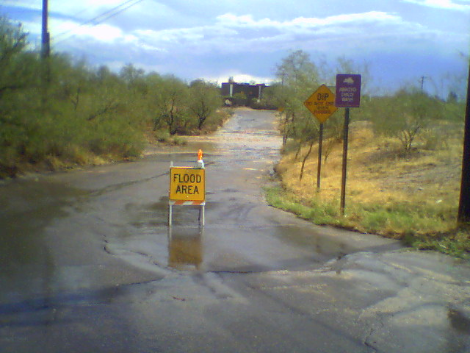
Figure 1: Flooded Arroyo Chico Wash at Highland Ave, Tucson, AZ. July 7, 2006. Moments after this photograph was taken, a truck attempted to cross the wash but then turned back. Why?

Ashley Coles

Department of Geography and
Regional Development

Dr. Katherine K. Hirschboeck
Laboratory of Tree-Ring Research
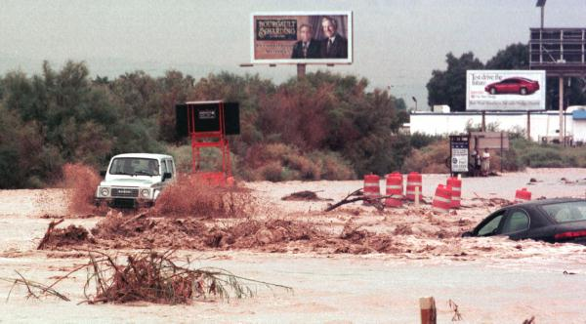
Figure 2: Cars attempt to cross a flooded wash in Las Vegas, July 28, 1999. Photo from www.lasvegassun.com

Are you worried that your carefully designed warnings and mitigation strategies are having little effect on some of Tucson’s residents?

Are you worried about the fact that every time a flash flood occurs, people deliberately put themselves at risk despite your best efforts to warn and educate them about the dangers of flash floods?

Are you interested in developing warnings and mitigation strategies that the public can more easily identify with and will then respond appropriately?
If so, please consider a research and development partnership between the Arizona Floodplain Managers Association (AFMA), the Tucson Flood Control District (FCD), the National Weather Service (NWS), the Arizona Division of Emergency Management (ADEM), and the Climate Assessment for the Southwest (CLIMAS) that aims to identify which cultural factors affect people’s risk perception and behavior during a flash flood, then together create products designed with these cultural factors in mind.

How does culture affect risk perception and response?
Culture refers to a way of life learned from and shared by a social unit, including but not limited to attitudes, beliefs, values, and habits. Values and social norms shape an individual’s worldview, and therefore affect how the individual will understand threats and determine appropriate methods of threat avoidance or amelioration. For example, research has shown that in individualistic societies such as the United States, a high sense of efficacy and control over one’s destiny acts as a double-edged sword: individuals need enough confidence to believe themselves capable of preventing or reducing flood loss, but not so much that they perceive themselves as invincible.
Why is a partnership necessary?
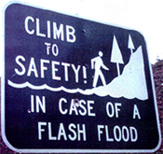
Your input throughout the project will ensure that (a) the questions most important to you are addressed, and (b) the information obtained in this study will have practical application. Since this project is designed to identify possible strategies to assist the flood management agencies in the development of programs to reduce losses in the community, obtaining the information that you believe we need is imperative.
CLIMAS can provide the experience, tools, and techniques necessary to conduct the cultural assessment. Through this cooperative effort, flood management agencies can explore alternative flood loss reduction products or programs with advice that the public will find easier to relate to and follow.

 | What can flood management agencies provide? | What can CLIMAS  provide?
Knowledge & experience | Flash flood mitigation/warnings,  Product/program implementation | Risk perception, techniques for assessing cultural perspectives and stakeholder needs, and integrating these into communication and operations
Interest | Reduction of loss to life and property | Reduction of loss to life and property

Proposed project structure:
Step 1: Forging the partnership. In a workshop hosted by CLIMAS, all participants would collectively determine the goals for the project, including what types of information we each bring to the table and what information we would need to reach our goals.

Step 2: Fieldwork. Surveys will be sent out according to collective agreement, including questions of interest from all participating agencies. Follow up interviews will also be conducted for a small portion of the surveyed public. We will collect and analyze data from the surveys and interviews.

Step 3: Present findings, feedback, brainstorming. We will present a technical report of the results of the surveys and interviews in a second group workshop, where you will have the opportunity to provide feedback. Then, together we will brainstorm ways to turn these findings into real, usable products for the public. If needed, we can reiterate Steps 2 and 3 until we are all satisfied with the products.

Step 4: Product testing. Newly developed products or programs will be presented to focus groups to determine general attitudes the public might have about such products, as well as ways to improve them.

Step 5: Implementation of new products. Possible deliverables include warning phrase alteration, signs, and alternate route maps. A final report will include descriptions of research findings, workshop dynamics, and resulting products.

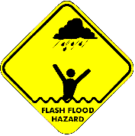

Thank you for your attention and consideration! If you are interested in pursuing this partnership with CLIMAS, please contact Ashley Coles at your earliest convenience.

E-mail: ashley.coles@gmail.com
Phone: 520-331-0704
Office: 105 W. Stadium | University of Arizona | Tucson, AZ 85721

