An Integrated Set of Recommendations
for Vegetation Management in the Santa Fe Watershed

Dr. Ellis Margolis, University of Arizona, Laboratory of Tree-Ring Research
Dr. Melissa Savage, Emerita Faculty, Department of Geography, UCLA

The exclusion of fire since circa 1900 through grazing and fire suppression has altered forest structure and increased crown fire hazard in many forest types throughout the Western United States. Ponderosa pine forests of the Southwest have experienced particularly dramatic changes and have been the primary focus of forest restoration (Allen et al. 2002). However, other forest types (e.g., spruce-fir and aspen/mixed-conifer) are naturally dense, historically burned in crown fires and may not require restoration (Margolis et al. 2007). Recent crown fires resulting from forest density changes in ponderosa pine combined with warming temperatures (Westerling et al. 2006) have caused extensive and severe hydrologic damage in many watersheds across the region. Post-crown fire flood events can be orders of magnitude greater than pre-fire flows (e.g., Veenhuis 2002) and have resulted in catastrophic debris flows in some locations (e.g., Cannon & Reneau 2000).
The overly dense mid-elevation ponderosa pine forests of the Santa Fe Watershed were prioritized for restoration and crown fire hazard reduction due to the importance of the watershed to the water supply of Santa Fe, NM. A crown fire in the watershed would overload the water treatment plant with ash and potentially threaten the two dams and reservoirs used for water storage. Initial mechanical treatments of 7,270 acres of upland, pine-dominant forests in the watershed temporarily reduced the risk of crown fire, but maintenance treatments are vital for future forest health and protection of the water supply. The 6600 acre Wilderness Area in the upper reaches of the watershed has not been treated and very little is know about the forests and potential for treatment in this area. The riparian corridor was not thinned, and is in relatively good functioning condition.
We provide an integrated set of recommendations for vegetation management in the upper Santa Fe Watershed, the portion of the Santa Fe River above the Water Treatment Plant. The upper watershed is divided into two management areas, the lower-upper watershed and the upper-upper watershed (referred to as the Wilderness Area in this document) (Figure 1). The management recommendations are primarily focusing on two objectives: 1) long-range maintenance of the restored part of the forest, and 2) potential strategies for managing the untreated portion of the forest in the watershed. These recommendations emphasize both forest health and the use of thinning, fire management, and other tools for reducing the impact of severe fire on the forest and water supply. The model may also be widely useful, as there is little post-thinning forest management in the region.

Lower-Upper Watershed Prescribed Fire Plan Review & Long-Term Maintenance
Task: Make recommendations for a schedule of prescribed burning for maintenance of restored conditions in the ponderosa pine stands in the Watershed, incorporating District knowledge and experience, including recommendations on interval cycle and seasonality of burns.
Thinning, either by masticating machinery or by hand, alters the fuel structure of the forest by changing live vertical fuels into dead horizontal fuels. An important review of restored forest stands, “Wildland Fire Effects in Silviculturally Treated vs. Untreated Stands of New Mexico and Arizona,” (Cram et al. 2006), concluded that mechanical thinning followed by prescribed fire decreased fire severity and fireline intensity. The most important objective for the Santa Fe Watershed burn plan is that fuel loads be reduced in a timely way and with consideration of the spatial pattern on the landscape of high fuel loads, in order to minimize the risk of a woody debris-fueled high intensity fire. Therefore, it is desirable to maintain maximum flexibility in burn prescriptions as long as ecological needs are met.
The area covered by the Prescribed Fire Plan (Isakson 2006) is 7,270 acres, between 7,400 and 9,800 feet in elevation with an average slope of 45%. The Plan covers only areas which have not been previously pile or broadcast burned. Trees have been thinned to a density ranging between 50 and 100 trees per acre in the area. Fuel loads are estimated at 2 to 6 tons/acre on south aspects with limited thinning, 10 to 36 tons/acre on south aspects with heavy thinning, 40 to 50 tons/acre on north aspects with heavy thinning, and 18 to 27 tons/acre in masticated areas. The suppression goals for this phase of prescribed burning are to control 90% of the high intensity wildfires at 10 acres or less and 90% of the low intensity wildfires at 20 acres or less.

Prescribed Burning Intervals
Maintenance burning is necessary in future years for two reasons. First, burning is required to reduce the fuel loads produced by tree thinning. Secondly, burning is needed to prevent the re-accumulation of biomass in treated forest stands to maintain the reduced risk of high intensity fire. Ideally, the long-term burn periodicity in the Watershed should be similar to the historical fire regime return interval. Balmat et al. (2005) reconstructed a mean fire interval in the lower-upper Watershed of 8 years (1600-1850, all scars), with a maximum fire interval of 18 yrs and a minimum of 1yr. A study by Finney and others (2005) found that fuel treatments significantly reduced fire severity when the treatments occurred between 3 and 9 years before a wildfire, with fire severity increasing with time since treatment. They suggest that the history of the fuel treatments is less important than the time since last treatment. The study also makes the case that it may take repeated prescribed burns before wildland fire use can play its desired role. In order to prevent a return to stand conditions that support a crown fire, prescribed fire should be reintroduced into thinned forests early and often.
We recommend a schedule of four prescribed fire entries into the Watershed to move stand conditions toward those that will allow natural, low-intensity fires to burn. The first entry will be the burning of piled dead and down woody fuels. The second and subsequent entries will be using broadcast burning; the second and third entry will be made using backing fires, and the fourth entry using a head fire. First entries into areas with fuel piles can occur at the same time that second broadcast burns have begun in other areas.
Some prescribed burning has already occurred in the thinned portion of the Watershed (Table 1). Of the 5,285 acres mechanically thinned, two-thirds were cut by chainsaw and piles made of the fuels. These piles need to be burned before any further prescribed fire is to be allowed. As of Spring, 2008 1,548 acres of piles have been burned and 2,446 acres of piles remain to be burned. After all piles have been burned, broadcast burning is implemented. Areas that have been shredded into chunks by machines rather than cut by hand do not leave fuels that require piling and burning, and can be broadcast burned directly after treatment. As of Spring, 2008, 200 acres have already been broadcast burned once, and another 7,070 acres require a first broadcast burn. The first entry—pile burning—plus the second entry—the initial broadcast burn of thinned acres—should be accomplished by 2011 in the Watershed.
The method of broadcast burning for the second and third fire entries uses a “backing fire” to maximize fire control in what are sometimes moderate to heavy horizontal surface fuels and ladder fuels. At this point, fuels are sufficiently reduced such that the fourth entry fire can be a “head fire,” which is faster and is less expensive to conduct than the back-burns.

Table 1. Proposed Prescribed Burn Schedule for Thinned Forest Stands in Santa Fe Watershed
TREATMENT  TYPE | TIME  FRAME | COMPLETED  ACRES | REMAINING ACRES
Mechanical Treatment | 2003-2006 | 5,285 | 0
Cut and Pile | 2003-2006 | 3,994 | 0
Masticated | 2003-2006 | 1,291 | 0
1st Entry Pile Burn | 2003-2011 | 1,548 | 2,446
2nd Entry Broadcast Burn: backing fire | 2005-2011 | 200 | 7,070
3rd Entry Broadcast Burn: backing fire | 2012-2019 | 0 | 7,270
4th Entry Broadcast Burn: head fire | 2019-2026 | 0 | 7,270

Prescribed burning must be implemented when weather and fuel conditions fall in a safe window: dry enough to adequately burn the fuels, yet wet enough to prevent an escaped wildfire, and during proper wind direction and dispersal conditions so that areas sensitive to smoke are not affected. Burn-season weather conditions will affect the pace at which the burn schedule is accomplished. Individual dry years or a prolonged drought may significantly hamper the pace of burning. Under optimal weather and smoke dispersal conditions about 80 acres can be broadcast burned per day. At least 13 days of appropriate burning conditions will be needed each year to reach 1,000 acres of burning. The burn schedule must be flexible enough that more acres can be burned in suitable weather to make up for the lack of burning in unsuitably dry periods.
A primary concern of burning more than 1,000 acres per year is the issue of increasing runoff and sedimentation to the Santa Fe River. However, paired basin monitoring of Watershed treatments to date have shown no increase in sedimentation or ash-laden runoff after mechanical thinning, pile burning or broadcast burning. In addition, hydrologic models developed for the Los Alamos watershed and used to analyze the Cerro Grande fire have provided a useful methodology for assessing the potential impacts of fire treatments in the Santa Fe Watershed and for estimating the risk to water supplies if the treatments are not maintained over time. Modeling of the Santa Fe Watershed predicts that there will be no significant sedimentation from annual fire treatments of 1,000 acres per year. Now that mechanical treatments are complete on 5,285 acres, sedimentation is not predicted even with modeling of natural fire events in the lower-upper watershed under extreme weather conditions. Based on these predictions of sedimentation, no threshold is set to define the maximum number acres that can be burned if suitable conditions exist.
The long-term goal is to burn the entire treated area in the Watershed at a burn interval that will prevent fuel accumulation —especially the establishment of thickets of young trees that increase crown fire hazard. An approximate schedule of an average of 1,000 acres of broadcast burn per year will accomplish a prescribed burn of the entire Watershed every 7 years. This mimics the average historical fire frequency for natural fires in the Watershed, and falls within the 3 to 9 year return interval suggested by Finney and others (2005). The clock on the period of burn interval begins as soon as thinning treatments are complete in any particular area.
The cost for long-term maintenance fire management in the lower-upper watershed was estimated (Table 2) based on the schedule of treatments outlined above. Cost was calculated based on 2007 cost per acre for each treatment type (Appendix A).

Burn Seasonality
The Prescribed Fire Plan calls for burning at three times of year: “Broadcast burning with piles will occur when fuel and moisture conditions allow, but will generally be in fall, winter, or after summer monsoons have begun. First entry broadcast burning will occur in the late summer or fall when environmental parameters can be met.” Considering the fuel loads still on the ground, these are the safest seasons for prescribed burning in this watershed. Climatic conditions are unstable in the spring, with the potential for sudden, high winds followed by a predictably dry and warm early summer pre-monsoon period. There also tends to be an abrupt transition from very snowy conditions, preventing an efficient burn, to risky dry conditions with unpredictable winds.
Understory plants in low-intensity fire adapted forests recover quickly after fire, and although there is some evidence that response of understory plants varies by burn season, there is not yet a consensus on which seasons are likely to produce the best response. Fall burns can encourage the growth of exotics, such as Dalmatian toadflax and cheatgrass (Abella and Covington 2004). Monitoring to detect changes in abundance of non-native invasive species could be focused on areas burned in the fall.

Table 2. Projected Maintenance Fire Treatment Costs in the lower-upper Santa Fe Watershed
YEAR | TREATMENT | ACRES | COST | TREATMENT | ACRES | COST | PROJECTED ANNUAL COST
2008 | 1st Entry pile burn | 612 | $107,013 | 2nd Entry broadcast | 1000 | $145,000 | $252,013
2009 | 1st Entry pile burn | 612 | $107,013 | 2nd Entry broadcast | 1000 | $145,000 | $252,013
2010 | 1st Entry pile burn | 612 | $107,013 | 2nd Entry broadcast | 1000 | $145,000 | $252,013
2011 | 1st Entry pile burn | 612 | $107,013 | 3rd Entry broadcast | 1000 | $125,000 | $232,013
2012 |  |  |  | 3rd Entry broadcast | 1000 | $125,000 | $125,000
2013 |  |  |  | 3rd Entry broadcast | 1000 | $125,000 | $125,000
2014 |  |  |  | 3rd Entry broadcast | 1000 | $125,000 | $125,000
2015 |  |  |  | 3rd Entry broadcast | 1000 | $125,000 | $125,000
2016 |  |  |  | 3rd Entry broadcast | 1000 | $125,000 | $125,000
2017 |  |  |  | 3rd Entry broadcast | 1000 | $125,000 | $125,000
2018 |  |  |  | 4th Entry broadcast | 1000 | $100,000 | $100,000
2019 |  |  |  | 4th Entry broadcast | 1000 | $100,000 | $100,000
2020 |  |  |  | 4th Entry broadcast | 1000 | $100,000 | $100,000
2021 |  |  |  | 4th Entry broadcast | 1000 | $100,000 | $100,000
2022 |  |  |  | 4th Entry broadcast | 1000 | $100,000 | $100,000
2023 |  |  |  | 4th Entry broadcast | 1000 | $100,000 | $100,000
2024 |  |  |  | 4th Entry broadcast | 1000 | $100,000 | $100,000
2025 |  |  |  | 5th Entry broadcast | 1000 | $100,000 | $100,000
2026 |  |  |  | 5th Entry broadcast | 1000 | $100,000 | $100,000
2027 |  |  |  | 5th Entry broadcast | 1000 | $100,000 | $100,000
TOTAL 20-YEAR PROJECTED COST |  |  |  |  |  |  | $3,043,800

Smoke Issue Review
Task: Review the smoke impacts of the USFS burn plan
The USFS burn plan outlines multiple smoke monitoring and mitigation options to ensure compliance with New Mexico Environment Department – Air Quality Bureau (NMED – AQB) standards in respect to smoke emissions from prescribed fire. These include:
Smoke monitoring - smoke monitoring of volume, lifting and dispersal to be recorded on standard forms required by NMED – AQB that is reported hourly to the burn boss. Trigger point: the burn boss must consider a change in action (including shutting down the burn) if the smoke monitoring device (located on Upper Canyon Rd) exceeds the 24hr EPA smoke limit.
Identification of sensitive areas – the City of Santa Fe and surrounding areas, the I-25 corridor and the Pecos Wilderness area are all listed as areas sensitive to smoke
Smoke mitigation options - seven management options are listed in the burn plan to help the burn boss reduce smoke dispersal to sensitive areas, including adjusting the daily burn window, reduced burn block sizes and taking breaks after days with heavy smoke production.
A separate smoke monitoring plan (USFS 2002) describes detailed visual and instrumented smoke monitoring, mitigation, and lists an additional 10 smoke sensitive areas extending as far away as Taos and the Wheeler Peak Wilderness, NM. Smoke dispersion modeling (SASEM) is outlined (Hudnell 2000) for multiple burn prescriptions and the results indicate that National Ambient Air Quality Standards are not expected to be exceeded during any prescribed burn scenario. This is in contrast to the modeled wildfire scenario, which did exceed air quality standards.
These preparations for potential air quality problems due to smoke seem to have been effective based on the monitoring report for April – December 2003 (Barkmann 2003). During this period the 24-hr average recorded by the real-time instrumentation never exceeded the federal standard (for particulates less than 2.5 microns in diameter) and the 1-hr average reached the “unhealthy for sensitive groups” threshold for only six 1-hr periods. These data cover 17 burn days and 650 acres of pile burning.
To mitigate the effects of smoke from fire management in the watershed we recommend the continuation of current smoke management practices combined with continued public outreach.

Other Long-term Maintenance Concerns
1. Evaluate piñon-juniper stands in the lowest part of the Watershed. A plan for the treatment of the piñon-juniper stands in the lower part of the watershed should be developed, including prescribed burning if deemed necessary. These woodland stands should be inventoried to evaluate their condition, including whether density is within a historical range of variability, whether a fire occurring in the piñon-juniper stands could carry into the untreated stands above. An assessment of whether the understory is robust enough to minimize soil erosion should also be made, and if needed, some lop and scatter treatments should be implemented to improve grass and forb cover in order to reduce soil erosion.
2. Continue to protect Southwestern white pine. During planning of restoration treatments, a concern was expressed for the fate of Southwestern white pines in the Watershed, whose populations have suffered in the West in recent years. The protection of southwestern white pines should continue to be an objective throughout long-term prescribed burning maintenance.
3. Protect against invasive grasses and forbs. A lag in the population expansion of undesirable invasive species into restored forests has been reported in some treatment areas. In particular, the establishment of cheat grass (Bromus tectorum L.) is a concern, due to the ability of cheat grass stands to significantly alter fire regimes. Most notably, cheat grass can compete vigorously with native grasses during a drought, and forest restorations that occur during a dry period should be aware of the potential for cheat grass invasion.
Wilderness Area
Task: Make an integrated set of recommendations for reducing the threat of catastrophic fire within the Wilderness portion of the watershed, and other objectives including maintenance and restoring forest health, consistent with Wilderness values. The strategy will include:
• A general ecological description of current and historical vegetation and fire regimes in the Wilderness portion of the Santa Fe Watershed.
• Criteria to evaluate where treatments are recommended, potential, and not recommended, and identification of these areas. Treatments may include strategically placed hand cutting of trees, prescribed fire, and naturally ignited fire used for resource benefit.

Vegetation
Current:
The combined influence of elevation, aspect, soils and disturbance history have resulted in current dominant vegetation types that range from mesic alpine grasslands above tree-line to xeric, sparse pine and oak types with yucca and cactus present on rocky, south-facing, exposed slopes at the lowest elevations. The best existing vegetation map contains 10 vegetation classes present in the Wilderness Area (Figure 2). The relatively coarse scale of the map combines vegetation types that may in fact have differing fire regimes (e.g., Gambel oak, ponderosa pine and piñon pine are all combined into a mixed conifer type) and thus should be used with caution when trying to map areas for fire management.
For the purpose of fire management, the vegetation of the Wilderness Area can be divided into two general types: 1) the lower elevation (<10,000 ft) mixed conifer forests and 2) the upper elevation (>10,000 ft) spruce-fir dominant forests (Figs. 1 &2). The general difference in vegetation types was very evident from on-the-ground field reconnaissance. This “division” is more accurately described as a gradient that varies with aspect and slope position. These two variables affect the local radiation and moisture balance that ultimately determines which tree species can survive at a particular site in the absence of disturbance. The two general vegetation types defined above are used in subsequent discussions of vegetation and fire regimes.
Spruce-fir zone
Age data of the dominant trees (largest diameter at breast height) is available for nine, 330 ft transects dispersed throughout the upper elevation spruce-fir zone (Margolis et al. 2007b). The collective age structure indicates that the majority of the establishment of the dominant trees occurred between circa 1700 and the mid-1800’s. Very few of the dominant trees established prior to circa 1650 or after circa 1900, with the peak number of trees establishing between 1760 and 1800. The age structure of dominant trees at the individual transects reveals the variability between plots within the spruce-fir zone.
Age data for smaller diameter (younger) trees is not available. These would be helpful to assess whether there have been changes in stand-density, and consequently crown fire hazard, that may have resulted from forest management over the last century. Without these data, we can use qualitative field observations and knowledge of the processes that control regeneration in these forest types to address this question. It is unlikely that stand-density has been affected by management in the spruce-fir zone for two reasons:
1) the effects of fire suppression on spruce-fir forests are thought to be minimal, because there are relatively few ignitions in this zone and crown fire burning in spruce-fir are virtually impossible to suppress
2) sub-alpine, spruce-fir vegetation types naturally increase in tree density with time following stand-replacing disturbance
Thus, the model of fire suppression causing increased stand-density and increased crown fire hazard that has been problematic in ponderosa pine forests (Allen et al. 2002) does not apply to these, upper elevation spruce-fir forests (Sibold et al. 2006).
Mixed-conifer zone
Tree age data are not available for the mixed-conifer zone. These data and stand-density estimates would be necessary to determine if increased understory recruitment has led to changes in fuel structure and ultimately changes in crown fire risk. The cessation of surface fire in these vegetation types due to grazing and fire suppression, similar to ponderosa pine, provides a mechanism for possible human-induced changes in stand density. Thus, quantitative analyses of stand-density changes would be necessary to justify thinning in the mixed conifer forests of the Wilderness Area based on the objective of forest restoration alone. However, strategic thinning on ridges or to break up large areas of continuous fuel, with the objective of crown fire hazard reduction for watershed protection could be justified without forest structure data.

Fire Regimes
Current:
All ignitions within the Wilderness Area are currently suppressed immediately, which has been the policy since the US Forest Service began managing the area as a closed municipal watershed in 1932. Six lightning ignitions have been reported between 1961 and 2000 (unpublished USFS GIS records). Thus, no fires greater than 1 acre have burned in the Wilderness Area for at least 47 years based on these records. Coarse-scale (1km resolution) fire regime condition class data indicates that 30% of the Wilderness Area is in class 3 (high departure from historical vegetation and disturbance regime conditions)(Table 3)(Hann et al. 2003). However, the coarse scale (1km resolution) of this remotely sensed model and the lack of local ground truthing decrease the confidence in these classifications.
Table 3. Fire Regime Condition Classes for the Santa Fe Watershed Wilderness Area. Minimum mapping unit is 1km X 1km.
Fire Regime Condition Class | area (acres) | percent of total area
0-35 yrs; Condition Class 1 | 1325.8660 | 20.1
0-35 yrs; Condition Class 2 | 139.7360 | 2.1
0-35 yrs; Condition Class 3 | 290.3310 | 4.4
35-100+ yrs; Condition Class 1 | 2737.9830 | 41.5
35-100+ yrs; Condition Class 2 | 382.5200 | 5.8
35-100+ yrs; Condition Class 3 | 1718.5520 | 26.1

Historical conditions:
Historically, fire was a relatively common, important ecological process in the Wilderness Area (Margolis et al. 2007b). The tree-ring record indicates that two types of historical fire regimes existed in the Wilderness Area: 1) a stand-replacing fire regime with no evidence of surface fire and 2) a mixed-severity fire regime with evidence of surface fire and smaller patches of stand-replacing fire. These two types of fire regimes were generally separated along vegetation and elevation boundaries.
The historical fire regime in the upper elevation (>10,000 ft) spruce-fir dominated forests was characterized by relatively widespread stand-replacing fire with no evidence of surface fire (i.e., fire scars or charred bark). The last widespread fire in these upper elevation vegetation types burned as a stand-replacing fire in 1685. Due to the stand-replacing nature of this type of fire regime, which kills and burns tree-ring evidence of prior fires, no fire return interval statistics could be derived for historical fire in the spruce-fir zone. Methods do exist to reconstruct landscape-scale fire frequency estimates (natural fire rotation) in crown fire regimes, but this requires more forest age data than is currently available.
Although no fire frequency estimates are available, fire-climate analyses suggest that an extreme single-year drought was associated with the last large stand-replacing fire. Additionally, similar forest types in the adjacent Tesuque watershed burned in two stand-replacing fires in the late 19th century (Margolis et al. 2007a). This may suggest that sufficient fuel existed over 100 years ago in the upper elevations of the Santa Fe Watershed (assuming that the forest was similar in age to the Tesuque watershed at the time of the last fire) and that an additional 120 years of fuel has accumulated in the Wilderness Area since then.
The historical fire regime in the lower elevation (<10,000 ft) pine and mixed-conifer forests in the Wilderness Area had evidence of repeated surface fire (i.e., individual trees with multiple fire scars) and the potential for smaller (<100 acres) stand-replacing fire patches in some locations. The last fire recorded by fire scars was in 1879 and the last widespread fire was in 1842, which was recorded by >50% of the fire-scarred trees. Widespread surface fire occurrence was less frequent on average (20% scarred WMFI = 33 yrs; Table 4) compared to the mid-elevation ponderosa pine dominated forests below the Wilderness Boundary (20% scarred WMFI = 16 yrs; Balmat et al. 2005).
Examining the historical fire regime with more detail than central tendency statistics (mean and median) can provide, the tree-ring record indicates that the frequency of fire varied considerably over the last 400 years. Small fires (recorded only by single trees) occurred somewhere within the study area as frequently as one year apart (all scars, minimum interval = 1 yr), whereas widespread fires (scarring >25% of recording trees) were not recorded during a 94 year fire gap between 1748 and 1842. This range of fire intervals emphasizes the need to consider variability during fire restoration. Strong relationships between variability in reconstructed climate variables (Palmer Drought Severity Index, precipitation and the Niño3 index) and fire occurrence indicate that much of the historical variability in fire frequency was driven by the inherent variability of climate in the Southwest. This relationship breaks down in the 20th century, when no fires were recorded in the study area. Future, managed fire regimes would be most natural if these two processes (fire occurrence and climate variability) were re-coupled.
Table 4. Santa Fe Wilderness Area mixed-conifer fire interval statistics (1595-2006).
Filter | Number of intervals | Mean fire interval | Median fire interval | Weibull median fire interval | Minimum interval | Maximum interval
all scars | 18 | 15.56 | 15.5 | 13.56 | 1 | 31
10% | 9 | 31.11 | 30 | 29.69 | 15 | 71
20% | 7 | 34.71 | 30 | 33.31 | 16 | 71
25% | 6 | 40.5 | 31 | 37.18 | 16 | 94

In the following section we identify criteria and general locations where treatments are recommended, not recommended and where there is the potential for treatment pending additional data. Treatments may include strategically placed hand cutting of trees, mechanical thinning on strategic ridgetop locations immediately adjacent to the Wilderness boundary, prescribed fire, and naturally ignited fire used for resource benefit.

Criteria used for designating levels of recommendation for treatment types:
Criteria were developed to determine where treatments in the Wilderness Area are 1) recommended, 2) not recommended and 3) there is potential for treatment pending additional data. These criteria were used to ultimately map areas of each treatment type (Figure 3), quantify a range of acres in each treatment and recommendation class, and estimate max and minimum potential cost (Table 5). The criteria cover the two primary objectives of the forest management in the watershed: 1) reduce the risk of catastrophic crown fire for protection of the water resource and 2) maintain or restore forest health. Decisions regarding the criteria are based on available forest structure and age data (presented above), current and historical fire regime data (presented above), and general knowledge of fire behavior in southwestern montane forest types. The concept of historical range of variability (HRV): the ecological conditions, and the spatial and temporal variation in these conditions that are relatively unaffected by people (Landres et al. 1999), was used to determine where areas were in a “natural state” (based on HRV) when the objective of forest health was considered. The treatment types considered are 1) fire, 2) hand thinning, and 3) mechanical thinning immediately adjacent to the Wilderness boundary.
We begin with criteria for determining areas where treatment is NOT RECOMMENDED. These are primarily areas where we do have sufficient data to evaluate the decision criteria. A benefit of excluding areas from consideration for treatment is that it minimizes the land area for future decisions regarding treatment.
Fire treatment (prescribed fire or fire for used for resource benefit) is not recommended based on the following criteria:
- Forests are in natural state (based on HRV of fire regime) OR
- Forests are in unnaturally dense state and crown fire is likely if burned now without prior treatment OR
- Forests naturally burned in crown fire and will likely do so if burned now
Hand thinning is not recommended for the following reasons:
- Forests are in natural state (based on HRV of forest age and structure) OR
2. These areas overlap in the spruce-fir zone and a single NOT RECOMMENDED class covering the fire and thinning class is presented on the map.
Fire treatment (prescribed fire or fire used for resource benefit) is POTENTIAL based on the following criteria:
- Forests fuel structure (crown base height, crown spacing, surface fuel loads) is conducive to low intensity surface fire in some locations, based on preliminary field observations. However, we need spatially explicit data on vegetation type and fuel structure to ultimately recommend spatially explicit fire treatments. Collection and analysis of these data should be high priority.
Hand thinning is POTENTIAL for the following reasons:
- Forests are in unnaturally dense state (based on HRV) AND…
- Areas are in strategic locations (e.g., ridges) that would reduce the risk of fire from adjacent watersheds from entering the Santa Fe Watershed or facilitate the containment of fire within the Wilderness Area.
The majority of the mixed conifer area, which is where there was evidence of historical surface, was mapped as a POTENTIAL treatment area covering both fire and hand thinning. It is not likely that the whole are would be burned or hand thinned, thus estimates of a proportion of the area were made (10% hand thinned in strategic locations and 25% burned in relatively flat areas with natural boundaries for holding line protection). The specific location of these areas requires more data. An additional category was mapped (POTENTIAL hand thinning), where ridges drop from the watershed boundary and could be used as strategic holding locations.
Mechanized thinning treatment is RECOMMENDED for the following reasons:
- Areas are in strategic ridgetop locations immediately adjacent to the Wilderness boundary, where fire has the highest probability of entering the Santa Fe Watershed based on a range of prevailing wind directions (S - W) and public access to land that may lead to increased ignitions.
This category was mapped and treatment area and cost estimated (Figure 3, Table 5).
Summary of the Wilderness Area recommendations:
1. Wilderness Area spruce-fir zone:
• Recommendation – No treatment
Treatment is NOT RECOMMENDED for 4,017 acres of spruce-fir vegetation in the upper Santa Fe Watershed Wilderness Area due to the natural state of the forest and fire regime as compared to the historic range of variability derived from tree-rings.
2. Wilderness Area mixed conifer zone:
• Recommendation – Potential for fire and/or strategic hand thinning pending additional data
There is POTENTIAL for treatment of an estimated maximum of 780 acres (<1/3 of total area) of mixed conifer, ponderosa pine and Gambel oak vegetation in the lower portion of the Wilderness Area. Hand thinning and fire treatment would be aimed at breaking up contiguous fuels to reduce crown fire risk within the mixed conifer zone and maintaining or restoring areas with historical evidence of frequent surface fire regimes. The remaining area in the mixed conifer zone is likely too steep, dense and inaccessible to burn efficiently and without the risk of escaped crown fire into the adjacent spruce-fir zone.
3. Forested areas immediately outside of the Wilderness Area boundary:
• Recommendation – Mechanical thinning treatment
To reduce the risk of fire from entering the upper watershed from adjacent watersheds we recommend thinning an estimated 188 acres on the ridges immediately adjacent to the south and west of the Wilderness boundary. These boundaries have the highest risk of fire due to public access and prevailing wind direction.

Table 5. Area (acres) of four management options with different levels of recommendation and cost.
Management option | Recommended | Potential | Not Recommended | Potential maximum treatment (acres/$) | Potential minimum treatment (acres/$)
Hand cutting (along strategic ridges) | 0 | 230  (1/10 of MC) | 4017 | 230 ($161,000)  $700/acre | 0
Fire (prescribed or fire use) | 0 | 550  (1/4 of MC ) | 4017 | 550 ($79,750)  $145/acre | 0
Mechanical thinning (immediately adjacent to Wilderness Boundary) | 188 | ----------- | ------------ | 188/$177,660  $945/acre | 188/$177,660  $945/acre
Non-native tree removal in riparian corridor (2-mile reservoir to Nichols reservoir) | 10 | ----------- | ------------- | 10/$5,000  $500/acre | 10/$5,000  $500/acre
Total | 188 | 780 | 4017 | 978/$418,910 | 198/$182,660

Riparian Zone recommendations
Task: Create a plan for potential fuel reduction and/or restoration treatments in the riparian area between the two reservoirs and from the upper reservoir to the Wilderness section.
The riparian community along the Santa Fe River above Nichols Reservoir is reasonably intact relative to other southwestern riparian zones, and relative to the pre-treatment conifer forest of the Watershed. The 1998 Tolisano study of the riparian zone stated that “the overall hydrologic and ecological features suggest a resilient and healthy riparian ecosystem.”
Existing conditions:
Riparian zones comprise the vegetation systems adjacent to rivers where dynamic processes of erosion, deposition, and water flow occur. Typically, riparian communities occupy a small portion of the landscape, but contain the majority of plant diversity in the landscape. There are approximately 10 miles of stream from the headwaters to McClure Reservoir, and three miles of stream between the two reservoirs. Several prior studies have characterized existing conditions of the riparian community in the Watershed.

Tolisano report
The Tolisano Report (1998) characterized existing conditions in three stretches of the Santa Fe River: lower, middle and upper. The upper reach of the river courses through the very steep portion of the Watershed, where canyon walls dip steeply to the river, confining the riparian zone to a narrow strip. This part of the riparian community is fairly undisturbed and likely near historical conditions. The middle reach of the river was defined by Tolisano as the reach from McClure Reservoir to a point within the Wilderness, thus encompassing the reach from McClure to the Wilderness boundary and extending above it. The river in this reach emerges from the steeply cut canyon, and spreads out into a wider floodplain. In this section, the floodplain is recharged with overbank surface flows periodically, has a shallow ground water table, and supports more species and higher structural diversity.
The reach between the reservoirs, Tolisano’s ‘lower reach,’ was characterized by “a mix of properly functioning riparian conditions.” Tolisano used the BLM’s Proper Functioning Conditions (PFC) methodology to measure riparian community health (BLM 1993). For the reach between the dams, the PFC ratings for canopy cover, vegetation width, structural diversity, ground diversity, were all graded as “properly functioning hydrologic and ecological features”—reflecting “adequate levels of “biological diversity, ecological structure and resilience, growth, vigor, and regenerative capacity to ensure the long term viability of the ecosystem”, and site diversity, channel stability and canopy cover ranked at “optimal condition”—reflecting “high levels” of those traits. Tolisano described this portion of the riparian community as “highly diverse in composition and structure,” with a wide riparian zone with multiple canopy layers, numerous shrubs and an abundant understory of saplings, shrubs and herbaceous plants. River banks are “highly stable” and sediment effectively dispersed downstream. Tolisano notes that the riparian zone between the two reservoirs is dependant upon the timing and quantity of water releases from McClure, and that the condition of the riparian community in this reach seems to reflect an adequate release pattern.
Below Nichols Reservoir, however, Tolisano observed more degraded conditions. There is little overbank flooding in this reach, although the width of the riparian zone continues to be reasonably wide, reflecting an adequate water table. Non-native invasive species, such as Russian olive and Siberian elms, have moved into the riparian community below Nichols Reservoir. Tolisano notes that these species could easily travel upstream and invade the upper river communities, and that this would significantly reduce the quality of wildlife habitat of the riparian community.

Rocky Mountain Research Station data
Rocky Mountain Research Station sampled vegetation in the riparian community as part of the monitoring effort that accompanied forest treatments. The data documents that, although the community is fairly diverse, five species account for 90% of the trees found in the sampled riparian community: aspen (Populus tremuloides) (113/acre - 27% of all trees), ponderosa pine (Pinus ponderosa) (89/acre - 21%), mountain alder (Alnus tenuifolia) (70/acre - 17%), white fir (Abies concolor) (64/acre - 15%), and Douglas fir (Pseudotsuga menziesii) (44/acre - 10%). Other tree species found on the site in smaller numbers include narrowleaf cottonwood (Populus angustifolia) (16/ac), Rocky Mountain maple (Acer glabrum) (8/ac), limber pine (Pinus flexilis) (6/ac), Rocky Mountain juniper (Juniperus scopulorum) (4/ac), Gambel oak (Quercus gambelii) (3/ac), chokecherry (Prunus virginiana) (1/ac), piñyon pine (Pinus edulis) (1/ac) and snowberry (Symphoricarpos spp.) (1/ac).
The study documented dead standing trees in the riparian zone, 26/acre for snags larger than ~ 5” and 93/acre for snags smaller than ~ 5”. Aspen are the most numerous snags (average dbh 9” [diameter breast height]), ponderosa pine (average dbh 6”), Doug fir (average dbh 5”), cottonwood (average dbh 11”), and white fir (average dbh 7”). Most are relatively small size snags, which tend to fall more rapidly than larger snags.
The largest live trees on the site are ponderosa pine, with 20% of trees over 16” dbh. Of the other four most common trees, there were few large trees: only 7% of white fir, 3% of Douglas fir, and 5% of aspen were larger than 16” dbh; no mountain alder trees were larger than 5” dbh. Nearly 75% of the aspen are smaller than 8” dbh. In general, especially in moist sites, size reflects age, and, together with what we know about human impacts in the past, the data support the case that most trees in the riparian community established fairly recently.

Blue Earth Existing Conditions Report
This report documented in detail the species composition and distribution of the various types of riparian communities found in the Watershed. The author discusses the issue of water release from McClure Dam and its effect on the community. He notes that flooding has been reduced enough that the upper portions of the floodplain have become drier and more suitable to conifer establishment than riparian vegetation: “The floodplain has essentially become abandoned and now comprises a terrace.” In addition, sampling was conducted in August, at which time there was no water flowing in the riverbed, and water occurred in isolated pools only. The report points out both the benefits of flow regulation—reduced destructive effects of flooding, such as destruction of beaver dams at peak flow—and the disadvantages—reduced overbank flows that favor establishment of riparian species.

Potential Riparian Community Restoration Treatments
A series of recommendations for the riparian community have been made in various agency and other documents over the history of the restoration project for the Santa Fe Watershed, and we here consider their merits.
Fuel reduction/thin conifers to reduce fire risk One potential restoration treatment is be the thinning of ponderosa pine trees and other conifers within the riparian community in order to lower the threat of crown fire. The Record of Decision calls for creating openings in the riparian community between the two reservoirs. A Forest Service document by Cassidy (2000) suggest that in both the riparian zone between the reservoirs, and above McClure to the Wilderness boundary, that the number and size of conifer trees, especially ponderosa pines, suppress riparian species regeneration and offer a crown fire threat. Cassidy suggests that the removal of smaller conifer trees (12 to 16” dbh) and a burn only scenario are both inadequate to address the problem; and that removal of conifer trees up to 24” dbh and the reintroduction of cool fires into the riparian zone are needed. Given the need to remove the biomass from the site and the impact of skidding or other surface removal, he suggested helicopter removal of trees as the best treatment option (Cassidy 2000).
What the historical structure and composition of tree species in the riparian was like in its historical range of variability is unclear. It is our assessment that the historical structure of the riparian community below the Wilderness boundary was sufficiently disrupted by human activities, especially by fuel wood cutting and intensive domestic grazing, that it is not possible to usefully reconstruct reference structures through tree-ring analysis. Pittinger (2000) suggests that the current riparian community established only 50 to 60 years ago. Given the human disruption of the past, it is more advisable to base ‘restoration’ on current conditions, than on reconstructed pre-settlement conditions.
The question of the desirable ratio of conifer trees to riparian vegetation is probably best asked in relation to fire risk. In terms of reduction of overall fire risk, the riparian zone is now effectively isolated from a spreading crown fire by thinning of the surrounding ponderosa pine forest. The likelihood of fire originating in the riparian zone and spreading into adjacent stands of conifers is low. Thinning conifers and removing the biomass would involve practical difficulties, considerable time and money, and disturbance impacts on the riparian community.
Moreover, given the low densities of adjacent thinned stands, the riparian zone offers an important refuge for wildlife seeking high density vegetation stands. Dodd et al. (2006), for example, recommend maintenance of such refuges of high-quality habitat in restored ponderosa pine forests for Abert squirrel (Sciurus aberti) populations. Since the riparian zone has been documented as largely within proper functioning conditions, and given the difficulties of removal of biomass, we do not recommend removal of any conifer trees from the riparian zone in the near term.
Planting trees and shrubs The Forest Service Record of Decision (2001) calls for planting additional trees and shrubs in the riparian zone, while retaining all willow, alder and cottonwoods in the riparian community. The Tolisano report also recommended planting of deciduous riparian species such as cottonwoods, alders, maple and box-elder trees below McClure Reservoir.
The riparian community appears to be in recovery from human impacts that were historically quite severe. Cutting of firewood and domestic grazing resulted in the past in nearly denuded areas around the Santa Fe River, as documented in photographs taken of the area early in the 20th century. Since there is insufficient information on species composition prior to human activities, and since the community is functioning well, it seems advisable to allow natural processes to shape the composition of the riparian community rather than artificially alter composition. Continued monitoring of riparian species populations should guide the decision to plant native species. We do not recommend planting in the riparian zone at this time.
Burn areas within the riparian community The “Monitoring Forest Treatments in the Santa Fe Municipal Watershed” (2003), discusses the TAG proposal that the effects of fire on riparian ecosystem be explored, including the suggestion of a small-scale study of the effects of fire on riparian sites. The TAG concluded that the study should be postponed until the main watershed thinning was complete. Now that the thinning is largely accomplished, is it appropriate to conduct a controlled experiment that tests the effect of fire on the current structure of the riparian community?
The probability of high-intensity fire entering the riparian corridor from adjacent forests is low, now that the matrix of conifer forest surrounding it has been thinned to a low density. The effects of fire on upland riparian zones in the West is poorly characterized (Reeves et al. (2006). However, the moist conditions of the riparian zone, and the presence of deciduous trees such as aspen with lower levels of volatile compounds than conifer trees, makes it less likely that fire would travel up the corridor under most climatic conditions. If portions of the riparian corridor were to burn naturally, they are likely to recover rapidly (Reeves et al. 2006). If there is a prolonged and severe drought, the vulnerability of the riparian zone to crown fire should be reassessed, particularly with regard to dead and down fuel load. We do not recommend burning with prescribed fire within the riparian zone at this time.
Down trees to mimic windfall Dead trees often falls across streams in complex patterns that enhance stream condition. Downed logs partially lying across streams can protect banks from erosion, dissipate stream energy, form pools, and store sediment. Stream banks can thereby store more moisture and nutrients. Cutting and dropping some ponderosa pine trees into the streambed has been suggested in order to introduce debris into the river.
The Tolisano Report documented fallen branches, whole trees, and other woody debris along the stream throughout the Watershed, and characterized the dead and down load as “representative of properly functioning or optimal ecological conditions.” Pittinger (2000) indicates the value of large woody debris, and the beaver dams that exist between the two reservoirs, in creating pools for trout. It was Tolisano’s opinion that there is already enough downed wood to represent a potential fire threat during a drought.
There appears to be no critical need for changing the structure of debris in the stream at this time, since the riparian community was recently given high marks for function. In addition, the RMRS sampling documented the presence of a number of dead standing trees, which will be falling in the future, some of which may fall into the stream. We believe it is preferable to let natural processes of tree mortality and fall help to shape the streambed in the future, and we do not recommend felling additional trees for this purpose.
Bring back the river otter The suggestion has been made, in the Tolisano report and elsewhere, to reintroduce the river otter to the Santa Fe River. The NM Department of Game and Fish is now in the midst of an effort to restore otters to the Rio Grande and Gila Rivers. The Santa Fe River, however, falls very short of an adequate prey base or an adequate flow to support an otter population, which would be isolated from other populations in the State in any case (Stuart 2006). We do not recommend otter reintroduction.
Release water from McClure Reservoir Spring flooding is a key natural process in southwestern riparian communities. On a regular basis, flooding brings sediment and nutrients, both of which encourage seedling germination. Flooding can favor species that require a mineral seedbed, and disperse seeds, such as those of cottonwoods.
The City Water gauge above McClure Reservoir, which measures the pulse of flow in spring from snowmelt, provides information that reflects the natural streamflow unaltered by dams. This gauge documents a fairly long record of year-round water flows, which, as expected, reach a maximum in spring during snowmelt (City of Santa Fe data). The average flow over this period, which contains some data reconstructed from reservoir levels and releases from the lower dam, is 425 acre feet per month, with a minimum of 0 acre feet per month, and a maximum of 4,820 acre feet per month (May, 1973). Although the latter value is an extreme value from a wet period, monthly flows in spring in the 2-3,000 acre feet per month value range are not uncommon. During dry periods maximum monthly values do not usually exceed ~ 1,000 acre feet per month at high flow in spring, and can be much lower. Stream flows are greatest, in general, during the three months that reflect snowmelt, i.e., April, May and June.
Streamflow modification is the most common form of restoration in southwestern riparian systems, as restoration of natural process is favored over structural modification (Follstad Shah 2007). One goal of restoration is to reestablish the natural processes that keep communities within their natural range of variability over time. This approach reduces the uncertainty that accompanies human choices in restoration work. The upper gauge streamflow data can be used to shape the release of water from the upper dam into the reach between the two reservoirs. Such a release of water in the spring period when snowmelt would have naturally occurred, would mimic a natural process that helped shape the riparian community in that stream reach. We recommend refining the spring release from McClure, a release of water from the upper dam that mimics the annual peak flows in springtime. The benefits to riparian features should be used as a guide to timing and quantity of releases.
One benefit of higher peak flows between the reservoirs should be a reduction in conifer seedling establishing within the floodplain. Sustained flows throughout the growing season between the reservoirs should also benefit riparian species establishment. In addition, fires appear to have occurred in upland riparian zones with a frequency similar to the ponderosa pine forest matrix (Arno and Peterson 1983). Peak flows may sweep away and accelerate decay of the high fuel loads in parts of the riparian zone, and sustained summer flows would keep dead and down fuels moist throughout the natural fire season. Higher peak flow may also destabilize and, in time, fell some of the large established conifer trees in the riparian zone.
In the long-run, it would also be advisable to consider the ecological impacts of releases from Nichols Dam on the riparian zone below. Although there are water storage considerations that are not an issue for between-reservoirs release, the more degraded riparian corridor below Nichols Dam may benefit also from spring water releases.
Changing the pattern of springtime releases from the reservoirs, however, must be considered carefully. Tolisano, while noting the benefit of natural levels of flooding in springtime for the riparian community, also pointed out that current release levels appear to be adequate to produce a healthy community. Any adjustment of release flows should be accompanied by intensive monitoring of PFC parameters, especially bank stability,
A final riparian issue is the presence of non-native invasive tree species below Nichols Reservoir. Russian olive and Siberian elms are currently growing around the decommissioned Two-Mile Dam, and populations of the invasive forb Toadflax have been observed in this area (Tolisano 1998, Pittenger 2000). Without treatment, it is likely that invasive non-native species that occur in the lower reach of the Watershed riparian zone will soon disperse and establish farther up the river. It is not altogether clear what the role of these invasive trees is in the riparian ecosystem, for example, whether or not they are deleterious or beneficial to native bird populations. Nevertheless, it seems best to err on the side of caution in regard to the spread of non-native trees farther into the upper Watershed.

Summary of riparian restoration recommendations
The riparian community in the Santa Fe Watershed is, on the whole, in relatively good condition. Judged by both the standard of crown fire risk and general ecological integrity, the riparian community is in need of little treatment. The lowest portion of the riparian community in the Watershed is the most degraded. We recommend the following:
a. The reach from McClure Reservoir to the Wilderness Boundary
• Recommendation: No treatment
We believe that no treatments are necessary in this reach of the river. Continued monitoring of structural conditions and proper functioning condition are recommended.
b. From Nichols to McClure Reservoirs
• Recommendation: Consider refining the pattern of seasonal water release from McClure Reservoir based on ecological impacts to the riparian community. Variability in annual streamflow, as reflected in the gauge above McClure Reservoir, should be reflected in variability in the releases. This action should be accompanied by continuing monitoring to ensure that PFC values are not negatively affected over time.
c. Below Nichols Reservoir
• Recommendation: Remove non-native tree species found growing below Nichols Dam. Below Nichols Dam (below the water supply intake), treat stumps of Russian olive with short-lived herbicide to prevent resprouting; periodically revisit the treatment to prevent reestablishment of non-native tree species.
Monitoring On-going monitoring the ecological integrity and functioning of the riparian community is essential. Virtually all documents created for the restoration treatment plan suggest that monitoring be part of the long-range management of the Watershed. We recommend continued use of the Proper Functioning Condition methodology, particularly since there is existing baseline data. Two system components need on-going monitoring attention: 1) the integrity of riparian function, and 2) the populations of non-native tree and other invasive plant species, which can disperse and establish quickly, and destabilize riparian communities along the length of the river above Nichols Reservoir. We also recommend that monitoring track changes in riparian conditions that may result from drought and warming trends. We recommend that all monitoring data be placed in a permanent archive in the New Mexico Forest and Watershed Restoration Institute at Highlands University.
Bibiliography
Abella, S. R and W.W. Covington. 2004. Monitoring an Arizona Ponderosa Pine Restoration: Sampling Efficiency and Multivariate Analysis of Understory Vegetation. Restoration Ecology 12: 359-367.
Allen,C.D., M. Savage, D.A. Falk, K.F. Suckling, T.W. Swetnam T. Schulke, P.B. Stacey, P. Morgan, M. Hoffman, and J.T. Klingel. 2002. Ecological restoration of Southwestern ponderosa pine ecosystems: A broad perspective. Ecological Applications 12: 1418-1433.
Arno, S.F. and T.D. Peterson. 1983. Variation in estimates of fire intervals: a closer look at fire history on the Bitterroot National Forest. USDA Forest Service Research Paper INT-301.
Balmat, J., C. H. Baisan, and T.W. Swetnam. 2005. Sensitivity of Semi-Arid Southwestern Forests to Climate-Induced Disturbances: Fire History in Northern New Mexico. Final Report for NPS project No. CA124800002UAZ99.
Barkmann, G. 2003. Report on air quality monitoring related to burning in the Santa Fe Municipal Watershed for the period April-December 2003. On file at the USFS Espanola District Office, Espanola, NM.
Bureau of Land Management, USDI. 1993. Process for assessing Proper Functioning Condition. TR 1737-9 1993.
Cannon, S.H. and S.L. Reneau. 2000. Conditions for generation of fire-related debris flows, Capulin Canyon, New Mexico. Earth Surface Processes and Landforms 25: 1103-1121.
Cassidy, R. 2000. Santa Fe Watershed Project: riparian corridor potential treatments and mitigation measures. (unpublished).
Cram, D.S., T.T. Baker, and J.C. Boren. 2006. Wildland Fire Effects in Silviculturally Treated vs. Untreated Stands of New Mexico and Arizona. USDA Forest Service Rocky Mountain Research Station Research Paper RMRS-RP-55.
Dodd, N.L., E.R.E. Schweinsburg, and S. Boe. 2006. Landscape-scale forest habitat relationships to tassel-eared squirrel populations: Implications for ponderosa pine forest restoration. Restoration Ecology 14: 537-547.
Finney, M.A., C.W. McHugh, and I. C. Grenfell. 2005. Stand- and landscape-level effects of prescribed burning on two Arizona wildfires. Canadian Journal of Forest Research 35: 1714-1722.
Follstad Shah, J.J., C.N. Dahm, S.P. Gloss, and E.S. Bernhardt. 2007. River and riparian restoration in the Southwest: Results of the National River Restoration Science Synthesis Project. Restoration Ecology 15: 550-562.
Hann, W., D. Havline, A. Shlisky, et al. 2003. Interagency and the Nature Conservancy fire regime condition class website. USDA Forest Service, US Department of the Interior, The Nature Conservancy, and Systems for Environmental Management [frcc.gov].
Hudnell, L. 2000. NEPA specialist report: Santa Fe Watershed Air Report. On file at the USFS Espanola District Office, Espanola, NM.
Isackson, D. 2006. Prescribed Fire Plan. USFS Santa Fe National Forest, Espanola Ranger District. Updated 2008 by B. Skeen, R. Tingle, E. Zaharis, and L. Garcia.
Landres, P.B., P. Morgan, and F.J. Swanson. 1999. Overview of the use of natural variability concepts in managing ecological systems. Ecological Applications 9: 1179-1188.
Margolis, E.Q., T.W. Swetnam, and C.D. Allen. 2007a. A stand-replacing fire history in the Southern Rocky Mountains. Canadian Journal of Forest Research 37:2227-2241.
Margolis, E.Q., T.W. Swetnam, C.D. Allen, and K. Beeley. 2007b. Response of Western Mountain Ecosystems to Climatic Variability and Change: The Western Mountain Initiative – Upper Santa Fe Watershed. Final Report for Cooperative Agreement No. H1200050003.
Pittenger, J. 2000. Report on existing biological conditions and analysis of effects of alternatives for the Santa Fe Municipal Watershed Project. Blue Earth Ecological Consultants, Santa Fe, NM.
Reeves, G.H., P.A. Bisson, B.E. Rieman, and L.E. Benda. 2006. Postfire logging in riparian areas. Conservation Biology 20: 994-1004.
Santa Fe National Forest, USDA Forest Service, Southwestern Region. 2001. Santa Fe Municipal Watershed Project: Final Environmental Impact Statement. US Department of Agriculture.
Sibold,J.S., T.T. Veblen, and M.E. Gonzalez. 2006. Spatial and temporal variation in historic fire regimes in subalpine forests across the Colorado Front Range in Rocky Mountain National Park, Colorado, USA. Journal of Biogeography 33: 631-647.
Stuart, J. 2006. Feasibility Study: Potential for Restoration of River Otters in New Mexico. New Mexico Department of Game and Fish. (unpublished document).
Tolisano, J. 1998. Inventory and analysis of the riparian ecosystem in the Santa Fe Municipal Watershed. College of Santa Fe, Santa Fe. (unpublished report).
Unpublished data. Karen Bagne, source. Santa Fe Watershed Monitoring Data. USDA Forest Service Rocky Mountain Research Station, Albuquerque.
Veenhuis, J.E. 2002. Effects of wildfire on the hydrology of Capulin and Rito de los Frijoles Canyons, Bandelier National Monument, New Mexico.
Westerling,A.L., H.G. Hidalgo, D.R. Cayan, and T.W. Swetnam, 2006. Warming and earlier spring increase western US forest wildfire activity. Science 313: 940-943.
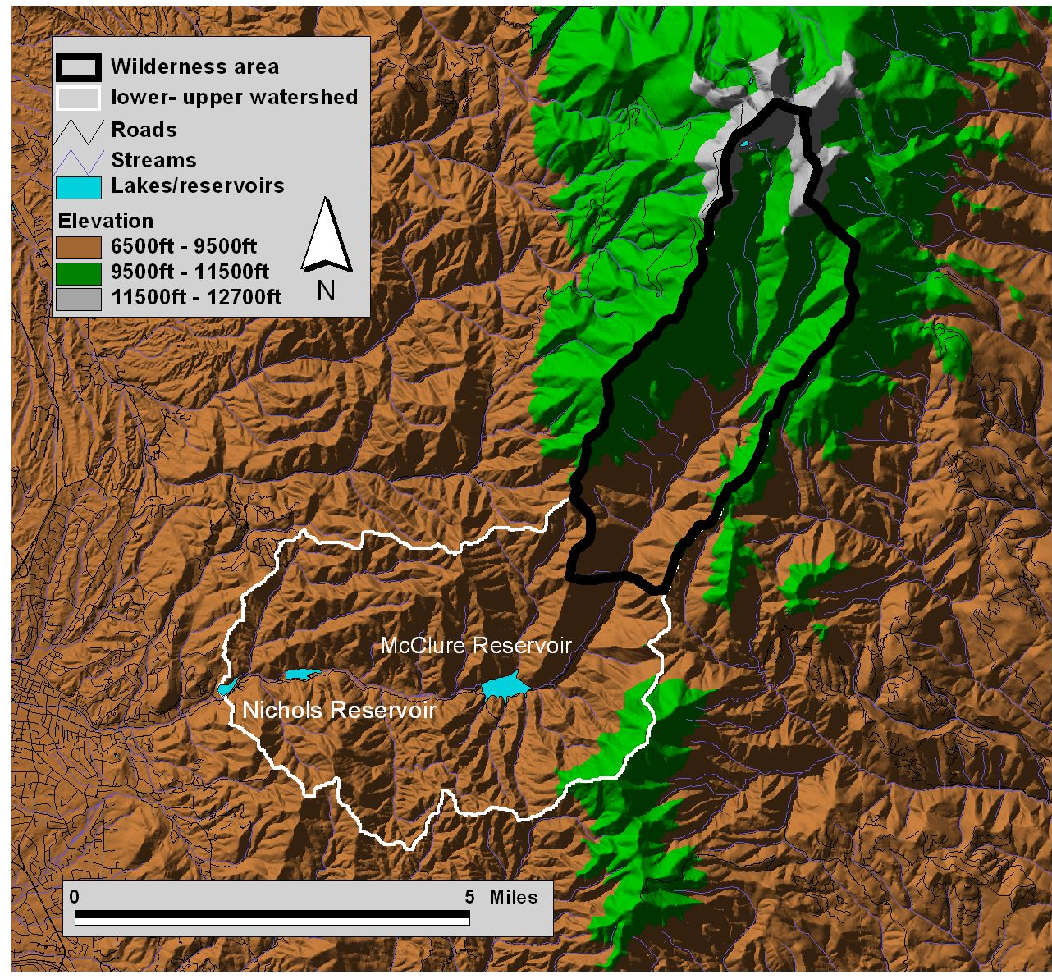
Figure 1. Shaded relief digital elevation map of the upper Santa Fe Watershed, NM. The two management areas discussed in the text, 1) the Wilderness area and 2) the lower-upper watershed are delineated.
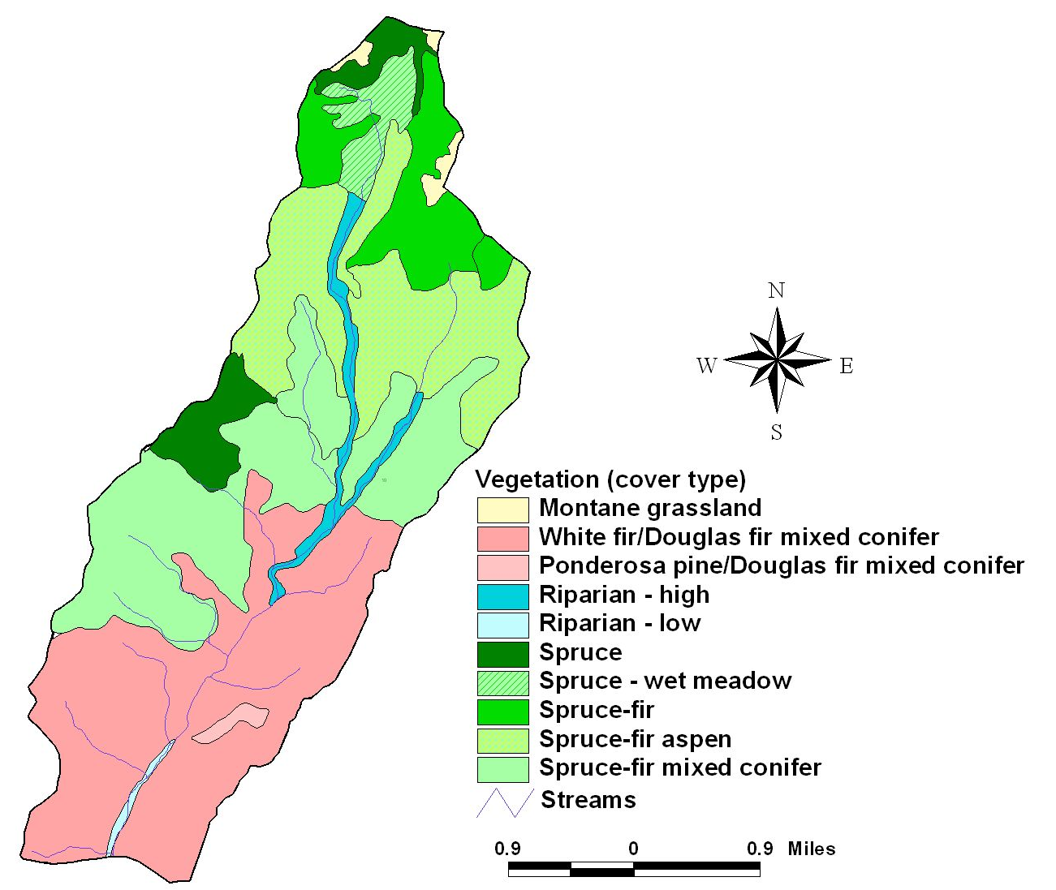
Figure 2. Vegetation types of the Santa Fe Watershed Wilderness Area.

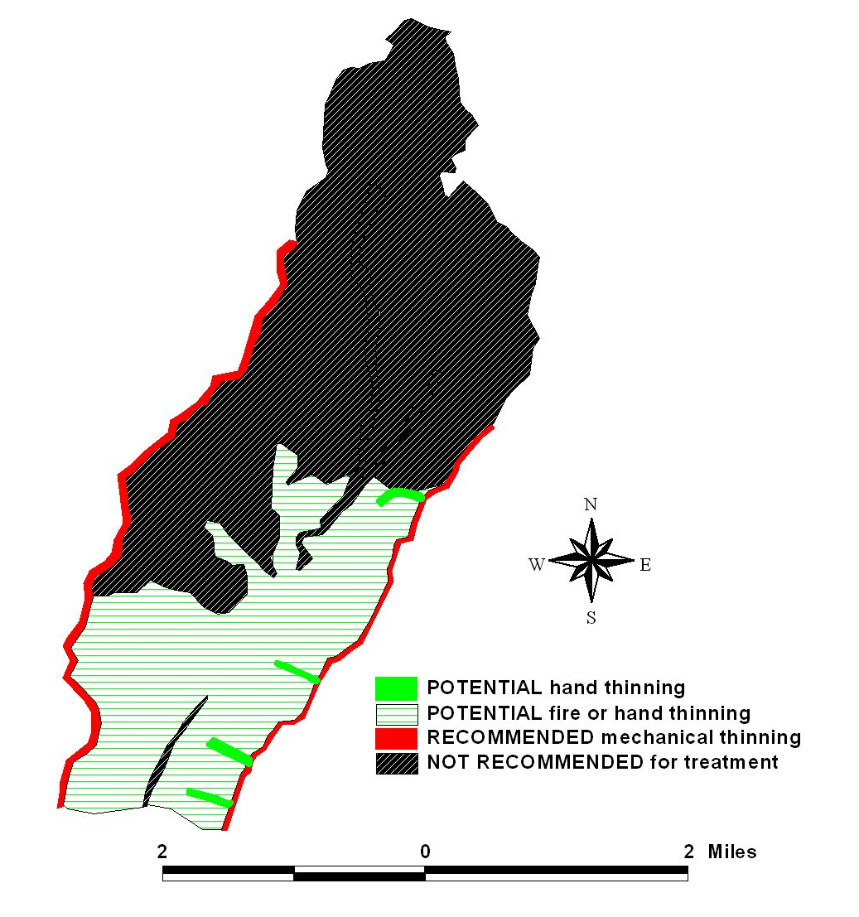
Figure 3. Treatment recommendation map for the upper Santa Fe Watershed Wilderness Area.

Appendix A - Projected Costs/Acre for Maintenance Fire Treatments
TREATMENT TYPE | $/ACRE IN 2007
Mechanical | $945
1st Entry Pile Burning | $175
2nd Entry Broadcast Burn: backing fire | $145
3r^{d} Entry Broadcast Burn: backing fire | $125
4th Entry Broadcast Burn: head fire | $100

