Response of Western Mountain Ecosystems to Climatic Variability and Change: The Western Mountain Initiative – Upper Santa Fe Watershed

Interim Progress Report for Cooperative Agreement No.

between

United States Department of the Interior

U.S. Geological Survey

Box 25046 M.S. 204B

Denver Federal Center

Denver, Colorado 80225

and

The University of Arizona

Laboratory of Tree-Ring Research

West Stadium 105 B

Tucson, Arizona 85719

Administered through the Desert Southwest Cooperative Ecosystems Studies Unit

15 December 2007

Report prepared by

Ellis Margolis, Dr. Thomas Swetnam
Laboratory of Tree-Ring Research, University of Arizona
Craig Allen, USGS Jemez Mts. Field Station, Bandelier National Monument

Kay Beeley, Bandelier National Monument
Background and Need
Forests and woodlands cover vast areas in the southwestern United States, including tens of millions of hectares of piñon-juniper, ponderosa pine, mixed conifer, and spruce-fir ecosystems. Additional scientific information on historical ranges of variability of disturbance regimes and associated ecosystem changes (Swetnam et al. 1999) are needed to guide the substantial backlog of ecological restoration work in Southwestern forests (Allen et al. 2002). Also, ongoing climate changes are expected to produce large shifts in vegetation distributions, largely due to mortality from fires, insect outbreaks, and direct dieback (Westerling et al. 2006, Breshears et al. 2006); information on past fire:climate relationships will help assessments of climate change risks to local forests. This project will study the sensitivity of mountain ecosystems to climate-induced variability and change through determination of long-term relationships between climate and fire events in northern New Mexico.
The increased vegetation stress and mortality caused by predicted climate changes are particularly expected to lead to increasing impacts from fire in the Southwest. Fire is a keystone ecological process in most Southwestern ecosystems (Swetnam and Baisan 1996, Allen 2002). Historic and prehistoric fire activity in the Southwest is known to be related to both drought episodes (Swetnam and Betancourt 1998) and warmer temperatures (Westerling et al. 2006), and any increase in drought stress in this region can be expected to result in more extreme fire events, with associated major effects on ecosystems and watersheds. Even without global change impacts, the Southwest has been experiencing increases in severe fire activity due to the increased fuel buildups associated with fire suppression efforts this century (Swetnam and Betancourt 1998, Allen et al. 2002). However, most of our knowledge of prehistoric fire events in the Southwest comes from sampling fire scars that recorded low-intensity, high frequency fires (see review by Swetnam and Baisan 1996), although it is apparent that extensive mixed-severity and high severity crown fires also occurred in some higher-elevation Southwestern forests in the mid to late 1800s. Little is known about the frequency, extent, and climatic conditions associated with these pre-1900 mixed-severity and crown fires (but see Margolis 2003, 2007, Margolis et al. in press), even though it is the severe fire activity that is becoming increasingly prevalent today and that will become an even more pressing issue in coming decades as expected climate changes stress Southwestern vegetation.
Much research exists for Southwestern fire regimes (Touchan et al. 1996, Allen 2002), including fire-climate relationships (Swetnam and Baisan 1996, Swetnam and Betancourt 1998, Swetnam et al. 1999). Significant variability in past fire regimes is evident, depending upon such local factors as vegetation/fuel type, topography, and land-use history. This fire regime research has explicitly worked to develop information at multiple spatial scales, ranging from individual tree samples up to 10-ha sites, watersheds, mountain ranges, and ultimately the entire Southwest region (Swetnam et al. 1999, see graphics at: http://biology.usgs.gov/luhna/chap9.html). In northern New Mexico, perhaps the largest spatial gap in the fire scar record is the Sangre de Cristo Mountains. This project will use dendrochronological approaches to reconstruct fire histories in a key area in the Sangre de Cristos – the upper Santa Fe River Watershed, which is vitally important to the city of Santa Fe. Most of this watershed above Santa Fe is US Forest Service land (Espanola District), where they are engaged in collaborative efforts with the City of Santa Fe and others to reduce fire risk, restore forest health, including low severity fire.
Recent fire history research on the middle-elevation ponderosa pine forests of the Santa Fe watershed (Balmat et al. 2005) has provided support for the ongoing fire hazard reduction and forest restoration project in the lower portions of the closed watershed. Tree-ring analysis revealed that low intensity surface fire was an important process in these pine and xeric mixed conifer forests of the watershed for at least 700 years. Exclusion of fire by grazing and fire suppression dramatically altered these forests and increased the risk of a watershed-scale catastrophic crown fire. The ongoing fuels treatment project has begun to reduce the fire hazard in the overgrown pine forests. This consequently reduces the risk of a post-fire flood or debris flow that would jeopardize ~ 40% of the city’s water supply (Grant 2002). However, the current treatment only covers approximately 60% of the watershed at high risk of crown fire.
Treatments in the remainder of the upper watershed may be necessary to ensure the future of the city’s water supply and reduce the risk of post-fire flooding. The fire history of the remaining upper 40% (~ 5000 acres) of the Santa Fe watershed is unknown, and these higher elevation mixed-conifer and spruce-fir forests almost certainly have a different historical fire regime than the lower-elevation forests studied to date. Fire history research in the adjacent Tesuque watershed and other sites in the upper Rio Grande Basin indicate that climate-driven, stand-replacing crown fire is part of the natural disturbance regime in the upper montane forests of the region (Margolis 2003, Margolis et al – in press). Still, fire suppression in the past may have led to substantial increases in forest density in at least portions of the upper watershed and thereby increased the risk of extensive crown fire, but details of this fire history are not yet known.
Project Goals
Our research goals were to reconstruct fire history and climate relationships for the mesic forests of the upper Santa Fe Watershed, providing essential information to support management of these and similar nearby forests, including those of the upper Frijoles and Alamo watersheds in Bandelier National Monument.

The complex topography of the upper Santa Fe watershed supports various vegetation types from xeric mixed conifer to mesic spruce-fir forests. This mosaic of vegetation types likely has a complex fire history and subsequently variability in fire hazard. Due to the restrictions of the Forest Service Wilderness Area designation of the upper watershed, mechanical fuels treatment is not permitted and prescribed fire would likely be the tool of choice. This situation is similar to that of the high-elevation forests found in the Cerro Grande area of the upper Frijoles watershed in Bandelier National Monument, where the park’s revamped fire management program is working to reintroduce fire in a similarly difficult landscape setting. Improved understanding of fire history in the upper Santa Fe River watershed is needed to determine fire regime patterns, including climate drivers, over the past several centuries in this area. Knowledge of the extent and frequency of past surface fires or crown fires would be valuable to help determine what types of prescribed fire treatments during a restoration phase could be appropriate (and in what areas), and what types of future “natural” fires or “maintenance” prescribed fires would be appropriate. More generally, it is widely recognized that knowledge of past fire history is a fundamental starting point for developing wilderness fire plans, regardless of whether naturalness, resource utilization, or other objectives are primary considerations (Parsons et al. 1986, Agee 1993, Swetnam et al. 1999).
High quality data and graphical information on the fire and vegetation history of this watershed will benefit ongoing and future hazard fuel reduction efforts in the local area (including at Bandelier National Monument), helping to garner additional public and project financial support. The information developed by this research on fire-climate relationships, spatial patterns of fire activity across topographic and elevational gradients, and little-known histories of mixed-severity fire events will also help support the objectives of the new fire management plan at Bandelier to reintroduce fire to the park’s high elevation forests. This information will also be valuable for all fire and land managers in northern New Mexico.
Study area:
The study area was located within the upper Santa Fe River Watershed, defined by the Pecos Wilderness Area and natural watershed boundaries (Figure 1). The 2669 ha study area was located near the southern limit of the Sangre de Cristo Mountains northeast of the city of Santa Fe, NM. Vegetation types in the study area transitioned from mesic, spruce-fir forests (>3000m) in the upper half of the study area to more arid pine and mixed conifer forests (<3000m) in the lower half. In other parts of the southwest U.S. and the Southern Rocky Mountains these two vegetation types have different fire regimes that require different methods for reconstructing fire history: 1) forest age structure methods for stand-replacing fire regimes in spruce fir and 2) fire scar-based methods for low severity surface fire regimes in pine and mixed conifer forests.
Methods
Due to the complexity of vegetation types and fire regimes in the upper watershed a combination of methods were necessary to reconstruct the fire history. Fire scar-based methods were used to reconstruct surface fire frequency, seasonality, and extent for the more xeric, mixed-confer portions of the watershed. However, fire-scarred trees are rare in the upper elevation spruce-fir forests for two reasons: 1) high severity, high intensity, stand-replacing crown fires destroy evidence of past fires and 2) the thin bark of spruce and fir species is more susceptible to being fatally girdled by low-intensity surface fire, thus leaving no evidence of the most recent fire (e.g. fire scars).
In forest types where fire scars were not abundant, age structure-based fire history methods were applied (Heinselman 1973; Agee 1993; Johnson & Gutsell 1994, Margolis 2003, Margolis et al. in revision). This method dates the origin of the forests that regenerated following a stand-replacing fire event. Labor intensive age structure sampling was required to determine the age of various patches of forest that regenerated after multiple fire events. Satellite imagery, aerial photography, and field observations were used to predetermine potential post-fire forest patches. Tree-ring sampling of these patches was used to determine the age of the oldest trees, thereby estimating the time since the last fire. The precision of fire dates derived solely from age structure was not annual, since the trees may take years to decades to regenerate following a fire. Due to the long return intervals (100 yrs to > 400 yrs) of crown fire regimes (Turner & Romme 1994), decadal precision is still valuable. However, annually-precise fire dates may be determined if fire scars, fire-killed trees or injured trees are present in adjacent areas or unburned patches or lower on the landscape (Margolis 2003).
The approximate season of fire occurrence were determined by analyzing the relative position of each fire scar within the annual growth ring. Relationships between climate and fire occurrence were assessed using the high-quality tree-ring reconstructions of climate that exist for this region (cf. Swetnam and Baisan 1996), along with instrumental records where the period of record is long enough to overlap the largely pre-1900 fire-scar record (e.g., Santa Fe weather records go back to 1850).
Sampling design
We designed a sampling scheme to test the hypothesis of independence between forest age in the upper elevation (>3000m) spruce-fir forest zone and historic fire dates. Annually dated historic fire dates were derived from direct tree-ring evidence of fire (e.g., fire scars and conifer death dates) and indirect evidence of fire (e.g., resin ducts and growth changes in the tree rings). To estimate forest age we used a systematic, gridded sampling design (Figure 1). We generated a 1 km grid beginning with a random location in the study area. The grid was oriented along cardinal directions to facilitate navigation in the field. Two grid points (24 and 28) initially fell within unforested vegetation types and were relocated 50 km inside the nearest forested area.
In the topographically complex mountains of the semi-arid southwest U.S., aspect can be an important variable in determining vegetation and fire regimes through effects on moisture availability. To ensure that the distribution of aspect at our sample points was proportional to the relative abundance of aspect classes in the study area we stratified the sampling grid by aspect class. The percent of sample points in the four primary aspect classes (N,S,E,W) was distributed approximately equal to the percent of land area in each aspect class (Figure 2). The sampling design slightly over (under) samples east (south) facing slopes compared to relative presence in the study area.
To determine stand age at each grid point we collected increment cores from the 20 largest (diameter at breast height (dbh)) trees along a 100m by 20m belt transect. The transect was centered on the grid point and the long axis was oriented parallel to the contour of the slope (i.e., sideslope). The location along the transect of the sampled trees was recorded. To determine tree age increment cores were collected as close to the base of the tree as possible (<0.3m). We angled the borer down to intersect the root crown in an attempt to sample all the years of tree growth. To further increase the accuracy of tree age we re-sampled trees until we extracted a core containing rings estimated to be within 5 years of the pith ring.
In the lower elevation (<3000m) pine and mixed conifer forest portion of the study areas we did not collect age structure as described above. In contrast to the upper elevation forests, fire scarred trees were present in these drier forest types and were determined to be the best evidence of the fire history. Although present, fire scarred trees were not abundant, even in the drier, lower elevations of the upper watershed. We did not locate any fire scarred trees within 50m of the low elevation gridpoints we visited (1, 2, 6, and 7). Because of the relative scarcity of fire scars we used a targeted approach to locate and collect these samples. Fire scarred trees were most abundant on ridges, apparently because fire intensity was lower and allowed trees to survive fires that were otherwise stand-replacing on the adjacent steep slopes. We searched and sampled ridges with the goal of obtaining a relatively even distribution of fire scar plot locations. The final spatial distribution of the fire scar sample plots was ultimately determined by the distribution of the samples and therefore is not evenly distributed.
Where fire-scarred trees and remnant wood was present we used a plot-based sampling approach. Samples from multiple trees were collected within a 50m search radius that defined the plot. Collecting multiple trees within a plot increased the probability of recording all fires that actually occurred in that area. This is necessary because trees are imperfect recorders of fire, such that individual trees may not record (as fire scars) all fires that burned around the tree. Wedges and cross-sections were collected with a cross-cut saw from fire scarred logs, stumps and rarely from live trees using standard procedures for fire scar collection in wilderness areas (e.g. Baisan & Swetnam 1990).
Data Analysis

Results
We collected 240 cores from 188 trees at 9 age structure grid points and 3 additional locations containing quaking aspen (Fig 3). All of the age structure transects were located in the upper half of the study area (>3000m), in forest types dominated by Engelmann spruce and sub-alpine fir. Direct evidence of fire (e.g., fire scars or charred wood) was not present within or between the upper elevation age structure plots we sampled (9 of 14 total upper elevation grid points). In the lower elevation (<3000m) pine and mixed conifer forests we collected 25 fire scar specimens from 23 fire scarred conifers at 12 fire scar plots.
Spring 2007 - sample preparation, database design, data entry, and sample dating
A database was designed and populated to include all 254 collected tree-ring samples. Database fields include: 1) sample ID, 2) species, 3) dbh, 4) sample type, 5) sample height, 6) plot ID, 7) sample preparation status, 8) and sample dating status.
Ninety three percent of the samples were glued, cut-down, and sanded. Twenty seven percent of these prepared samples have been dendrochronologically crossdated.

Plans for coming year
Summer 2007 – Design and populate tree-ring age structure and fire scar database, complete sample crossdating and data analysis.
Fall 2007 – write final report
December 31, 2007 - Final Report, including database, maps, and text writeup –
References

Agee,J.K. 1993. Fire Ecology of Pacific Northwest Forests. Island Press, Washington, D.C.
Allen, C.D. 2002. Lots of lightning and plenty of people: An ecological history of fire in the upland Southwest. Chapter 5 (pp. 143-193) in: T.R. Vale (ed.), Fire, Native Peoples, and the Natural Landscape. Island Press, Covelo, CA.
Allen, C.D., M. Savage, D.A. Falk, K.F. Suckling, T.W. Swetnam, T. Schulke, P.B. Stacey, P. Morgan, M. Hoffman, and J.Klingel. 2002. Ecological restoration of Southwestern ponderosa pine ecosystems: A broad perspective. Ecological Applications 12(5):1418-1433.
Balmat,J., Baisan,C.H., and Swetnam,T.W. 2005. Sensitivity of Semi-Arid Southwestern Forests to Climate-Induced Disturbances: Fire History in Northern New Mexico. Final Report for NPS project # CA124800002UAZ99.
Breshears, D.D., N.S. Cobb, P.M. Rich, K.P. Price, C.D. Allen, R.G. Balice, W.H. Romme, J.H. Kastens, M.L. Floyd, J. Belnap, J.J. Anderson, O.B. Myers, and C.W. Meyer. 2005. Regional vegetation die-off in response to global-change type drought. Proceedings of the National Academy of Sciences, U.S.A. 102:15144-15148.
Grant,P. 2002. Santa Fe River Watershed Restoration Action Strategy. Santa Fe Watershed Association, Santa Fe, NM.
Heinselman,M.L. 1973. Fire in the virgin forests of the Boundary Waters Canoe Area, Minnesota. Quaternary Research 3: 329-382.
Johnson,E.A. and Gutsell,S.L. 1994. Fire frequency models, methods and interpretations. Advances in Ecological Research 25: 239-287.
Margolis, Ellis Q. 2003. Stand-replacing fire history and aspen ecology in the upper Rio Grande Basin. M.S. Thesis, University of Arizona, Tucson, AZ.
Margolis, Ellis Q. 2007. Fire history and fire-climate relationships in upper elevation forests of the southwestern United States. Ph.D. Dissertation, University of Arizona, Tucson, AZ.
Margolis, E.Q., T.W. Swetnam, C.D. Allen. In press. A stand-replacing fire history in the Southern Rocky Mountains. Canadian Journal of Forest Research
Parsons, D.J., D.M. Graber, J. H. Agee, and J.W. Van Wagtendonk. 1986. Natural fire management in National Parks. Environmental Management 10(1):21-24.
Swetnam,T.W., Allen,C.D., and Betancourt,J.L. 1999. Applied historical ecology: Using the past to manage for the future. Ecological Applications 9: 1189-1206.
Swetnam, T. W. and C. H. Baisan. 1996. Historical fire regime patterns in the Southwestern United States since AD 1700. In C. Allen, editor, Fire effects in Southwestern Forests, Proceedings of the Second La Mesa Fire Symposium, Los Alamos, New Mexico, March 29-31, 1994. USDA Forest Service General Technical Report RM-GTR-286:11-32.
Swetnam, T. W., and J. L. Betancourt. 1998. Mesoscale disturbance and ecological response to decadal climatic variability in the American Southwest. Journal of Climate 11:3128-3147.
Touchan, R., C.D. Allen, and T.W. Swetnam. 1996. Fire History and Climatic Patterns in Ponderosa Pine and Mixed-Conifer Forests of the Jemez Mountains, Northern New Mexico. pp. 33-46 In: Allen, C.D., (technical editor). Proceedings of the 1994 Symposium on the La Mesa Fire. USDA Forest Service General Technical Report RM-286, Fort Collins, CO. 216 pp.
Turner,M.G. and Romme,W.H. 1994. Landscape dynamics in crown fire ecosystems. Landscape Ecology 9: 59-77.
Westerling, A.L., H.G. Hidalgo, D.R. Cayan, and T.W. Swetnam. 2006. Warming and earlier spring increase western U.S. forest wildfire activity. Sciencexpress. www.sciencexpress.org/ 6 july 2006/ pages 1 -9/ 10.1126/ science.1128834.
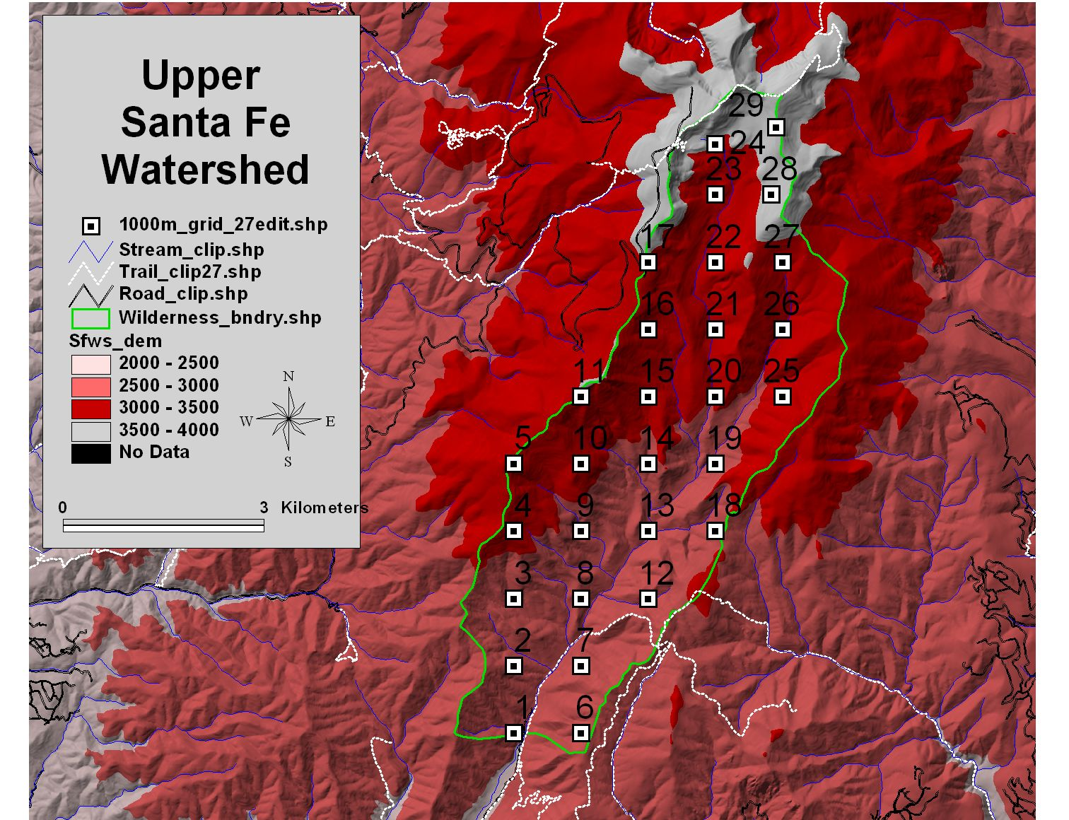

Figure 1. Sampling grid (1 km grid point spacing) used to sample forest age structure for stand-replacing fire history reconstruction in the upper Santa Fe Watershed, NM. The 3000m elevation boundary approximates the ecotone between the spruce-fir and the pine and mixed conifer forests.

Figure 2. Percent of study area (left) and sample grid points (right) in four aspect classes.

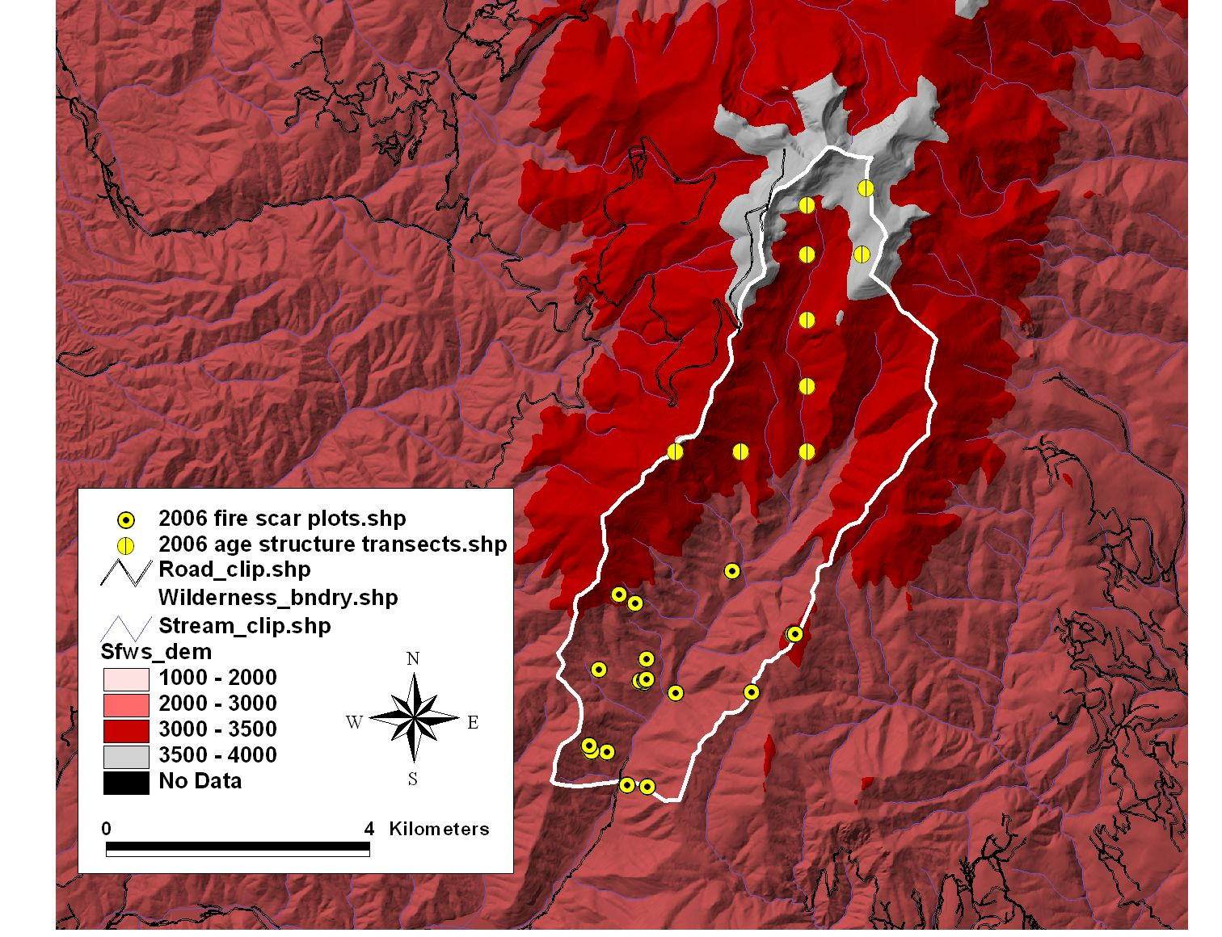
Figure 3. Location of age structure transects (>3000m) and fire scar plots (<3000m) sampled for fire history reconstruction.
Figure 4. Age structure of the dominant trees (largest diameter at breast height) from the Santa Fe Watershed Wilderness Area. Data are pooled into 10-year classes (plotted on center) and presented as inner-ring dates (a) and estimated pith dates (b). Data include all trees from all sampled age structure plots (see Figure 3).
Figure 5. Age structure of the dominant trees at individual transects (e.g., 11) from the Santa Fe Watershed Wilderness Area. The lack of trees pre-dating the 1685 fire at multiple transects suggests that this fire was stand-replacing in parts of the upper watershed. Tree age data are pooled into 10-year classes (plotted on the last year of the decade) and presented as estimated pith dates.

