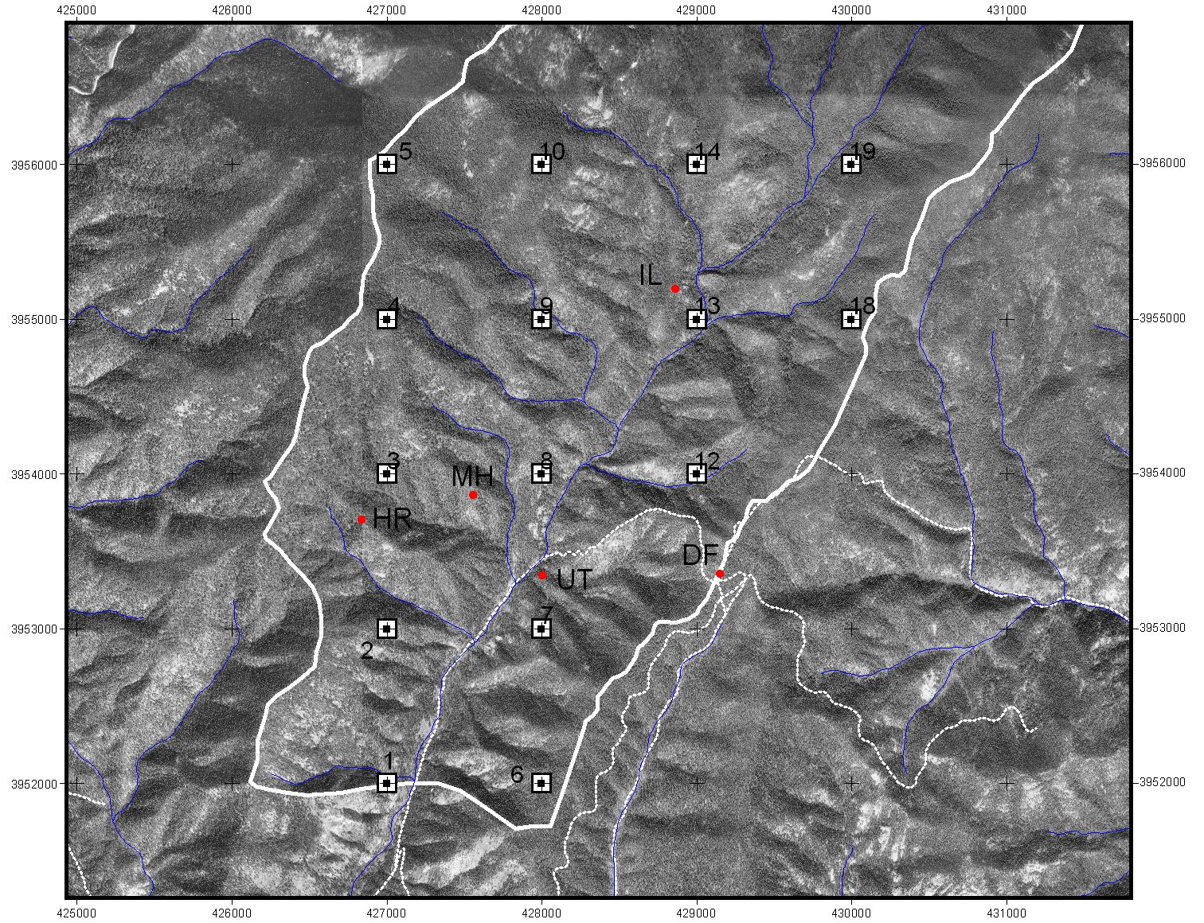

MH – More Hail - No dated samples (Tables: samples or samplefeatures) MH1 or MH2 – prepped?
HR – next to plot #3 , DF – next to plot #12, UT – between plot #7 and #8, IL – N of plot #13, MH – between #3 and #8
JBwilderness_samples_9_06
HR-1
HR-2 dated 1516,1546,1587, 1622, 1715, 1819, 1842
HR-3
IL-1
IL-2 dated 1715, 1748
IL-3
IL-4 dated 1685, 1748, 1795, 1819 death date
IL-5
IL-6
MH-1
MH-2
UT-1
UT-2 dated 1599, 1624,
UT-3A dated 1715, 1729
UT-3B dated 1819 death date
UT-3C dated 1579, 1599, 1716, 1729, 1748
UT-4 dated 1715, 1748, 1842 death date
DF-1
DF-2
DF-3 dated 1773
DF-4
DF-5 dated 1842
DF-6 dated 1842

JBwilderness_samples_dated9_06
SampleID | WoodSource | Year | FireYear | Feature | Position | Interpreter | Confidence | Notes
DF-3 | Stump | 1725 |  | Pith | Not Applicable | jdb | Uncertain | +-1725
DF-3 | Stump | 1839 |  | Outermost ring | Not Applicable | jdb | Uncertain | +-1839 weathered death date (1842 fire? But this tree is a cut stump)
DF-3 | Stump | 1773 | 1773 | Fire scar | Unknown | jdb | Uncertain | 1772-3; tree only recording in this year--remainder of sample is weathered
DF-3 | Stump | 1787 |  | Undetermined scar | Latewood | jdb | Certain | weathered injury, cannot tell if scar
DF-5 | Live tree | 1794 |  | Pith | Not Applicable | jdb | Certain
DF-5 | Live tree | 2004 |  | Bark | Not Applicable | jdb | Certain
DF-5 | Live tree | 1842 | 1842 | Fire scar | Dormant | jdb | Certain
DF-5 | Live tree | 1843 |  | Begin recording fire | Not Applicable | jdb | Unknown
DF-6 | Live tree | 1790 |  | Pith | Not Applicable | jdb | Uncertain | +-
DF-6 | Live tree | 2004 |  | Bark | Not Applicable | jdb | Certain
DF-6 | Live tree | 1842 | 1842 | Fire scar | Middle earlywood | jdb | Certain | l better clarity
DF-6 | Live tree | 1860 |  | Split in ring | Unknown | jdb | Certain
DF-6 | Live tree | 1843 |  | Begin recording fire | Not Applicable | jdb | Unknown
HR-2 | Live tree | 1485 |  | Pith | Not Applicable |  | Certain
HR-2 | Live tree | 2004 |  | Bark | Not Applicable |  | Certain
HR-2 | Live tree | 1516 | 1516 | Fire scar | Dormant |  | Certain
HR-2 | Live tree | 1546 | 1546 | Fire scar | Dormant |  | Certain | r better
HR-2 | Live tree | 1587 | 1587 | Fire scar | Unknown |  | Certain | l better L better
HR-2 | Live tree | 1517 |  | Begin recording fire | Not Applicable |  | Unknown
HR-2 | Live tree | 1715 | 1715 | Fire scar | Unknown |  | Certain | L better
HR-2 | Live tree | 1622 | 1622 | Fire scar | Unknown |  | Certain
HR-2 | Live tree | 1685 | 1685 | Fire scar | Unknown |  | Certain
HR-2 | Live tree | 1715 |  | Last year before missing segment | Not Applicable |  | Unknown | 1716-1818 not recording
HR-2 | Live tree | 1819 |  | First year after missing segment | Not Applicable |  | Unknown | 1716-1818 not recording
HR-2 | Live tree | 1819 | 1819 | Fire scar | Unknown |  | Certain
HR-2 | Live tree | 1842 | 1842 | Fire scar | Unknown |  | Certain
HR-2 | Live tree | 1950 |  | Undetermined scar | Unknown |  | Uncertain | 1950s injury, date unknown
HR-2 | Live tree | 1815 |  | Undetermined scar | Unknown |  | Uncertain | 1809-1813+ weathered outer ring
IL-2 | Snag | 1662 |  | Pith | Not Applicable | jdb | Certain
IL-2 | Snag | 1863 |  | Outermost ring | Not Applicable | jdb | Uncertain | 1863+, death
IL-2 | Snag | 1715 | 1715 | Fire scar | Dormant | jdb | Certain
IL-2 | Snag | 1716 |  | Begin recording fire | Not Applicable | jdb | Unknown
IL-2 | Snag | 1748 | 1748 | Fire scar | Unknown | jdb | Certain
IL-4 | Snag | 1611 |  | Innermost ring | Not Applicable | jdb | Certain
IL-4 | Snag | 1819 |  | Outermost ring | Not Applicable | jdb | Certain | 1819 partial; death by fire
IL-4 | Snag | 1685 | 1685 | Fire scar | Dormant | jdb | Certain | 1685m
IL-4 | Snag | 1748 | 1748 | Fire scar | Dormant | jdb | Certain | d-ee
IL-4 | Snag | 1795 | 1795 | Fire scar | Unknown | jdb | Uncertain | 1791-95 fire scar
IL-4 | Snag | 1686 |  | Begin recording fire | Not Applicable | jdb | Unknown
UT-2 | Log | 1472 |  | Pith | Not Applicable | jdb | Uncertain | +-
UT-2 | Log | 1654 |  | Outermost ring | Not Applicable | jdb | Certain
UT-2 | Log | 1493 |  | Undetermined scar | Latewood | jdb | Certain
UT-2 | Log | 1599 | 1599 | Fire scar | Dormant | jdb | Certain
UT-2 | Log | 1624 | 1624 | Fire scar | Late earlywood | jdb | Certain | l:1624le-1625d(poor), r:1624me-le(good), assume 1624le
UT-2 | Log | 1600 |  | Begin recording fire | Not Applicable | jdb | Unknown
UT-3A | Snag | 1534 |  | Innermost ring | Not Applicable | jdb | Certain
UT-3A | Snag | 1828 |  | Outermost ring | Not Applicable | jdb | Uncertain | +-
UT-3A | Snag | 1715 | 1715 | Fire scar | Unknown | jdb | Certain
UT-3A | Snag | 1721 |  | Undetermined scar | Unknown | jdb | Certain
UT-3A | Snag | 1729 | 1729 | Fire scar | Unknown | jdb | Certain | best clarity on internal end
UT-3A | Snag | 1742 |  | Undetermined scar | Unknown | jdb | Certain
UT-3A | Snag | 1716 |  | Begin recording fire | Not Applicable | jdb | Unknown
UT-3B | Snag | 1779 |  | Innermost ring | Not Applicable | jdb | Certain | 1779 is common fire year, but this inner ring has no evidence of fire (pitching, scar remnants, charcoal
UT-3B | Snag | 1817 |  | Outermost ring | Not Applicable | jdb | Certain | death, weathered (1819 fire)
UT-3C | Snag | 1506 |  | Innermost ring | Not Applicable | jdb | Certain
UT-3C | Snag | 1822 |  | Outermost ring | Not Applicable | jdb | Certain
UT-3C | Snag | 1579 | 1579 | Split in ring | Dormant | jdb | Certain
UT-3C | Snag | 1599 | 1599 | Fire scar | Middle earlywood | jdb | Certain
UT-3C | Snag | 1716 | 1716 | Fire scar | Dormant | jdb | Certain | (not 1715), tied to segment BEGIN
UT-3C | Snag | 1748 | 1748 | Fire scar | Unknown | jdb | Certain | 1748m, 1748le-49d, assume 1748e
UT-3C | Snag | 1728 |  | Undetermined scar | Dormant | jdb | Certain
UT-3C | Snag | 1729 | 1729 | Fire scar | Dormant | jdb | Certain
UT-3C | Snag | 1721 |  | Undetermined scar | Dormant | jdb | Uncertain | fire scar or part of 1716 curl?
UT-3C | Snag | 1580 |  | Begin recording fire | Not Applicable | jdb | Unknown
UT-3C | Snag | 1627 |  | Stop recording fire | Not Applicable | jdb | Unknown | catface missing
UT-3C | Snag | 1717 |  | Begin recording fire | Not Applicable | jdb | Unknown | end of missing catface
UT-4 | Snag | 1602 |  | Innermost ring | Not Applicable | jdb | Certain
UT-4 | Snag | 1841 |  | Outermost ring | Not Applicable | jdb | Certain | 1842 death by fire
UT-4 | Snag | 1715 | 1715 | Fire scar | Middle earlywood | jdb | Certain
UT-4 | Snag | 1748 | 1748 | Fire scar | Dormant | jdb | Certain
UT-4 | Snag | 1716 |  | Begin recording fire | Not Applicable | jdb | Unknown

