Utilizing dendrochronology to calibrate life stage assessments of *Ceanothus verrucosus* individuals at Cabrillo National Monument

*Ellis Margolis and Eze Ahanonu, University of Arizona, Laboratory of Tree-Ring Research*

**Summary - We successfully crossdated the annual growth rings of 32 samples from 17 *C. verrucosus* individuals. Visual and correlation analyses indicated crossdating of annual growth ring patterns within and among plants, as well as crossdating with a nearby Torrey Pine tree-ring width series (and P. lagunae) from near the CA/Mex border. The crossdating, or pattern matching, allowed us to date the actual years of growth of the dead samples. The strong common variability of ring width among individuals indicates the potential for climate-growth analyses that will determine the climate variables that are important for plant growth. Non-concentric, lobate growth and topographically driven variability among site conditions and growth rates are the major challenges for estimating plant age from stem measurements. There is a moderate correlation between the diameter of measured radius stems and the stem age (r = 0.56), but average diameter measurements of the full stem correlate poorly with crossdated stem age (r = 0.19).**

Research Questions

The goals of this research were to determine if CEVE consistently forms identifiable annual growth rings that can be used to determine plant age. Our specific research questions included: (1) Does the variability in CEVE ring width crossdate withina single plant (i.e., is there correlation between multiple measured ring width series from a single plant)? (2) Does the variability in CEVE ring width crossdate betweenindividual plants (i.e., is there correlation between mean ring width series from multiple plants within a site)? (3) Does the inter-annual variability in CEVE ring width crossdate with nearby Torrey Pine (*Pinus torreyana*) and Pinon pine (*Pinus monophylla*) tree-ring width?

(2) to determine if the age of CEVE correlates to stem diameter. To answer this question we will compare dated CEVE sections and stems to their measured diameters and

Research Design & Methodology

In 2007, multiple samples from dead standing CEVE were cut as part of a study to evaluate the longevity and viability of the fire-dependent species using a dynamical population model (Lawson et al. 2010). Lawson et al. (2010) ring-counted the sections to estimate age and the inner ring year was assigned to a possible fire initiation date (1912) to estimate the year of death. Working with Cabrillo National Monument, we obtained # of the previously analyzed samples with the most rings from the standing dead CEVE and collected additional samples from branches and secondary stems of # live CEVE in # - # 2015. Live material allowed us to anchor our dating to the known last year of growth (2014), which turned out to be crucial for testing for verifying annual ring formation and providing insights into CEVE phenology.

All samples were cut with a bandsaw to reveal a flat cross-sectional surface, glued to backing board if in multiple pieces, and then sanded with progressively finer sand paper (to 15 micron grit) to reveal the cellular structure of the growth rings (Figure 1, Appendix A) (Fig. 4). Samples from the same individuals were identified, previous identification codes from prior analyses were recorded, and all samples were re-labeled with a new code (CEA) and continuous numbers (Table 1).

Initial assessments to determine annual rings in the dead stems were made and used to measure total ring width for a minimum of two radii per sample. The tree-ring program COFECHA (Holmes 1983) was used to determine if there is statistically significant correlation in ring width variability within and among individual plants. If crossdating among CEVE samples is confirmed, then sample ages will be determined. To determine the calendar year of rings formation, we will use correlation analysis to determine if the CEVE crossdate with the existing nearby Torrey Pine (Pinus torreyana) tree-ring width chronology (Biondi et al. 1997). If crossdating between the P. Torreyana and the CEVE is confirmed then annual calendar dates will be assigned to each CEVE sample (i.e., inner and outer ring dates).

**CEA 1:**

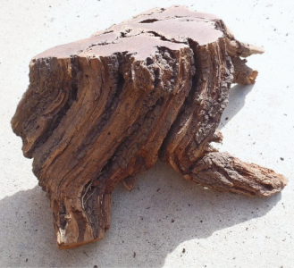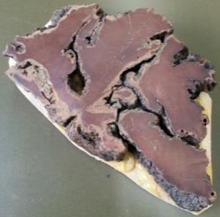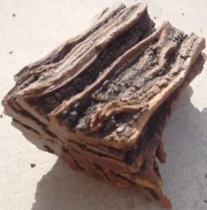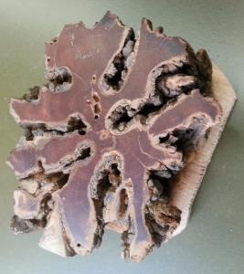

**CEA3:**

Figure 1. Original (left) and final (right) growth ring samples from two *C. Verrucosus* individuals.

Results

We prepared and assessed 59 samples from 17 *C. verrucosus* individuals, including samples from five live plants sampled in May and June 2015. We successfully crossdated the annual growth rings of 32 samples from 17 C. verrucosus individuals. All but one of the samples that were not measured were from small secondary stems containing very few rings (< 15), which were already replicated from other samples. One of the old samples from plant CEA 5A was taken from near the root crown, thereby distorting the growth rings, and could not be accurately measured.

Analysis and relative crossdating of a common ring width pattern among individuals

Growth rings were marked for two radii on all dead samples. Skeleton plots of relative narrow and wide rings were used to compare ring width patterns within and between plants and with the existing Torry pine chronology (Stokes and Smiley, 1968). Gsrowth ring boundaries were very diffuse and potential micro rings that were just a few cells wide, complicated the identification of ring boundaries (e.g., Figure 2). Initial assessments of growth rings were measured on 11 samples as a preliminary test for statistical “crossdating”, or growth ring pattern matching, between and within samples. All but one sample had unknown and eroded outter ring dates, therefore there was no way to verify absolute calendar dating. However, there were consistent and statistically significant correlations of growth ring patterns among all measured samples, except CEA16 (Table 2). Although we don’t yet know the calendar dates of these samples, it is clear that the growth ring variability is driven by a common signal, likely climate. Once we are able to crossdate one of the samples to a calendar year, then we will be able to assign calendar years to all the samples.

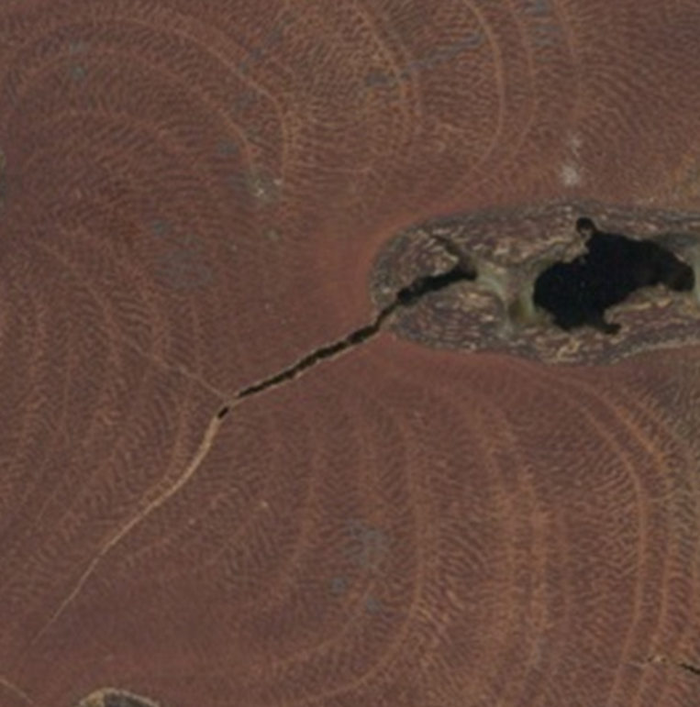

Figure 2. Lobate form and diffuse and variable growth ring boundaries of *C. Verrucosus.*

Table 2. Moving window (50-year) correlation statistics indicating highly similar ring width variability within and among all CEVE individuals (1890 – 2014).

|  |  |  |  |  |
| --- | --- | --- | --- | --- |
|  |  |  |  |  |

CEA 16 (Alternate ID sp100, “Miramar”) – This was the only sample with intact sapwood and intact outer-most growth rings (i.e., a bark ring). This indicates that the outer-most growth ring was the year the sample died. The sample also contained char on the bark, indicating that it likely died in a fire. This sample had the clearest and most distinct growth ring boundaries. Ring width measurements from this sample statistically crossdated (r = 0.37) with the Torrey Pine chronology at a position that would put the death date in 2003. This is a known fire year in the area, which is independent evidence suggesting that it is correct. Because the Torrey pine chronology ends in 1994, there were only 34 years of overlap with CEA 16 to test for crossdating (1960 – 1994).

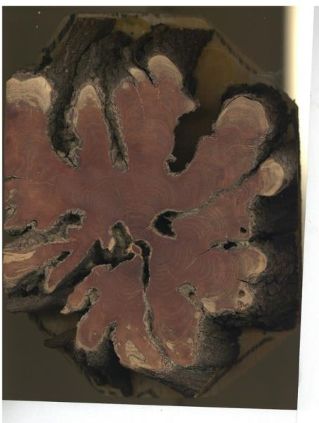

Figure 3. CEA16 (“Miramar” sample) was the only sample with intact sapwood and a bark ring (light colored wood near outside). Statistical crossdating with the Torrey Pine chronology indicates a death date of fall 2003, a known local fire year.

Next steps

Spatial location, collection dates, and known fire dates (e.g., time markers) for the remnant samples would be helpful to work out the crossdating. Additional samples with known death dates from nearby the analyzed remnant samples, would be helpful for identifying the calendar years of these dead samples. Pin-pricking of the stems at multiple time intervals of living individuals to mark the timing of growth throughout the year could also be considered. This could be done with branches to reduce effects on the individuals , and then the whole section (pin & all) would be collected and analyzed. The relative crossdating among all remnant samples indicates that a common factor, presumably climate, is controlling the ring growth. Once the crossdating is worked out, the strong common ring width patterns provides incredible potential to determine the climate variable that are controlling growth of *C. verrucosus*.

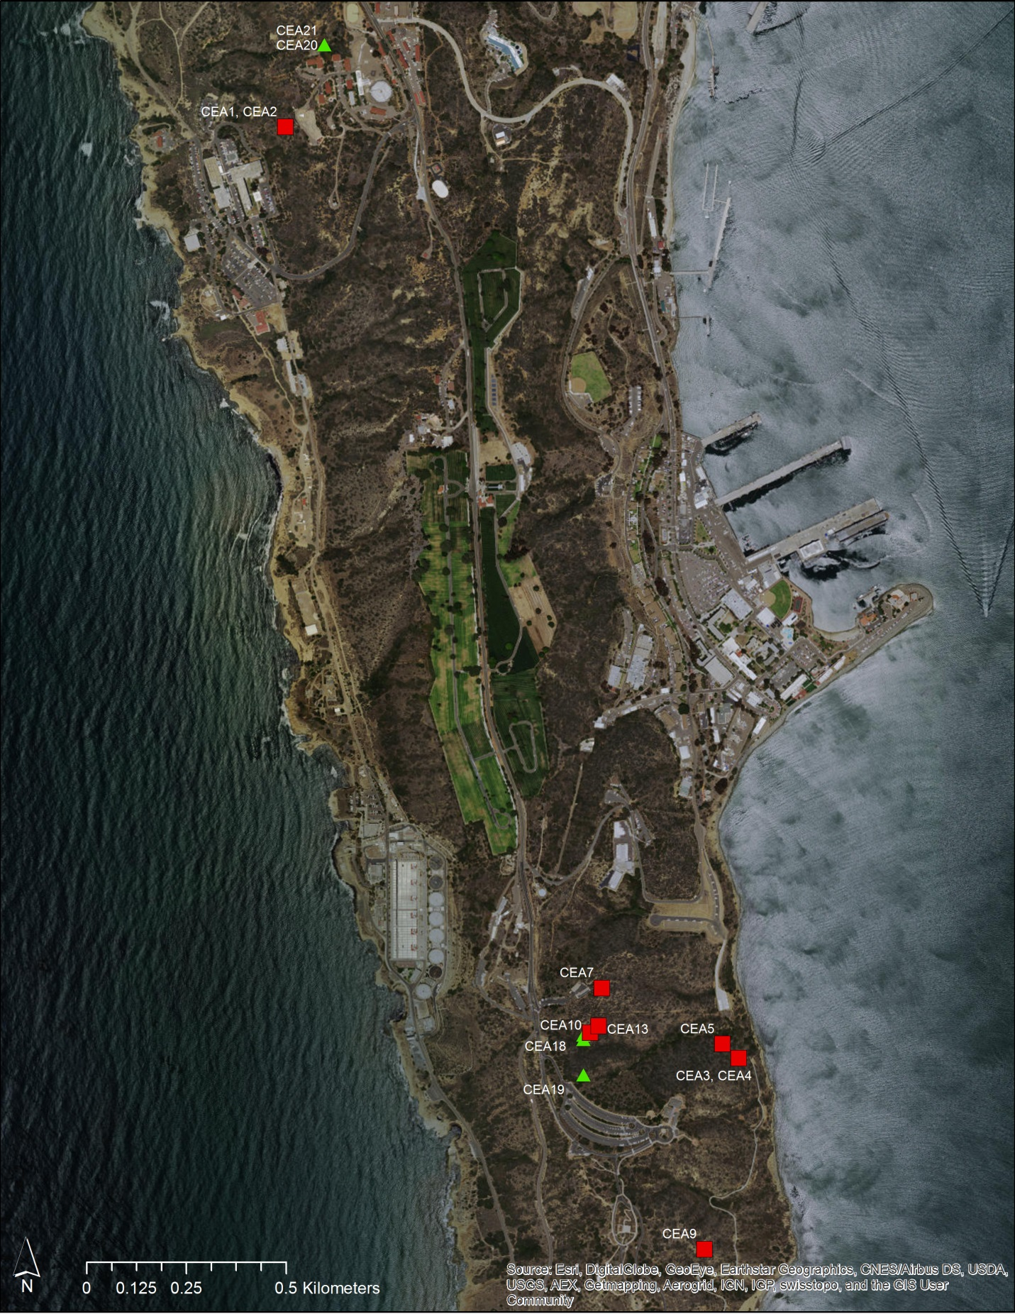

Figure #. Map of all CEVE samples from Point Loma. Plant CEA16 was from Miramar and not on map.

**Appendix A**

**Photographs of C. Verrucosus growth ring samples**

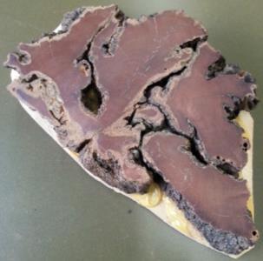

**CEA 1:**

**CEA 2:**

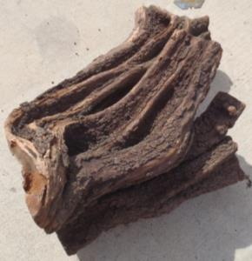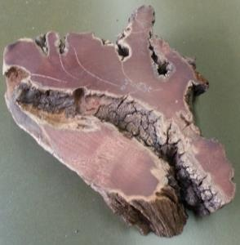

**CEA3:**

**CEA4:**

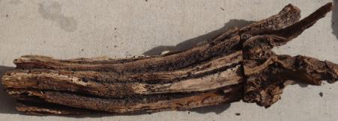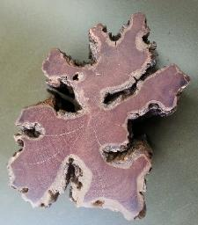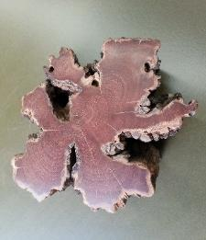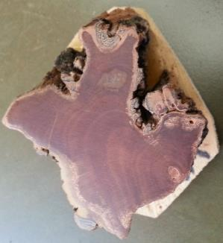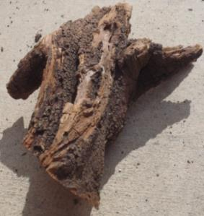

**CEA5:**

**CEA6:**

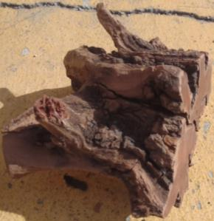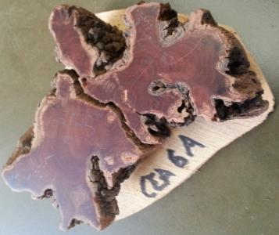

**CEA7:**

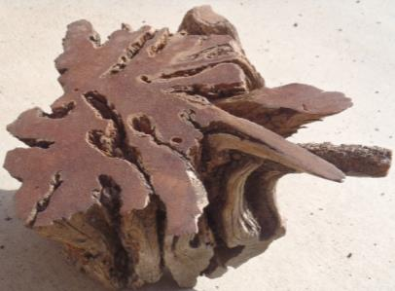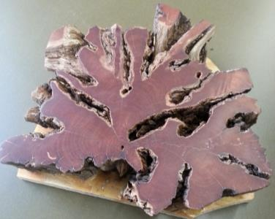

**CEA8:**

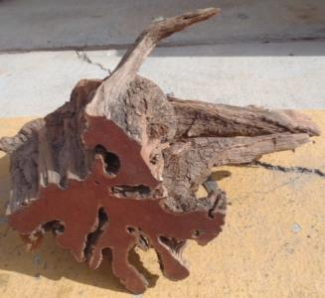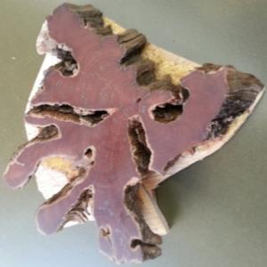

**CEA9:**

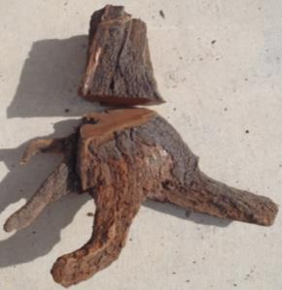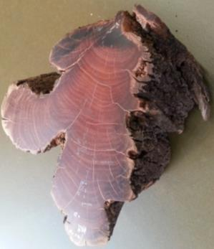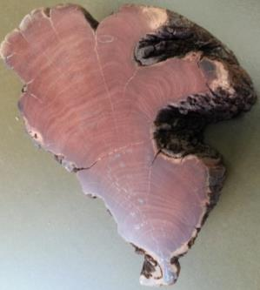

**CEA10:**

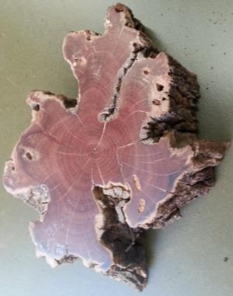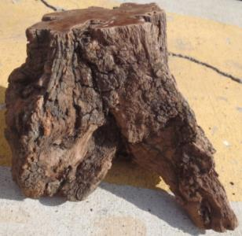

**CEA11:**

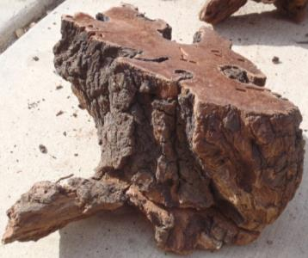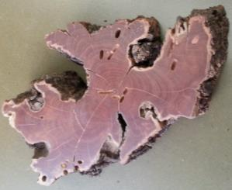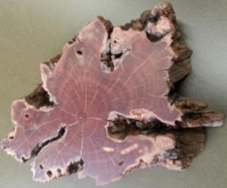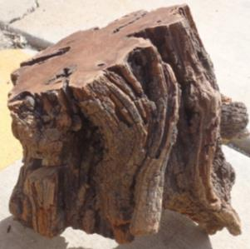

**CEA12:**

**CEA13:**

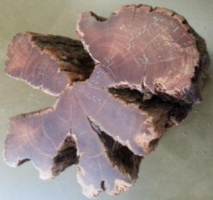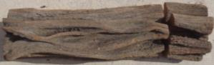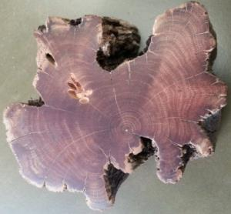

**CEA14:**

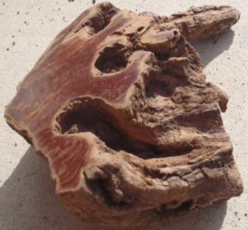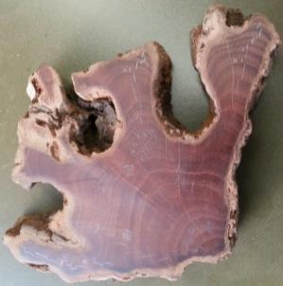

**CEA15:**

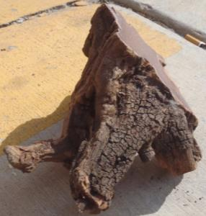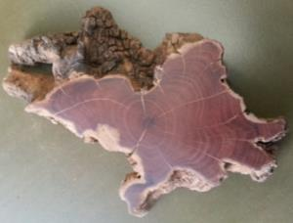

**CEA16:**

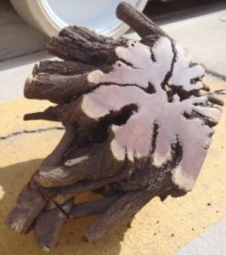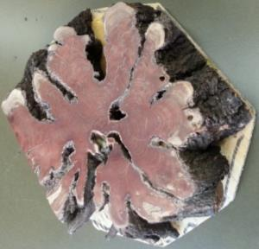

**Appendix B**

**Inventory of *C. verrucosus* individuals, samples, and alternate identification codes.**

|  |  |  |
| --- | --- | --- |
| SampleID | ShrubID | Alternate ID's |
| CEA1 | CEA1 | T333, M 5.25, 8 |
| CEA10 | CEA10 | P1, 001 |
| CEA10A | CEA10 | P1, 001 |
| CEA10B | CEA10 | P1, 002 |
| CEA10C | CEA10 | P1, 003 |
| CEA10D | CEA10 | P1, 002 |
| CEA10E | CEA10 | P1, 003 |
| CEA13A | CEA13 | P11, 001 |
| CEA13B | CEA13 | P11, 002 |
| CEA13C | CEA13 | P11, 001A |
| CEA14 | CEA14 | P3 |
| CEA14A | CEA14 | P3 |
| CEA15 | CEA15 | P4, 001 |
| CEA15A | CEA15 | P4, 001 |
| CEA16 | CEA16 | sp 100 |
| CEA16A | CEA16 | sp 100 |
| CEA17A | CEA17 | LS01 |
| CEA17B | CEA17 | LS01 |
| CEA17C | CEA17 | LS01 |
| CEA17D | CEA17 | LS01 |
| CEA18A | CEA18 | LS02 |
| CEA18B | CEA18 | LS02 |
| CEA18C | CEA18 | LS02 |
| CEA18D | CEA18 | LS02 |
| CEA18E | CEA18 | LS02 |
| CEA18F | CEA18 | LS02 |
| CEA18G | CEA18 | LS02 |
| CEA18H | CEA18 | LS02 |
| CEA19A | CEA19 | LS03 |
| CEA19B | CEA19 | LS03 |
| CEA19C | CEA19 | LS03 |
| CEA19D | CEA19 | LS03 |
| CEA19E | CEA19 | LS03 |
| CEA19F | CEA19 | LS03 |
| CEA1A | CEA1 |  |
| CEA2 | CEA2 | T333, M 5.0 |
| CEA20A | CEA20 | LS04 |
| CEA20B | CEA20 | LS04 |
| CEA20C | CEA20 | LS04 |
| CEA21A | CEA21 | LS05 |
| CEA21B | CEA21 | LS05 |
| CEA2A | CEA2 |  |
| CEA3 | CEA3 | T504, I 37.5, 2 |
| CEA3A | CEA3 | T504, I 37.5, 2 |
| CEA4A | CEA4 | T504, M 39, 1 |
| CEA4B | CEA4 | T504, M 39, 2 |
| CEA4C | CEA4 | T504, M 39, 2A |
| CEA4D | CEA4 | T504, M 39, 2B |
| CEA5 | CEA5 | T449, M 14, 001 |
| CEA5A | CEA5 | T449, M 14, 001 |
| CEA5B | CEA5 | T449, M 14, 002 |
| CEA5C | CEA5 | T449, M 14, 002 |
| CEA7 | CEA7 | P14, 001 |
| CEA7A | CEA7 | P14, 002 |
| CEA7B | CEA7 | P14, 002 |
| CEA7C | CEA7 | P14, 002 |
| CEA9A | CEA9 | P6, 001 |
| CEA9B | CEA9 | P6, 002 |
| CEA9C | CEA9 | P6, 002A |

References

Stokes, M. A. and Smiley, T. L.1968. An introduction to tree-ring dating. University of Chicago, Chicago.