a. Project Title: Strategic Implementation in a Large Ponderosa Pine/Piñon-Juniper Landscape
b. Executive Summary: The amount of forest at risk of high-intensity wildfire is too large, and the resources are too limited, to restore small, isolated forest patches. We propose to effectively treat 2,500 acres by implementing strategically located thinning and mastication treatments on 675 acres in the most effective locations for reducing high-intensity fire spread. The strategic treatments will be followed by prescribed fire on the entire 2,500 acres. Treatment locations were pre-determined from a landscape assessment that included fire spread modeling, which indicated that strategically located treatment on just 20% of the forest would reduce catastrophic fire risk on 70% of the landscape. This is the first CFRP project to propose strategic implementation explicitly developed within a landscape-scale context, which will maximize the effectiveness of limited CFRP resources. The mechanical treatments will provide much-needed jobs (13 jobs) to the local communities and will come at a reduced cost to the project by using equipment purchased from a prior CFRP grant and an agreement with the Forest Service for the operators to obtain free-use permits to collect fuel wood. Importantly, we will also provide free use permits for fuel-wood for local residents who depend on this natural resource. Using a restoration curriculum developed in prior CFRP projects we will build on the success of prior youth education efforts through field-based skill development (monitoring training) for the Las Vegas YCC crew (10-15 youth). Continuing dialog with local residents through field-based outreach (60 - 100 adults) and the Sierra Club newsletter (~ 8,000 people) will foster support for the proposed implementation and future restoration in the region.
Partners: Santa Fe National Forest Pecos/Las Vegas Ranger District (SFNF PLVRD); Santa Fe National Forest Supervisors Office (SFNF SO); University of Arizona (UofA); Ecotone; Forest Guild; Northeastern Construction (NEC); Caro’s General Works (Caro’s); and the Northern New Mexico Group of the Sierra Club (Sierra Club).
c. Statement of Need: Like much of the West, frequent fires historically burned abundant grass cover on Rowe Mesa and maintained a relatively open ponderosa pine and piñon-juniper savanna. Through a site-specific landscape assessment, we used tree-ring fire scars and tree ages to determine that the last widespread fire occurred in 1870, and since then the forest density has increased six fold, predominantly through infill of small, dense piñon and juniper trees (Margolis 2011, CFRP project 34-10). This is reflected in the Fire Regime Condition Class (FRCC), which indicates that 95% of the area has a high or moderate departure from historical fire regimes. Consequently, the risk of unnatural, large, high intensity catastrophic fire has greatly increased and now threatens to destroy the remaining old and large trees (e.g., tree-ring dated piñon, juniper and ponderosa pine > 400 years old), degrade the upper Galisteo, Pecos, and Estancia watersheds, destroy wildlife habitat, threaten life and property of residents, and severely impact human uses of the landscape (e.g., fuel-wood collection, grazing, recreation, piñon harvest, and hunting).
Who will benefit from this project and how will they benefit?
Restoration would directly benefit local residents by reducing fire risk for those who live on Rowe/Glorieta Mesa and adjacent Wildland Urban Interface areas in Rowe, Glorieta, and Cañoncito. Two of the adjacent communities (Ojo de la Vaca/Glorieta Mesa and Cañoncito) are on the list of New Mexico Communities at Risk. Additionally, restoration would benefit local and region-wide residents who depend on the natural resources on Rowe Mesa for fuel-wood, grazing, recreation, piñon harvest, and hunting. Lastly, local residents would benefit through free permits for fuel wood, which is an important source of heat and income. Downstream residents would benefit from potentially greater storm water infiltration in forest soils, which would reduce erosion, flood impacts, and recharge aquifers that support people’s drinking water supplies.
d. Project History: There have been multiple fire reintroduction, forest restoration and planning projects on Rowe Mesa, which we will build upon and most importantly, link together. Our proposed implementation project builds most directly off of a landscape-scale planning grant (CFRP 34-10) that assessed the landscape condition, existing treatments, and modeled fire spread to identify our top priority, strategic implementation areas. This planning grant set the stage for future landscape-scale work on Rowe Mesa with a NEPA clearance of 17,500 acres (Appendix E), making it a high regional priority for future restoration. Importantly, our cost/acre for mastication is reduced ($275/acre) because our mastication operator will re-use equipment purchased through a prior CFRP grant (33-09).
Multiple prior CFRP implementation projects (25-01 and 23-04) were conducted within the grazing allotment on Rowe Mesa known as the Valle Grande Grass Bank. This area was managed collaboratively to alleviate pressure on overgrazed land in the region. A recent CFRP project (33-09) completed NEPA requirements for thinning and burning on 3,200 acres of the adjacent Barbero grazing allotment, of which 800 acres have been treated. The USFS has also conducted multiple recent prescribed burns on the mesa (Madrid I, 1998, Southwest Pasture, 1999; Madrid II, 2001; and Valle GrandeII, 2011) and is planning to use fire over large areas (multi-thousand acre burns). Our CFRP landscape assessment and planning grant (34-10) developed a comprehensive long-term plan for landscape-scale restoration, and our proposed implementation project targets the key pieces of land that need to be treated to tie the prior restoration work together and create resilience to future landscape-scale fires (see map, Appendix A).
An additional key component of prior CFRP projects on the Mesa was development of educational outreach and youth training. A youth education classroom and field curriculum covering ecosystem restoration and fire ecology was developed in CFRP project 23-04 and expanded in CFRP 34-10. The curriculum is publicly available online: http://www.forestguild.org/ycc.html). We will use this curriculum for field education and training for youth from the nearby Las Vegas YCC crew. We strongly believe that the continuation of the youth education and training is a key component of forest restoration so that future generations will support and be able to take part in the workforce of future restoration projects.
e. Project partners
Table 1. Project partners and roles for the proposed implementation project.
Collaborator | PD | R | EO | M | T | U | $+
SFNF Pecos/Las Vegas RD | X | X | X | X | X | X
SFNF Supervisors Office | X | X |  |  | X
University of Arizona | X | X | X | X | X |  | X
Forest Guild | X | X | X | X | X |  | X
Ecotone | X | X | X | X
Sierra Club | X |  | X | X |  |  | X
Northeastern Construction | X |  |  |  | X | X
Caro's General Works | X |  |  |  | X | X
- A letter of commitment from each collaborator is included in the appendix.
KEY:
PD: the partner assisted in proposal development
R: the partner has access to and will provide research about the proposed project area
EO: the partner will provide education and outreach to students and community;
M: the partner will participate in the Multiparty Monitoring Team
T: the collaborator will participate in the treatment of proposed project area
U: the collaborator will participate in utilization of small diameter product
$+: the partner is providing non-Federal match as cash or in-kind to the project. A detailed letter of commitment is provided in the appendix and information is provided in the budget detail.

Ellis Margolis, research associate at the University of Arizona, Tree-Ring Lab, will be the Project Coordinator, primary CFRP contact, and will attend the annual CFRP meeting to represent the project collaborators.
f. Objectives
Our project objectives fulfill the three applicable CFRP program objectives (1 - 3).
Our first objective is to effectively treat 2,500 acres of old-growth forest through mechanical treatment of 675 acres followed by prescribed fire. The project area and the strategic mechanical treatment locations were identified by a landscape assessment and fire modeling (CFRP planning grant 34-10) as the most effective locations to reduce fire spread on the 70,000 acre Rowe Mesa landscape. This objective satisfies CFRP objectives #1 “Reduce the threat of large, high-intensity wildfires and the negative effects of excessive competition between trees by restoring ecosystem functions, structures, and species composition” and CFRP Objective #2 “Re-establish fire regimes approximating those that shaped forest ecosystems prior to fire suppression.”
Our second objective is to use the thinned small diameter trees as fuel wood that will be provided free-of-cost to (1) local users and (2) the thinning operators to offset treatment cost, which will enable the treatment of more acres with the limited CFRP funding. This objective satisfies CFRP objective #3, “Improve the use of, or add value to, small diameter trees.”
Our third objective is to expand upon the youth education/training and adult outreach through field education and skill training (ecological monitoring) for local youth from the Las Vegas YCC crew, newsletter stories, outreach tours, and public events for local residents and conservation groups to our proposed restoration sites and other successful restoration efforts on Rowe Mesa.
Our fourth objective is to use a multi-party assessment to (a) monitor project completion, (b) treatment effectiveness (existing ecological conditions vs post-treatment conditions and desired conditions) by using the core ecological indicators, and (c) to monitor local socio-economic effects of the project through tracking of jobs, people trained, and education/outreach participation.
Proposed activities: Based on tree age and tree diameter measurements collected in the landscape assessment (CFRP 34-10), we developed a prescription of thin-from-below with a diameter cap of 12” drc (diameter at root crown). Mastication treatments will be used in areas with lower tree densities and along a private property boundary. The remaining denser forests will be hand thinned. Particular attention will be paid to the old and large trees identified in the landscape assessment; such that fuels will be removed from a buffer around these trees to prevent excessive scorch or torching during fire. Mechanical treatments will be scheduled to occur outside of the late-spring/summer time window that is critical for breeding birds. Using experienced local operators, and through oversight by an experienced implementation manager, Orlando Romero (Forest Guild) we will ensure that the safety of operators / operations will be assured.
This prescription will restore the forest structure and composition similar to when fires still burned frequently on Rowe Mesa (before ~ 1870) and protect the remaining old and large trees from excessive competition and crown fire hazard posed by the existing overly dense forest. Within the 2,500 acre treatment unit this prescription will be implemented in the areas (675 acres) prioritized by the FlamMap Treatment Optimization model (see map, Appendix A). By running hundreds of combinations of treatment locations and simulated fires, the model was used to determine that these areas were the most effective at reducing high-intensity fire behavior not only within the thinned areas, but also outside (e.g., downwind) of the thinned areas (Ager et al. 2010, Finney et al. 2007). This is accomplished by reducing the continuity of fuels and tree crown cover so that high intensity fire could not spread outside of treated areas to adjacent forest stands. Thus, by thinning only 675 acres, 2,500 acres are effectively “treated” with a first entry and ready for low intensity prescribed fire or managed wildfire at historic return intervals (average of 8 years), which the Pecos/Las Vegas District has committed to doing (see letter of commitment). Additionally, because of the central, “keystone” location of these treatments adjacent to prior CFRP treatments and recent prescribed fires, upon completion there will be over 7,000 acres that will be more resilient to wildfire and available to be burned with low severity fire. This complements a collaborative effort between the Santa Fe National Forest and the NM State Game and Fish that has prioritized Rowe Mesa for landscape-scale prescribed fire. Restoration (mechanical treatment and/or burning) with this strategic approach within a landscape-scale context is necessary to begin to tackle the overwhelming amount of forest at risk of unnatural high intensity wildfire in New Mexico. These large, strategic, fire-focused approaches are perhaps more urgent given the extremely large catastrophic fires in recent years (e.g., Las Conchas Fire).
Scientific justification: It is well documented that human-caused exclusion of frequent fires in Southwestern ponderosa pine forests has increased tree density and unnaturally increased high-intensity fire risk (Allen et al. 2002). However, there is less understanding of historical forest structure and fire regimes in piñon-juniper forests in the Southwest. In a recent review of piñon/juniper ecosystems of the Western U.S., Romme et al. (2009) stated that “pre-1900 disturbance regimes in piñon-juniper savannas are not well understood.” Therefore, to guide restoration efforts in this poorly understood forest type that dominates Rowe Mesa, and many parts of New Mexico, we derived historical fire and forest structure information from tree-rings, historical photos, Fire Regime Condition Class and Terrestrial Ecosystem Unit data (Margolis 2011, Rowe Mesa Landscape-scale Assessment, CFRP 34-10). We determined that much like pure Southwestern ponderosa pine forests, the piñon-juniper/ponderosa pine forests on Rowe Mesas were indeed historically maintained as a more open forest savanna by frequent, low intensity fire (mean fire frequency was 8 years, ranging from 1 to 20 years). Tree densities at the time of the last widespread fire (1870) averaged 70 trees/acre, whereas the current forest density has increased six-fold to an average of 440 trees/acre, 93% of which regenerated after the last fire (< 130 years old).
Location: Rowe Mesa is located in San Miguel County, managed by the Pecos/Las Vegas Ranger District of the SFNF. The proposed implementation area is in the south-central portion of the mesa (see map - Appendix A). The large mesa serves a multi-use purpose for local private landowners and many surrounding communities including Rowe, Pecos, Glorieta, Las Vegas, Mora, and Santa Fe. The mesa is traditional use land of Jemez, Santa Clara, and Santo Domingo Pueblos, among others. The small portion of the proposed treatment area bordering private land will be masticated to provide a more defensible fuel break.
Sustainability: Restored ecosystems enhance the sustainability of communities that depend on them for many ecosystem services (e.g., fuel wood, grazing, hunting, and piñon harvest). This proposed restoration treatment is a critical piece within the larger Rowe Mesa landscape, and is the first of many parts of a 17,500 acre phased NEPA clearance made possible through CFRP planning grant (34-10). The long-term sustainability and resilience of this heavily used, locally-important landscape will be enhanced through the collaborative partnerships among the many interested groups collaborating in this proposal and from prior collaborations (e.g., Forest Guild, Sierra Club, Quivira Coalition, Four Corners Institute, Crane Collaborations, Caro’s General Works, Ecotone, NE Contractors, and the Forest Service).
Education and outreach:
Our collaborative group is committed to education and outreach, particularly for local youth and local community members. Our education and outreach efforts will include:

1) The Forest Guild’s Youth Conservation Corps crew out of the Pecos/Las Vegas Ranger District will be trained in ecological monitoring skills and assist in the pre-and post- treatment ecological monitoring of the project area. In addition, we will also teach them about fire and forest restoration using activities from the restoration ecology curriculum developed as part of the Rowe Mesa CFRP planning grant (34-10). This field-based curriculum was successfully tested with local YCC crews (CFRP 34-10) and is publically available on the Forest Guild website: http://www.forestguild.org/ycc.html.

2) The Sierra Club will lead the effort to build on successful restoration education and outreach to the local communities and user groups through field tours of the restoration sites, public forums, and through their quarterly newsletter that reaches ~ 8,000 members in New Mexico. Site specific ecological information (e.g., fire and forest history) that was gathered as part of the landscape assessment by the UofA (CFRP 34-10) to guide the restoration efforts will be used as the core content for the outreach presentations and newsletter articles.

g. Work Plan
Table 2. Timeline.
What will be done? | Who will do it? | When will it be completed?
1st multiparty meeting | UofA, SFNF PLV RD | Completed 10/2012
Identify implementation contractors | UofA, SFNF PLV RD, Forest Guild, NEC, Caro’s | Completed 1/2013
2nd multiparty meeting | All collaborators | Yr1Q1
Organization and administration | UofA, Forest Guild | Yrs1-3
Implementation | NEC, Caro’s, Forest Guild, UofA, SFNF PLV RD, SFNF SO | Yrs1-3
Youth Education; field trip/monitoring training | UofA, Forest Guild YCC | Yr1Q4  Yr2Q3
Adult Outreach | Sierra Club, UofA, SFNF PLV RD | Development: Yr1Q1-2 Implementation: Yrs1-3Q4
Monitoring: Implementation, Ecological,  Socio-economic | UofA (lead),  UofA (lead)  Ecotone | Implementation: Yr1-Yr3  Ecological: Yr1Q1, Yr3Q3  Socio-economic: Yr1-Yr3
Evaluation Report to Forest Service | All (UofA lead) | Yr3Q4
Yr1Q1 = 1st quarter of project year 1
h. Monitoring and Evaluation Plan.
The UofA will be the monitoring lead in collaboration with the multiparty monitoring team (Table 1). All data will be housed at the UofA. We will use multiple methods to monitor and evaluate our project, with the goal of assessing and reporting on project impact and effectiveness, and additionally to make changes and improvements as we go along. In general, we will follow the methods from the CFRP Multiparty Monitoring Short Guide. First we will use implementation monitoring to evaluate the accomplishment of our project objectives. Second, to evaluate the ecological effects of the implementation treatments we will use the core ecological monitoring indicators: canopy cover (%), understory cover (% ground, herbaceous, and/or shrub), surface fuels (tons/acre), crown base height (ft.), and stand structure components (tree species, size, and density). Desired future ecological conditions will come from reconstructed forest variables (circa 1870, before fire exclusion) that were quantified in the associated landscape assessment and planning grant (CFRP 34-10). Additionally, we will quantify the presence of invasive plant species to monitor effects of treatments on invasive species abundance, and take plot photos pre- and post-treatment. The socio-economic monitoring will describe the socio-economic conditions of the proposed project area and the desired future condition (e.g., number of jobs created, number of people trained, and education/outreach participation). Additionally, we will use a scenario evaluation to further identify the socio-economic effects of: (1) catastrophic fire, (2) no-action, and (3) project implementation. Beyond the standard monitoring approaches, we will also implement a less formal, on-the-go evaluation (particularly for the initial implementation treatments) similar to the “after action review” process recently implemented in the Forest Service.
Table 3. Monitoring: desired outcome and monitoring variables
Implementation monitoring: project objectives | Desired outcome | Monitoring variables
Was the project collaborative? | Increased collaboration throughout project | # of meetings, meeting attendance, meeting notes
Were treatment acreage goals met? | Mech. treatment of 675 acres. | Annual treatment contractor performance evaluations
Were youth trained and educated on ecological restoration and monitoring? | 20 – 30 youth from YCC participating in ecological monitoring | Youth monitoring attendee evaluations
Was the community educated about local forest and fire restoration issues? | 60 – 100 field trip participants; 8,000 Sierra Club newsletter recipients | Field trip attendance, field trip attendee evaluations, comments on newsletter stories
Did the monitoring assess and report on the impacts and effectiveness of the project? | Multiparty monitoring tasks completed | Annual and project-end multi-party monitoring and evaluation reports
Existing socioeconomic condition | Desired future condition | Sample measurements
Lack of forest restoration job opportunities | Increase number of restoration job opportunities | Number, type and FTE of jobs
Need for more local workers and youth with forest restoration skills | Increased number of workers (and youth) with forest restoration skills | Questionnaires for restoration workers and youth involved in monitoring describing skills gained.
Incomplete understanding of historical role of fire in maintaining forested ecosystems in NM | Increased awareness and ecological background for specific project and overall forest restoration efforts | Number of events, number of attendees, attendees evaluation of events, number of newsletter recipients
Existing ecological condition | Desired future condition | Sample measurements*
High density (avg. > 400 trees/acre) of small trees (< 12” drc) | Similar to historical: (< 100 trees/acre) dominated by larger trees (> 12” drc) | Tree density, diameter, composition, plot photos in 4 cardinal directions
Low grass & herbaceous cover and high canopy cover | Increase understory cover and reduce canopy cover | 2 understory and canopy cover transects per plot
Variable surface and crown fuel loads | Change fuels structure to be more conducive to surface fire | Brown’s transects, crown base height
Invasive species present? Unknown | No change or reduction in invasive species abundance | Non-native species surveys
* All ecological variables will be measured in 30 treated and 30 untreated (control) fixed-radius common stand exam plots pre- and post-treatment. NMFWRI and USFS protocol will be followed so data can be shared and compared with other monitoring data.

Thank you for considering our proposal.
Ellis Margolis – project lead

Literature Cited

Ager, A.A., N.M. Vaillant, and M.A. Finney. 2010. A comparison of landscape fuel treatment strategies to mitigate wildland fire risk in the urban interface and preserve old forest structure. For. Ecol. Manag. 259(8):1556 –1570.
Allen,C.D., Savage,M., Falk,D.A., Suckling,K.F., Swetnam,T.W., Schulke,T., Stacey,P.B., Morgan,P., Hoffman,M., Klingel,J.T., 2002. Ecological restoration of Southwestern ponderosa pine ecosystems: A broad perspective. Ecological Applications 12, 1418-1433.
Finney, M.A., R.C. Seli, C.W. McHugh, A.A. Ager, B.Bahro, and J.K. Agee. 2007. Simulation of long-term landscape-level fuel treatment effects on large wildfires. Intl. J. Wildl. Fire. 16:712-727.
Margolis, E.Q. 2011. Rowe Mesa landscape assessment for restoration planning. Submitted to USDA Forest Service Pecos/Las Vegas Ranger District for CFRP grant 34-10.
Romme,W.H., Allen,C.D., Balley,J.D., Baker,W.L., Bestelmeyer,B.T., Brown,P.M., Eisenhart,K.S., Floyd,M.L., Huffman,D.W., Jacobs,B.F., Miller,R.F., Muldavin,E.H., Swetnam,T.W., Tausch,R.J., Weisberg,P.J., 2009. Historical and Modern Disturbance Regimes, Stand Structures, and Landscape Dynamics in Piñon-Juniper Vegetation of the Western United States. Rangeland Ecology & Management 62, 203-222.

Appendix A. Proposed project area map.
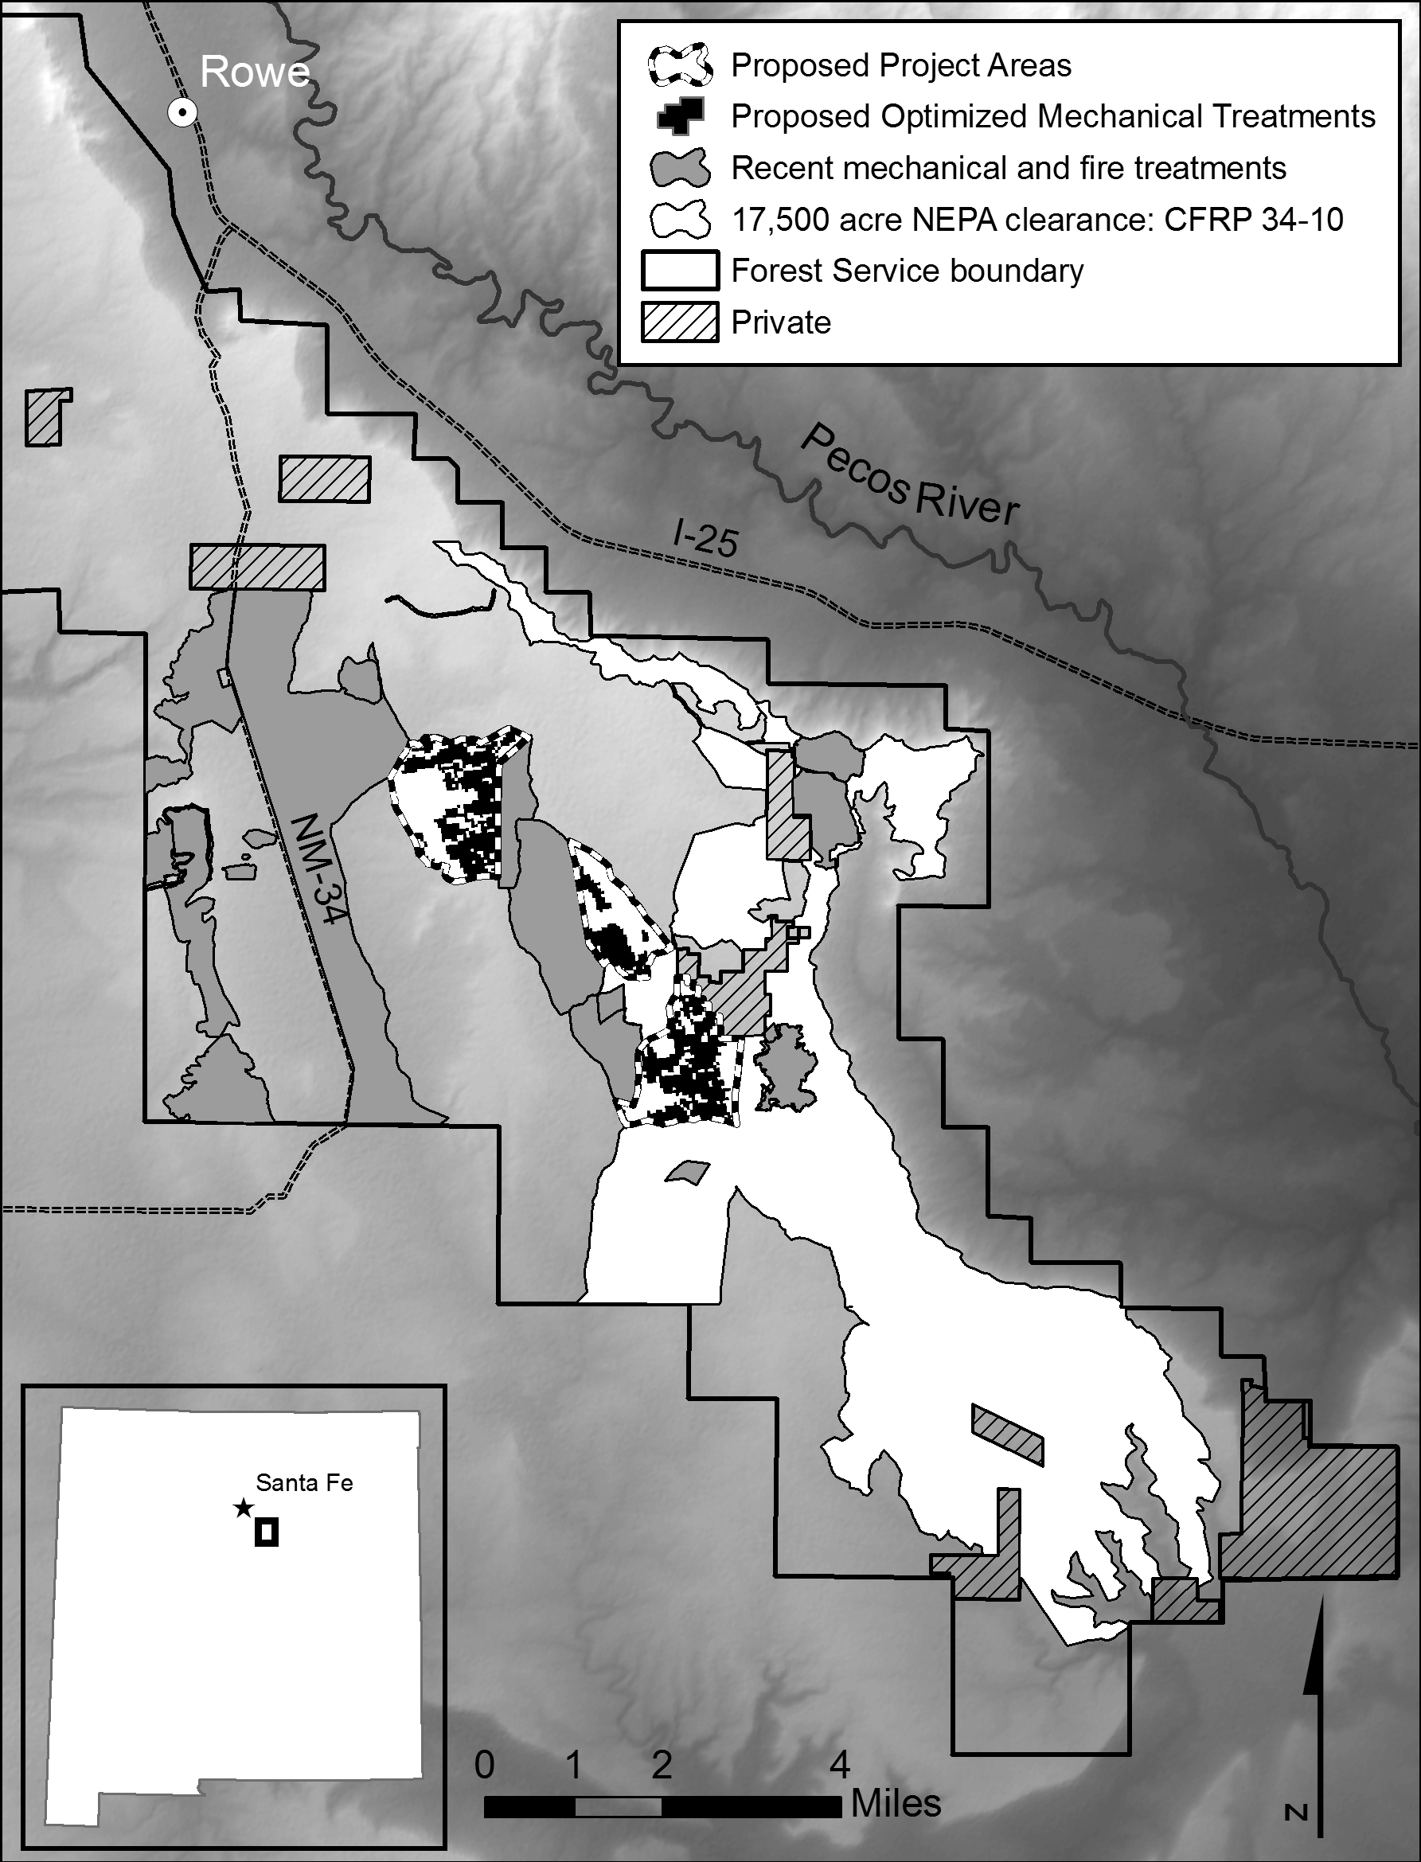
Figure 1. Proposed project areas (2,500 acres) and proposed optimized mechanical treatments (675 acres) that are part of broader landscape-scale restoration on Rowe Mesa, San Miguel County, NM (T13N, R13E). The proposed treatment areas build upon, and most importantly, connect multiple prior CFRP projects including the 17,500 acre phased NEPA clearance for landscape-scale restoration and prescribed fire (CFRP planning grant 34-10). Map by Ellis Margolis, 2/1/2013.

