Be a Dendrochronologist

- Label the parts of the cross section below using the words: Pith, Early Wood, Late Wood, & Bark

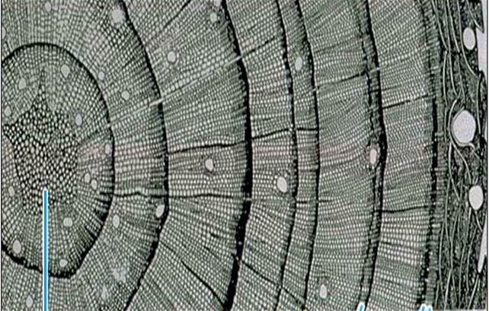

- What can a tree tell us? Name two things dendrochronologists can learn from tree rings.

- What two things affect the ring width in tree-rings?

- Describe a “good” forest fire. What happens to the landscape?

- Describe what happens to the landscape when fires are suppressed or put out? Does this change the way the land looks? Describe.

- How might climate change affected our lives?

- This tree was cut three years ago. Write that date here: __________________

- How old was this tree?

- What year did the tree start growing?

- Find the ring in the year you were born. Was it a wet or dry year?

- In what year of growth was there the least rainfall?

- In what year of growth was there the most rainfall?

