Be a Dendrochronologist

Label the parts of the cross section below using the words: Pith, Early Wood, Late Wood, & Bark

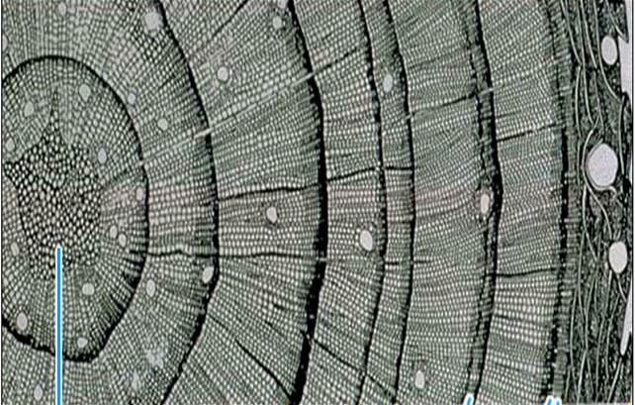

Tree rings contain up to 10,000 years of annual information about climate, fire history, insect outbreaks, glacial movement, and other disturbances. Examine the 50 years of tree-ring information below and see what patterns you can find!

Count the tree rings backwards from the bark (2007) to find the pith date (when the tree started growing). Mark every decade with a dot (hint: the years 2000 and 1990 have already been marked for you).

The tree rings are the white spaces between the lines. Think about what might cause variation in the tree-ring width.

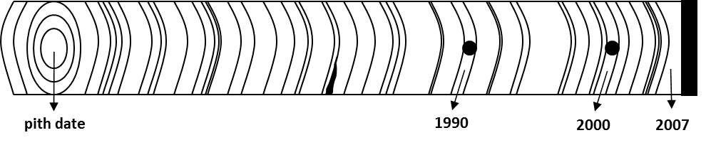
- What is the inner date (pith date) of the tree core?

- List the years of 5 of the narrowest rings.

- List two reasons why a tree would have narrow rings.

- Which year is there a visible scar?

- List two reasons a tree would have a scar.

Compare the precipitation record on the next page with the tree core and answer the following questions:

- Which year had the least amount of precipitation?

- Examine the tree ring for that year. Is it narrow or wide?

- What might be one reason you would want to study tree rings? Write three sentences about how tree rings can be used to study the environment.

Climate Data 1950–2007
Year | Precipitation (cm) |  | Year | Precipitation (cm)
1957 | 15.1 |  | 1980 | 19.1
1958 | 14.5 |  | 1981 | 17.6
1959 | 15.4 |  | 1982 | 18.7
1960 | 11.9 |  | 1983 | 18.6
1961 | 14.3 |  | 1984 | 16.3
1962 | 16.5 |  | 1985 | 14.9
1963 | 16.5 |  | 1986 | 16.2
1964 | 16.8 |  | 1987 | 15.2
1965 | 15.5 |  | 1988 | 11.9
1966 | 11.4 |  | 1989 | 15.1
1967 | 19.1 |  | 1990 | 13.5
1968 | 17.2 |  | 1991 | 16.1
1969 | 17.1 |  | 1992 | 15.6
1970 | 17.9 |  | 1993 | 20.3
1971 | 15.4 |  | 1994 | 14.3
1972 | 14.8 |  | 1995 | 19.5
1973 | 16.2 |  | 1996 | 13.7
1974 | 11.9 |  | 1997 | 18.2
1975 | 20.4 |  | 1998 | 15.6
1976 | 16.5 |  | 1999 | 10.9
1977 | 16.9 |  | 2000 | 12.9
1978 | 15.8 |  | 2001 | 14.4
1979 | 11.7 |  | 2002 | 16.7
 |  |  | 2003 | 12.2
 |  |  | 2004 | 9.7
 |  |  | 2005 | 11.7
 |  |  | 2006 | 15.0
 |  |  | 2007 | Data incomplete

