Be a Dendrochronologist

Introduction to Dendrochronology:

Label the parts of the cross section below using the words: Pith, Early Wood, Late Wood, & Bark

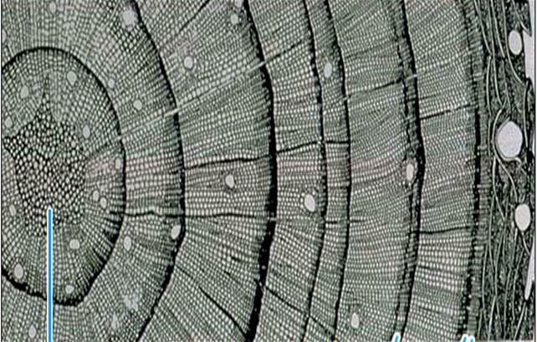

Matching Exercise

Students will learn how to pattern-match rings from core samples from 4 trees:
  - Sample 1: From a living tree from the Pinetown Forest, July 1993
  - Sample 2: From a tree from the Pinetown Christmas Tree Farm
  - Sample 3: From a log found near the main trail in Pinetown Forest
  - Sample 4: From a barn beam removed from Pinetown Hollow

Align the patterns in the samples. Determine the age of each tree (how many years it had been growing) by counting the rings and record in the chart below.
Sample | Age of Tree | Year Cut or Cored | Year Growth Began
1
2
3
4

Observations and Questions
- Which tree ring represents your birth year?

- What kind of growing season (good or bad) existed that year in Pinetown? How can you tell?

- If poor tree growth around Pinetown was mainly caused by drought, which years were probably drought years? How can you tell?

- Did Pinetown have more years of drought or plentiful rainfall?

- Why might a climatologist be interested in the tree-ring data from Pinetown?

- Is it likely to be more important to sample trees in the area that are quite old or ones that are fairly young? Why?

