Be a Dendrochronologist

- Label the parts of the cross section below using the words: Pith, Early Wood, Late Wood, & Bark

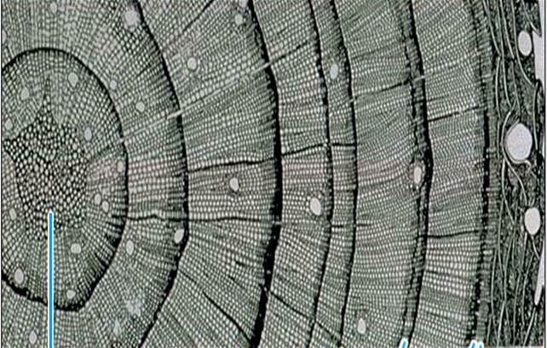

- What can a tree tell us? Name two things dendrochronologists can learn from tree rings.

- What two things affect the ring width in tree-rings?

- Pretend you are a tree. Draw your cross section, using your age to represent the annual rings.

