NAME ________________________________________________ GROUP # ________

GROUP ASSIGNMENT G-6: EARTHWEEK
Diary of the Planet: Global Warming Fingerprints & Harbingers
(worth 10 pts)
INDIVIDUAL MAKE-UP

PART I -- The GLOBAL WARMING: EARLY WARNING SIGNS Website
http://www.climatehotmap.org/http://www.climatehotmap.org/index.html
"An increasing body of observations gives
a collective picture of a warming world
and other changes in the climate system."
Intergovernmental Panel on Climate Change (IPCC), 2001
The goal of the website is to compile these observations in a somewhat systematic way and display them to the public as "Early Warning Signs" (aka "hotspots") (NOTE: these are NOT the same as the ecological hotspots discussed in IGC Chapter 18).
The website distinguishes two basic kinds of hotspots on their map:
"Fingerprints" of global warming -- such as heat waves, rising seas, and the melting of mountain glaciers -- are indicators of the global, long-term warming trend observed in the historical record. Fingerprints are what researchers seek to detect and then to confirm that climate change is indeed underway. [Click on the FINGERPRINTS link to learn more)
( 1) List the 4 fingerprints that are key indicators of global warming:
___________________________________ ________________________________
___________________________________ _________________________________
"Harbingers" -- such as exceptional droughts, fires, and downpours, the spread of disease-bearing insects or other carriers, and widespread bleaching of coral reefs -- may be directly or partly due to the warmer climate, but it is impossible to say for sure. Harbingers are events that are consistent, given our current scientific theories and models, with the kinds of impacts projected to occur as global climate change proceeds. [Click on the HARBINGERS link to learn more]
( 2) List the 6 types of harbingers on the website that MAY be linked to global warming:
___________________________________ ________________________________
___________________________________ _________________________________
___________________________________ _________________________________

Now you will examine specific regions based on your group folder color:
Red  (Groups 1-4) | Orange  (Groups 5-8) | Yellow  (Groups 9-12) | Green  (Groups 13-16) | Blue & Purple  (Groups 17-21)
Oceania & Asia | Europe/Russia | South & Central America | Africa & Antarctica | North America
For Part II:
Week ending  Sept 2, 2005 | Week ending  Oct 14, 2005 | Week ending  Jun 24, 2005 | Week ending  Jan 21, 2005 | Week ending  Aug 19, 2005

To begin, click on REGIONS and select one person in your group to read the description of your assigned region(s) out loud to the rest of the group.

(3) FINGERPRINTS IN YOUR REGION:

a. What is the most frequently occurring type (see #1) of fingerprint in your region?

b. What is the second most frequently occurring type of fingerprint in your region?

c. Are there any types that DON'T occur in your region? What are they?

(4) HARBINGERS IN YOUR REGION:

a. What is the most frequently occurring type (see #2) of harbinger in your region?

b.What is the second most frequently occurring type of harbinger in your region?

c. Are there any types that DON'T occur in your region? What are they?

PART II -- EARTHWEEK -- DIARY OF A PLANET website: http://www.earthweek.com/

To begin , click on "THIS WEEK" & then click on the map, a PDF file will open showing notable events that took place during the week ending Nov 18th.

Now, by going into ARCHIVE EDITIONS, find the week assigned to your group (see table above) and classify the events shown for that week into one of the following categories (see the example on the next page for guidance). Fill in the TABLE on the last page with this information & answer the remaining questions on the last page.

(1) Fingerprint
(2) Harbinger

(3) Direct Human Impact or Activity
(4) Geologic (non-climatic) Earth event

(5) Earth/Biologic Oddity
(6) Other

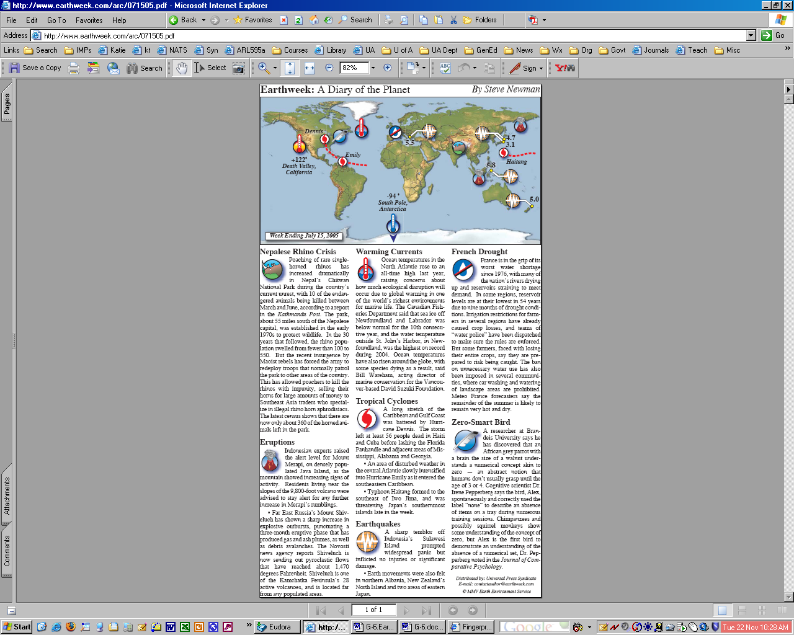
EXAMPLE:
Harbingers
Fingerprint
Geologic
(non-climatic)
Earth event
Direct Human Impact
Earth
Oddity

YOUR WEEK: ______________________________________

(1) Fingerprint
(2) Harbinger

(3) Direct Human Impact or Activity
(4) Geologic (non-climatic) Earth event

(5) Earth/Biologic Oddity
(6) Other

Earthweek event | Category

(5) The Early Warning Signs website's definition of a FINGERPRINT, is very specific -- did you find any fingerprints in your EARTHWEEK map?

What events DID you find that are directly or indirectly associated with global warming OR climate change in general?

Briefly describe them below, stating the link to climate change:

